**New Charting for Artificial Airways**

The Nursing Documentation Re-Design project has brought a change to how Artificial Airways will be charted.

**VUH ICU Go-Live schedule:**

**Nov 11: 10N, 11S**

**Nov 17: 8T3, 9T3, 10T3**

**Dec 1:    S54, COBS, 6T3, 7T3**

Charting security rules are in place so that only the Live ICUs will see the new charting options.  These rules are based off of the computer’s assigned unit.  If an RT starts the day with a virtual session using  a Live unit’s computer, she/he may need to start a new virtual session on a computer of a non-Live unit - and vice versa - to see the same options that nursing is seeing on any given patient.

For RTs, the new Start New Artificial Airway link sits where previous Airway charting was on the **Resp Care – Vent Data** and **Respiratory Care** tabs.  When an RT needs to start a new airway, click on the link and a pop-up window displays:

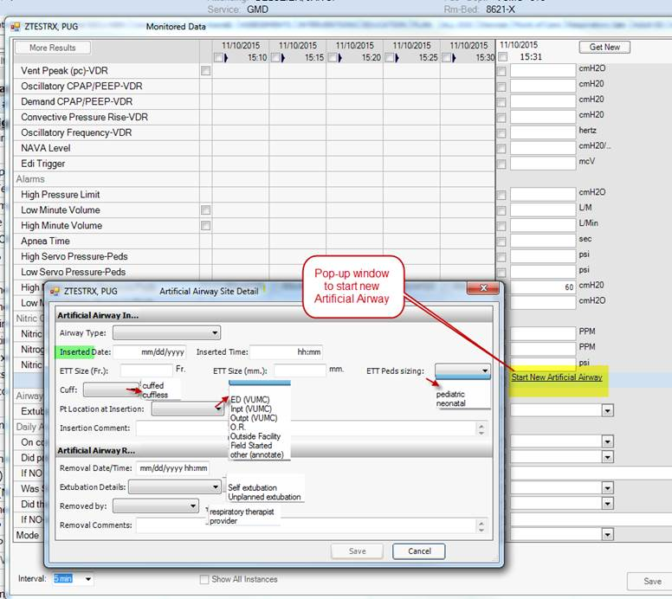

Once the airway is started, the pop-up window closes, and the trended assessment and intervention data is available to chart… usually.  One quirk of using this data type on a tab within the Monitored Vitals/DAS section of HED is that the trended assessment and intervention fields are not viewable immediately upon starting an airway, as they are if they were charted elsewhere.  The work-around is to close the “Resp Care – Vent Data” tab, open it again, hit Show All, and the fields will be there.

Example:

Start a new Nasal ETT…

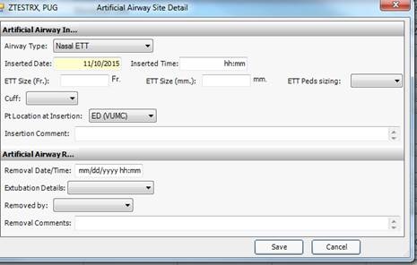

Click Save… the Pop-up box disappears but the charting is not viewable:

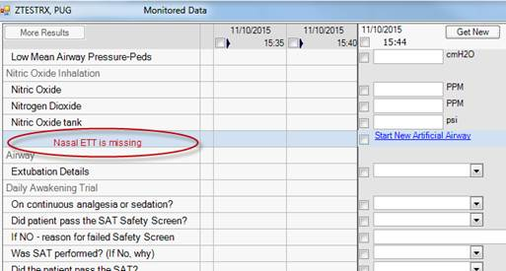

Close the window, Go back into the “Resp Care – Vent Data” tab, click Show All, and the charted airway is present, and trended assessment/intervention data is chartable.  \**This is only an issue when first starting an airway.  Once the trended fields are charted, they will appear with subsequent charting sessions.*

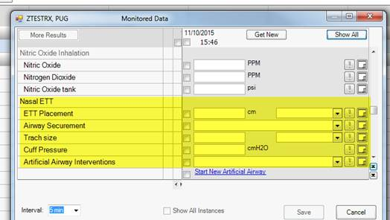

**To END/chart the Removal of an Artificial Airway**:

Go to the Respiratory Care tab – An Airway cannot be Ended within the “Resp Care – Vent Data” tab under the Monitored Vitals/DAS section.

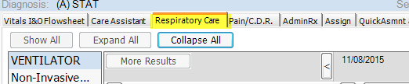

Click on the hover box next to the airway, and enter the Removal data, click Save.

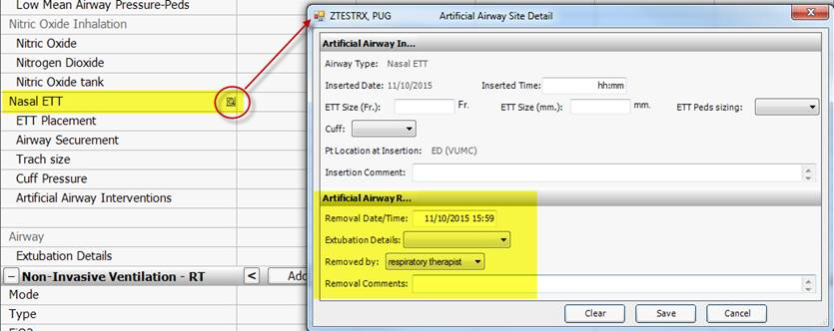

**An Ended/Removed Artificial Airway:**

