How to Enter Protocol Order for Resuming Diet with Specific Parameters
Why the Change:
- Providers will have option to specify parameters around when to resume diet orders after an event (test or procedure)
- Allows nurse to resume diet based on provider parameters by placing a protocol order
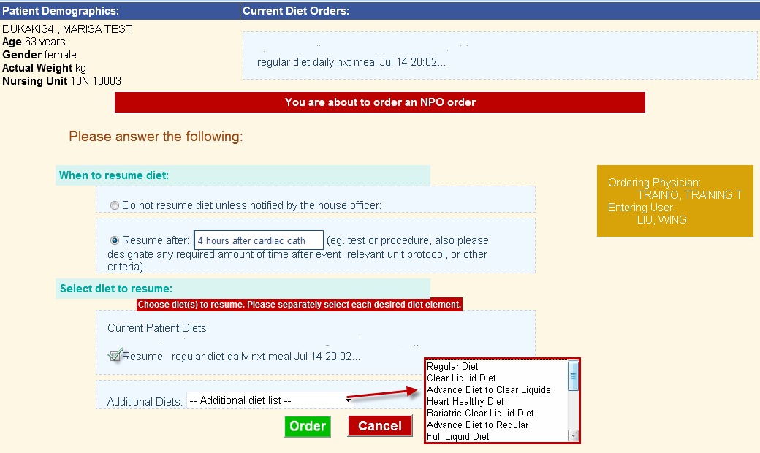
Nursing Workflow - How to resume diet for NPO orders with specific resume parameters
- Select protocol and ordering provider. Select discontinue.

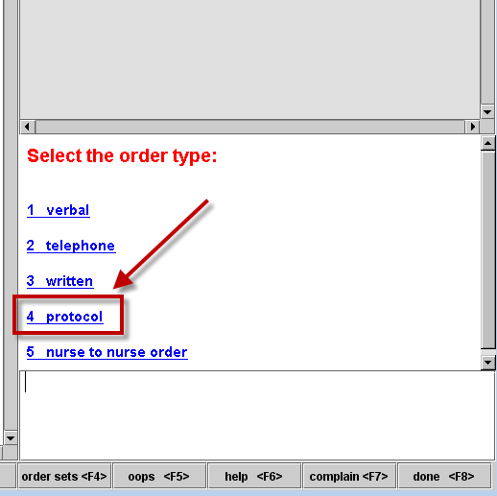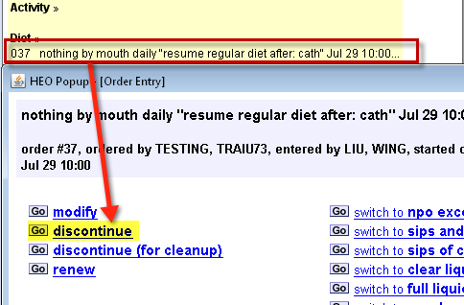

- Click Order to resume diet.
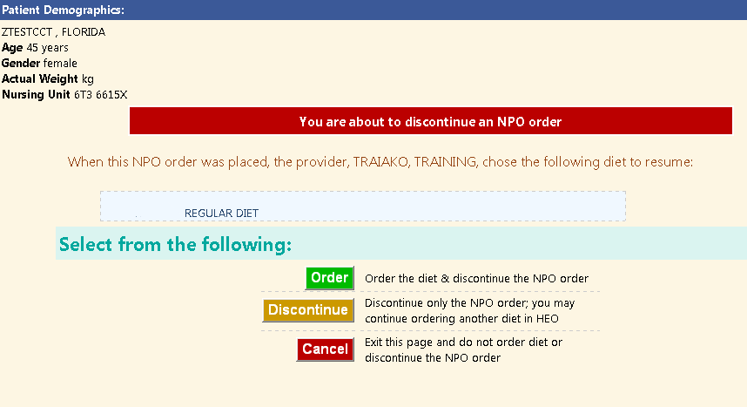

*Hint: You may be prompted to discontinue conflicting diets if placing diet order first*
