MLT 2.9

**New Features**

**Check off items that you have reviewed with the patient.**

Use of these checkboxes is optional; they are intended to help with long lists. These checkboxes can be turned on or off using the information button above the checkboxes.

**Notice: The checkbox information is not saved when you submit your work.**

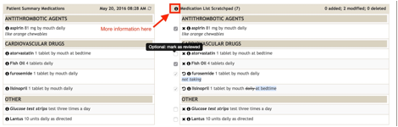

**Fixed “No known medications” workflow**

Quickly and easily add medications to the list when there were previously no known medications. You no longer need to delete "no known medications" in order to add medications to the list, just add the new medications in the rapid add box.

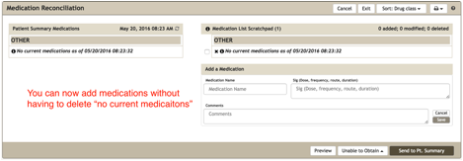

**Added a medication changes counter to top of scratch pad.**

Counts the number of items on the list, as well as the number of added, modified, and deleted items.

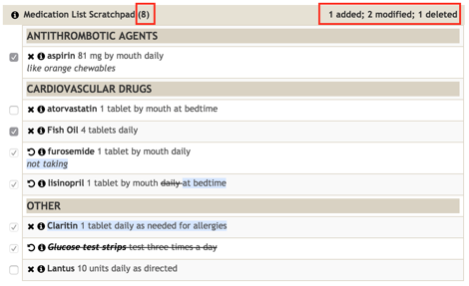

**Improved refresh notice in the summary screen**

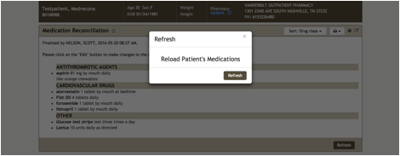

**TALLman lettering when entering medication names**

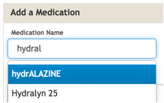

**Technical fixes**

Prevent Inactive RACFID from being used in Provider Lookup

Various bug and stability fixes