Insulin Vial Changes
*** Beginning June 25th and 26th, U-100 Regular and Lispro Insulin vials will change from 10 ml to 3 ml vials. This will affect all VUH in-patient areas and any out-patient areas that keep insulin vials.
*** The vials are the SAME concentration ~~ 100 Units/ml. The vials are just smaller!

Why are changes being made?
Safety Reasons:
- Decreased risk for catastrophic dosing errors i.e. less insulin in vial
- EACH patient will now have his/her OWN vial less risk for cross-contamination
- New vials have color-coding to distinguish b/t insulin types
Financial Reasons:
- Because Vanderbilt provides a disproportionate share of care to those in need in our community we are able to participate in a government program to purchase medications at a DEEPLY discounted rate.
- The rules for this program have been updated and now require all qualifying purchases be traced back to an individual patient dispense.
- Purchase/Use of smaller vials will result in less waste & less cost.
Process Changes:
- Floor stock process will stop @ go live; Use of 3ml vials will begin
- Regular, lispro and NPH will be dispensed as 3ml vials for individual patients only
- Regular and lispro will be loaded into the AcuDose non-refrigerated pockets for dispense when a patient need arises
- The vial will be removed from the AcuDose pocket for a pt
- The patient's name should be added to the patient vial (either with addressograph sticker, lab sticker or with a sharpie marker)
- The dose should be removed from the vial and then vial placed back in the Patient Specific Drawer of the AcuDose
- The auxillary bar code and high alert flag will still be attached to the 3ml vials as before
Aspart will be replaced by Lispro (this is a formulary change).

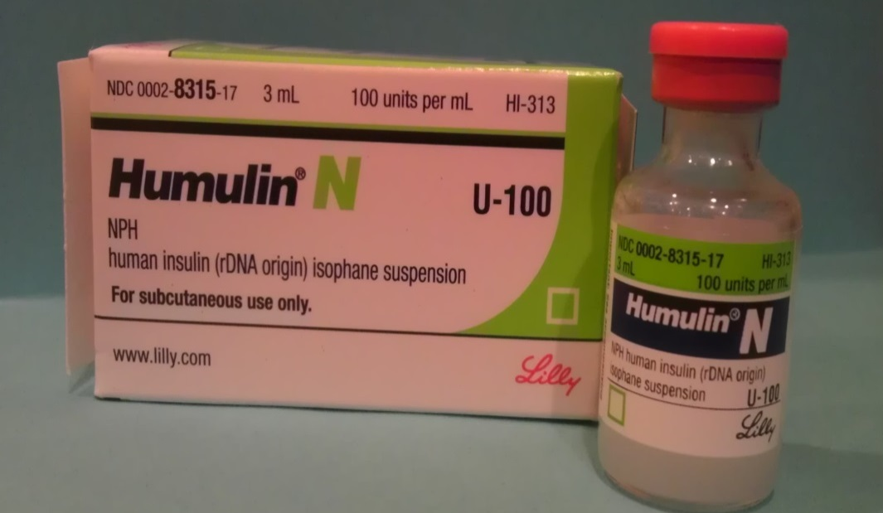
These Insulin Vials will be used now.
~~~~~~~~
Each patient will have his/her OWN vial.
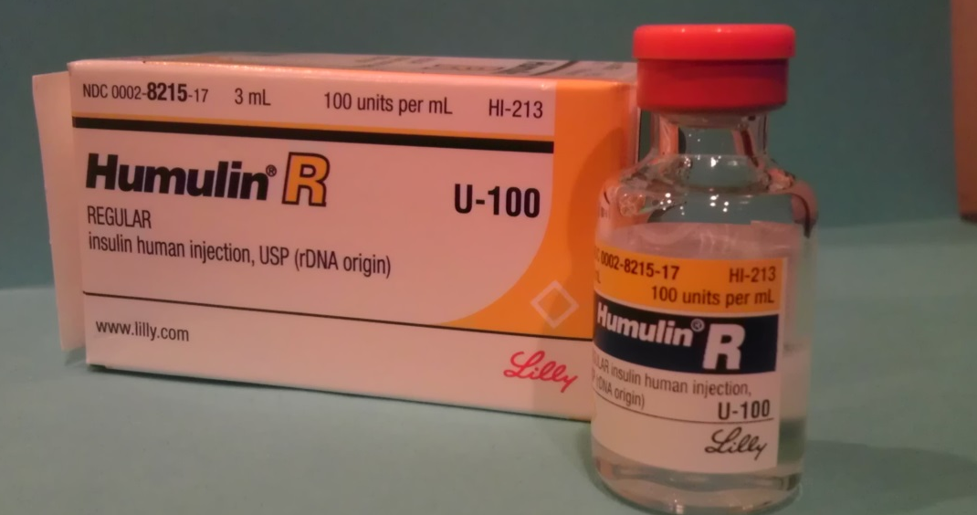
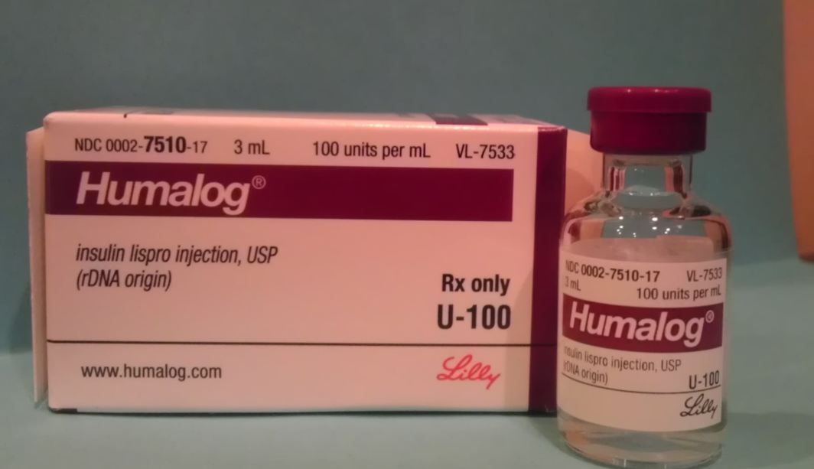
These Insulin Vials will be deleted from the system:

