Steps to Set Up Dashboard  IVT DASHBOARD TIP SHEET  - Sign on to StarPanel.  - Click on Dashboards in black bar.  - Click on Ancillary Dashboards.  - Click on IVT.  - IVT dashboard opens in top frame.  - Click on IVT under Dashboard and drag up to Favorites. |  | 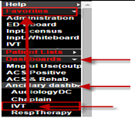
- Select Change Panel and select VUH or VCH (or appropriate units).  - Important For VCH only – to see all possible Peds user requests, when changing panel (step 4), click in the Multi Panels Mode checkbox, highlight VCH, 11N, S31. Sort by age to identify Peds patients on 11S and S31  - IV therapists only - Select Show this dashboard after login. | 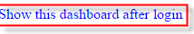  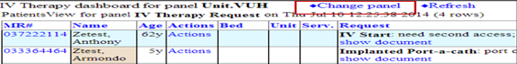
Steps to Use Dashboard Daily  - Sign on to Virtual CWS.  - Open HED and StarPanel.  - Review Requests listed in DB.  - If you get a page, other than a crisis request, tell the staff person to enter request in the IVT Request Form  - Look for new items by the white box under ACK column.  - Acknowledge new requests as soon as it is noticed by clicking on white box – this lets the nurse know it has been seen.  - Review new requests for priority compared to those on the list.  - Once it is known that an IVT will be doing the procedure, they will click in Priority box and enter in Hi, Med, or Low + their initials. It is now assigned. (Note: it may be acknowledged by one IVT- seen by hovering over the green box- yet assigned to another IVT- whose initials are in priority column).  - Go to patient room of next highest priority request and perform task.  - Document in HED.  - Toggle back to StarPanel and click Remove for that request.  - Start process over. | 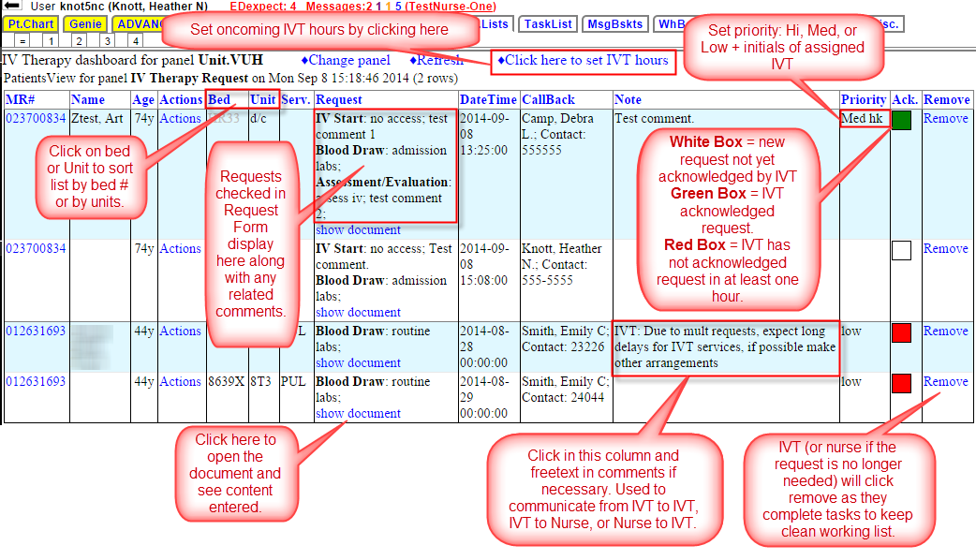
Before leaving your shift:
Enter the next shift’s coverage by clicking on “Click here to set IVT hours” and entering [example] “IVT Hours Tues 9/9/14:
VUH 0700 - 1700
VCH 0700-1900”
This will display the IVT coverage hours on the request form for the unit staff to see.
**If there is no oncoming IVT (sick call in or not scheduled) and there are still requests on the dashboard, you are expected to call the nurses back to inform them that there is no oncoming IVT and the request will not be completed. Then remove them from the dashboard.

