How to Order Durable Medical Equipment (DME) via RxStar
PURPOSE: Use RxStar to order DME
Date of Creation: | 10/11/11 | Date of latest revision:

- Go to RxStar.
- There is a filter (dropdown list) to the far right of the drug search box
  - The default filter is to "all prescriptions/OTC."
- Change to: "all medical supplies."
- Select your item e.g. diabetic test strips, walker, etc.

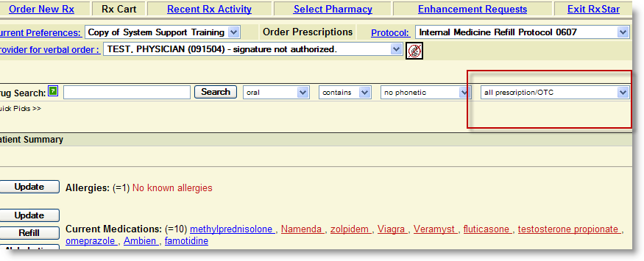
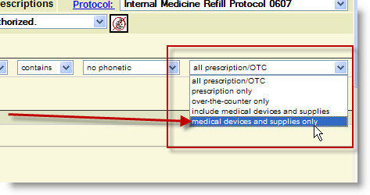
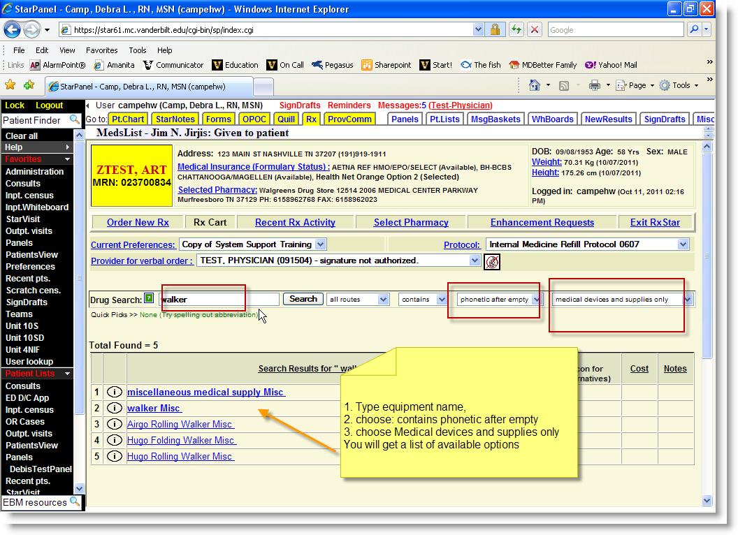

Please note: RxStar uses FDB (First Databank) database for our medication and DME options. We are not able to add medications or DME to RxStar. We do receive database updates, so new medications and DME are added periodically. Commode and hospital bed are not in the database.
For the DME that users cannot find, to prevent them from "free texting" each time, users can add their commode or hospital bed "prescriptions" as Favorites.

We have a Comments field on the bottom right of our RxBuilder page that allows users to add a comment. These comments appear on the prescription as well as within PSS (within brackets in the StarPanel view and within the comments field in PSS (note icon)). If users setup their prescriptions or DME with set comments that they always use, this will help too.

