Hold and Resume Orders Review Tools
4/5/13/lm
There are 3 different types of medication holds in WIZ/HEO providers can place:
- Indefinite hold
- Hold by date/time
- Hold by number of days
To resume meds in HEO/WIZ:
- Specify resume date/time at the time the med is put on hold
- Modify a med that has been on indefinite hold
How to see medications placed on hold:
- StarPanel – eMAR. Meds placed on hold in the future will appear as “Future Hold.” Meds currently held will appear with a “Held.” Meds no longer on hold will not have this verbiage in the eMAR.

- Inpatient All Orders – Select orders and inpatient & ED Orders from yellow menu. Select Inpatient/ED Orders (all cases). Meds currently on hold will display for the curent hospitalization. Any medications that were left on hold at the time patient is discharged will also display. Hover over med order to see further details on medication.
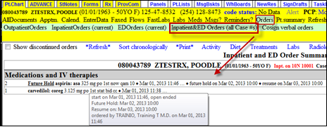
- WIZ/HEO – right clicking on the medication provides a history of the when the med was placed on hold
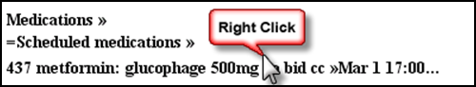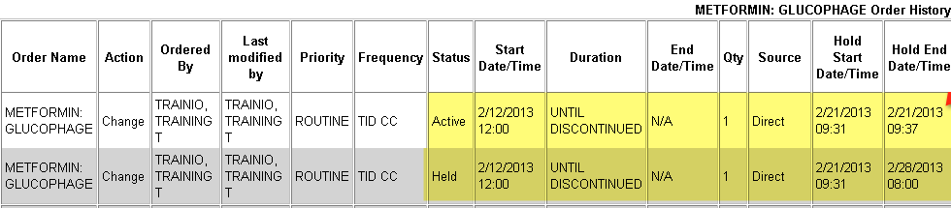
- Care Organizer – History screen displays the Hold status.
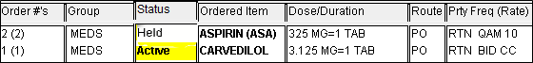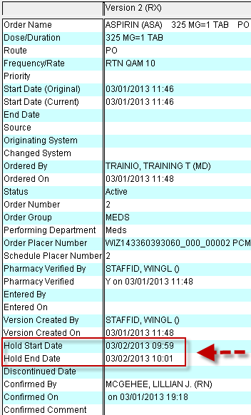

- HED PDFs – the HED MAR will display schedules placed on hold with date and time.
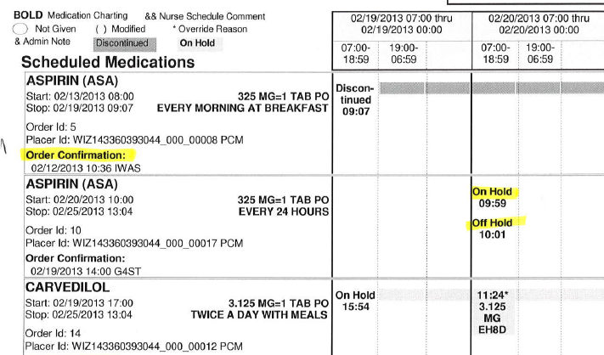

Limitations to holding medications:
- Limited to providers only
- Functionality not available in Emergency Departments
- Cannot place hold on IV insulin, IV Heparin, IV fluids, or RT meds

