There are written materials available on Safety/Falls that are language specific documents in E-docs.

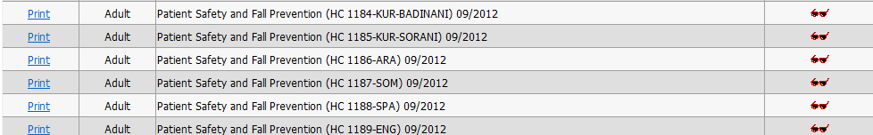

There is also a document on Patient Safety and Fall Prevention available in e-docs.

This can be printed and handed out to patients. English only.

**Patient Safety and Fall Prevention**

*The fact is, falling can be a very real hazard for patients who are ill or recovering*

*from illness. Most of the time, falling is due in some way to dizziness, weakness or*

*faintness. These are all feelings you may have while you are in the hospital or*

*at home recovering. Here are some things you can do to help prevent falls and*

*ensure your own safety.*

**IN THE HOSPITAL:**

**Be aware of your limitations.**

Many procedures, tests or even your illness may require bed rest or other restrictions. It may take time to

gather your strength.

**Take your time.**

Adjust your movements to go along with your strength. For example, after lying for long periods of time, sit up for

a while and let your blood pressure even out before standing or trying to walk.

**Make sure your bed is in the low position before you try to stand.**

It is important that your feet are firmly on the floor. If you feel unsteady, call for help by using the call button

on your bed.

**Wear socks with slip guards or rubber soled slippers.**

This will help prevent you from slipping.

**Stand up slowly.**

Don’t support yourself on objects that roll, such as the IV stand, the table that goes over your bed at mealtime, or a

wheelchair.

**Have a family member or friend stay with you at the hospital.**

Sometimes you can use the extra help.

**Keep the things you need or want within reach.**

If you need something and can’t get to it, ask for help.

**If you wear glasses or use hearing aids, keep them close by.**

These will help you be more aware of obstacles when moving around.

**PARTNERS IN CARE**

***Leaders in Health Care Education***

**INFORM. EDUCATE. MOTIVATE.**

**1**

**Adjust the lighting in your room.**

It is important that you can see well to avoid obstacles.

**Leave the light on in the bathroom.**

This will help light your way. Also, be sure to give yourself plenty of time to get there.

**Use the emergency call buttons in the bathroom or by your bed.**

Don’t be ashamed or afraid to ask for help, and please wait patiently for help to arrive.

**IN THE HOME:**

**Wear shoes with firm non-skid rubber soles.**

Loose fitting or slick soled shoes may make you more likely to trip.

**Put away throw rugs during your recovery.**

If you need to have them, fasten them firmly onto the floor or add non-skid backing.

**Keep lights on inside your home to light your way.**

This is especially important at the top and bottom of stairs, in bathrooms, hallways and in your bedroom.

**Add handrails to both sides of stairways for support.**

**Add grab bars to your bathroom for use in the shower, bathtub or by the toilet.**

**Put electrical cords along the walls, not across pathways.**

**Store all frequently used objects where you can easily reach them.**

If you can’t reach something, have someone else get it for you rather than use a ladder or stepstool.

**PARTNERS IN CARE**

**9**

**10**

**11**

**12**

**3**

**4**

**5**

**6**

**7**