**EasyID: Label Printing**

**When to use:**

It is now required to use EasyID labels for specimens that are run on IGEMS machines.

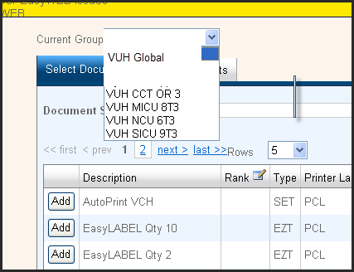HEO/Wiz labels can still be used for all other specimens or documents for scanning.

**How to Print EasyID Advance Labels:**

1. Click on the EasyID Advance icon on the desktop. 🡪
2. Log in with your VUNet ID and ePassword.
3. Select a printer group under the **Current Group** dropdown list.
4. On **Select Documents** tab, select **Add** by **EasyLABEL Qty 10** or **Qty 2**.

NEW PRINTER OPTIONS WITH QUANTITY CHOICES

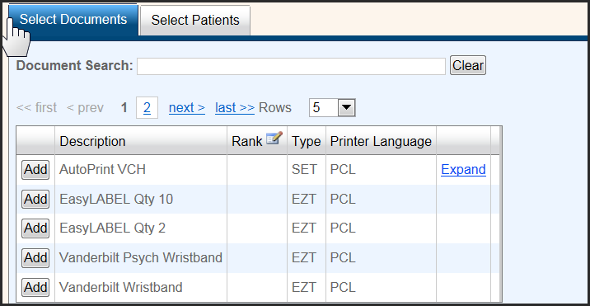

1. Go to **Select Patients** tab.

**3**

1. Select **Acct Num** in dropdown (says Patient Name by default- use account number for accuracy).
2. Type in account number and c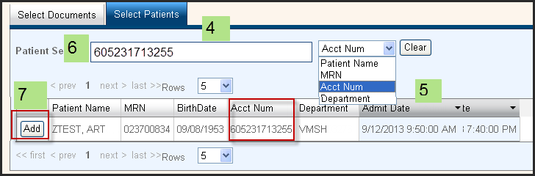lick **Add** by the correct row.
3. Go to **Output Summary** section.
4. Select # of copies – labels print in multiples of 2 or 10.
5. Click on **Print Documents**.

(*your selected default printer will display automatically in Destination- see setup instructions for more information)*

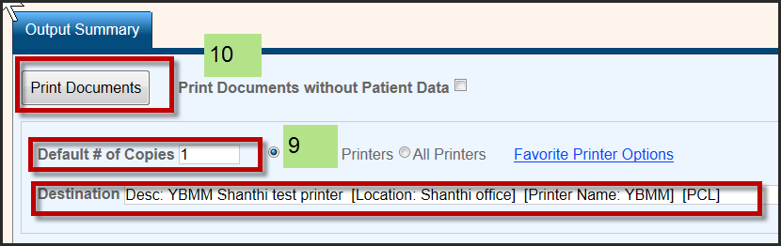

EasyLABEL QTY 2

Default # copies 1 = 2 labels printed

Default # copies 2 = 4 labels printed

Default # copies 3 = 6 labels printed

EasyLABEL QTY 10

Default # copies 1 = 10 labels printed Default # copies 2 = 20 labels printed

Default # copies 3 = 30 labels printed

1. Label will print to the printer you selected!