**EasyID Access Options: Global vs. Unit Specific**

**When to change your Current Group in EasyID:**

* Your printer group will automatically default to the last group you selected.
* When you open the dropdown list next to **Current Group**, you should see your home unit and an option for a global printer group.

**\*\*\*As long as you stay on your home unit you will not need to change your printer group!**

* All staff will have **one** of these global levels of access based on home unit or main work area. If you float to a different unit, you can see that unit’s EasyID armband or label printers by changing your group to VUH Global, VCH Global, or VPH Global as applicable.
* If you are a part of the float pool or are working on a different unit than normal, you **have** to change to a global printer group in order to print an EasyID armband or label on that unit.

**Listed below are the EasyID group options and the staff who should have access to them:**

**To begin:**

1. Click on the EasyID Advance icon on the desktop. 🡪
2. Log in with your VUNet ID and ePassword.

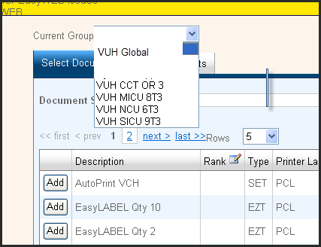

**How to change your printer group in EasyID:**

1. Select a printer group under the **Current Group** dropdown list.
2. Under **Output Summary** tab select **All Printers** to see the new list of printer options.
3. Type in unit destination or printer ID in **Destination** field to limit search results.
4. 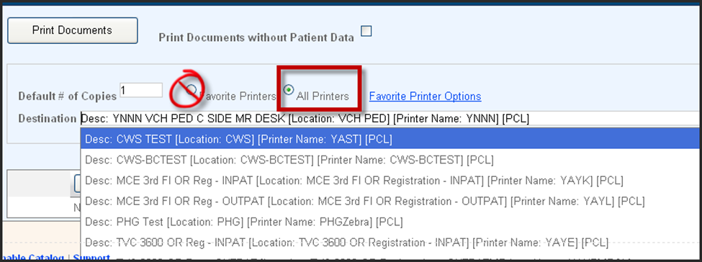Select correct printer and then click **Print Documents**.