**EasyID: Armband Printing**

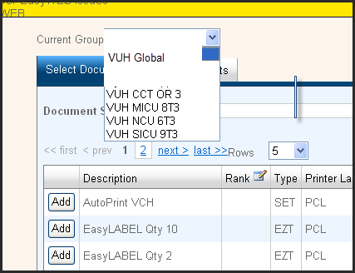**How to Print EasyID Advance Armbands:**

1. Click on the EasyID Advance icon on the desktop. 🡪
2. Log in with your VUNet ID and ePassword.
3. Select a printer group under the **Current Group** dropdown list.
4. On **Select Documents** tab, select **Add** by **Vanderbilt Wristband**.

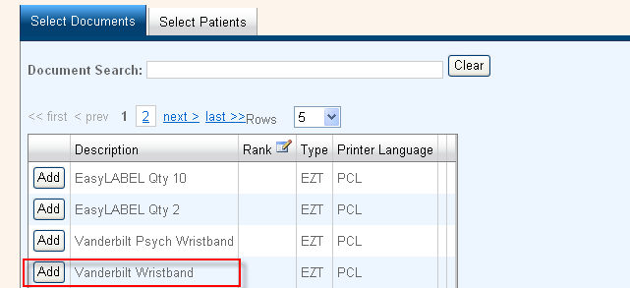

**3**

1. Go to **Select Patients** tab.
2. Select **Acct Num** in dropdown (says patient name by default- use account number for accuracy).
3. Type in account number in **Patient Search** box.
4. 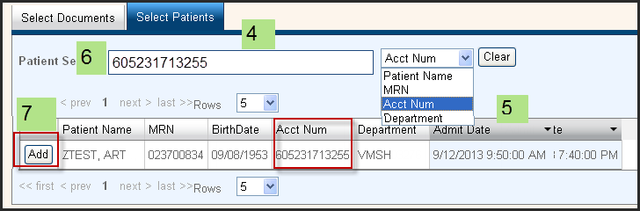 Click **Add** by the row with the correct account number and patient information.
5. Go to **Output Summary** section.
6. Verify you have selected the correct document and patient at the bottom of the summary box.
7. Your selected default printer will display automatically in **Destination**, click on the arrow next to **Destination** box to select a different favorite printer (see printer setup instructions if needed).
8. 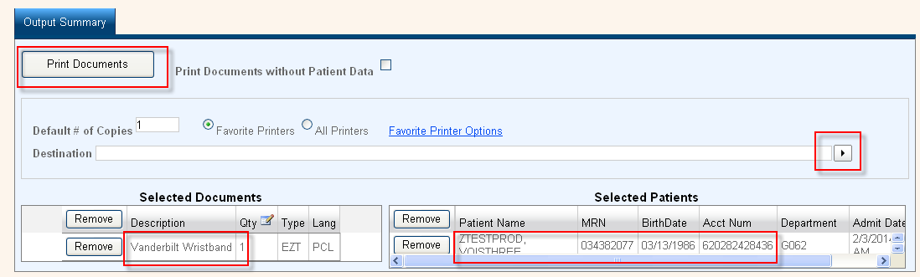Click on **Print Documents**.

**10**

**11**

1. Armband will print to the printer you selected!

**9**