Content Outline:
- General Information
- Frequently Asked Questions
- Troubleshooting

General Information:
- IV start and stop times are used to capture infusion details and charges for the Adult ED outpatient population. At this time, the Peds ED is not using this process, they continue to use the paper MAR to document these times.
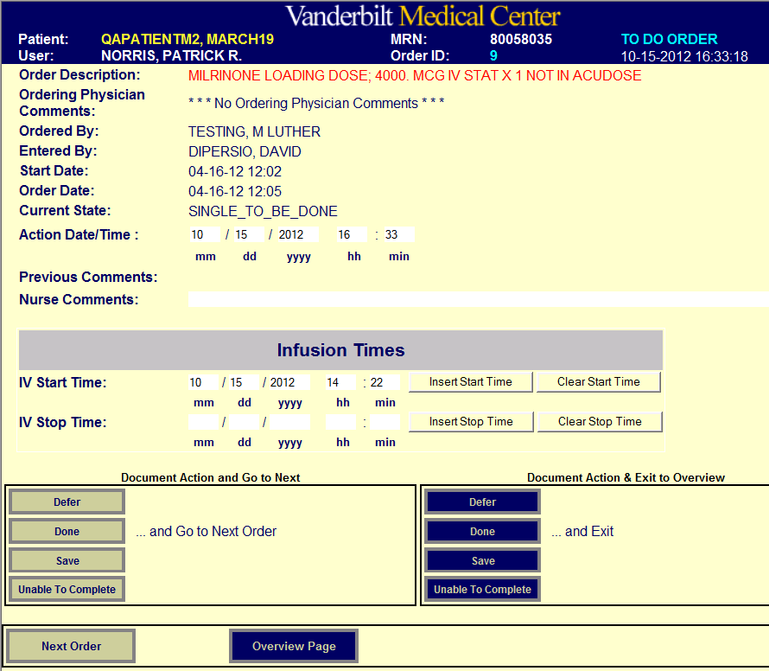
- Fields for documenting start and stop times (for non-repeating IV orders) are visible on the “New” and “To Do” order screens in Order Tracker. A “Save” button is also available on these screens so that staff can save the IV time entered without updating the status of the order.
Times can be manually entered or edited in these fields
Buttons to insert current time or clear IV start/stop time
“Save” buttons store start/stop time without changing order status
Frequently Asked Questions:
- Where and when are IV start / stop times entered?
IV start and stop times can be entered at any time. The data entry boxes appear when an order is marked either “New” or “To Do”. If an order is marked “Done”, click the “Edit” button to enter the IV times. (Users may find it easier to enter times prior to marking an order as “Done”.)

- Why do the start / stop time boxes appear for orders that are not infusions?
The IV start and stop fields will appear for all one-time (non-repeating) orders. It is difficult to automatically determine every order that might require start and stop time documentation, so Order Tracker allows times to be entered on any non-repeating order.

- How do I document start / stop times for repeating infusion orders?
At this time Order Tracker does not support IV start and stop times for repeating orders. A future version may provide this capability. Existing documentation procedures should be used if IV start and stop times need to be recorded for repeating orders.
- How will I know when an ordered IV infusion has been started?
The order will be labeled “IV” in the “Comm” column when a start time has been entered. When the stop time is entered, the “IV” will disappear.
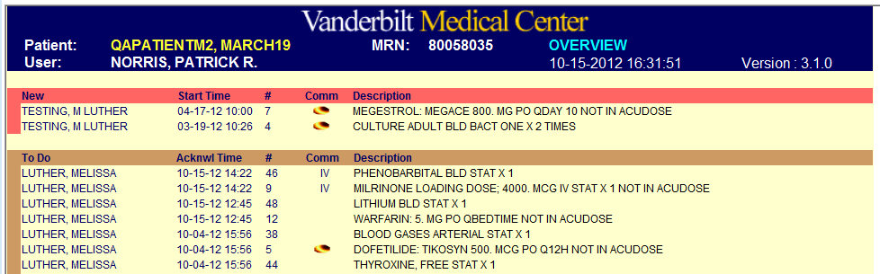
“IV” displayed when infusion has a start time entered
Troubleshooting:
- A start/stop time was documented for an order that is not an infusion.
If the order is “New” or “To Do”, click on the “Clear Start/Stop Time” button. If the order is marked “Done”, click the “Edit” button to bring up the IV start and stop time fields.
- The wrong start/stop time was entered.
The IV start/stop time fields can be manually changed at any time. (Again, if an order is “Done” click the “Edit” button on the order screen to show these fields).
- The staff member forgot to enter the start/stop time before marking an order as “Done”.
Click the “Edit” button to display the start/stop time fields and enter information.

