Custom Patient Education Instructions

Available for medications, diet, activity, and follow up appointments

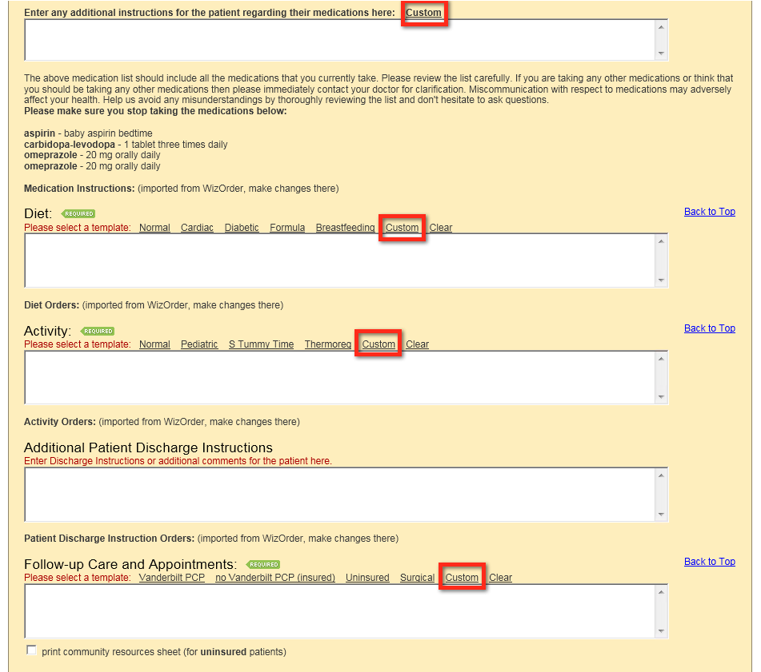

Selecting ‘Custom’ will bring up the create/insert screen for that section

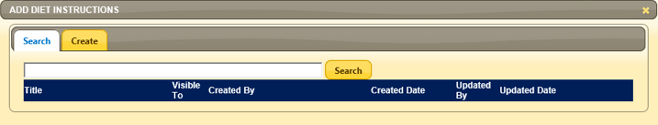

To start, click on the ‘Create’ tab

