What is DIRECT?
DIRECT is a communication mechanism that allows healthcare facilities and providers to electronically exchange patient medical data and records. In this initial phase we will only be receiving documents from outside providers. Phase 2 will include sending communications via Direct.

What is included within a DIRECT communication?
- Sender Information (e.g. Hospital for Transfers/Transitions or a referring clinic provider)
- Receiver Information (e.g. Access Center or an individual provider)
- Patient Information
- Attachments/Documents
- General Communication/Message

StarPanel

- Once the HIM Department indexes DIRECT communication-related attachments/documents to StarPanel, the attachment/document will appear in the new Outside Records tab.
  - When there are new documents to review (not incorporated), the “out.rec” tab label will be red.
  - If a physician has not “incorporated” or officially saved the document to the patient’s chart, the document name will be red.

  - Once a physician has saved the document to the patient’s chart, then the document name will change to blue and show who incorporated or saved the document to the chart. Only incorporated or saved DIRECT communication documents will appear in All Docs as well.

- Once the DIRECT communication attachments/documents are indexed to StarPanel, all users can view these documents under the Outside Records tab; however, only a physician can incorporate or save it to the patient’s charts.
  - Non-Physician View

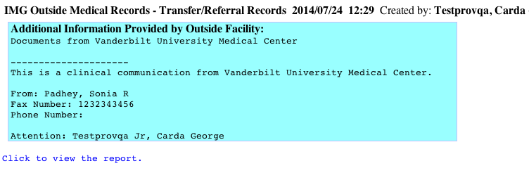

  - Physician View

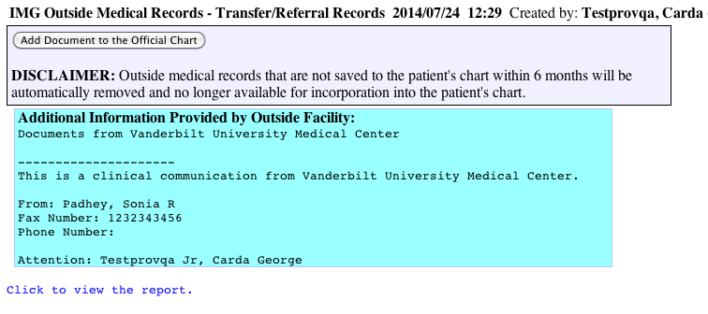

- If a DIRECT communication attachment/document has not been saved to the patient’s chart within six months, then StarPanel will hide this document.

NOTE: With the introduction of the new “Outside Records” tab within StarPanel, scanned documents indexed via Image Queue will also appear within this tab; however, these documents are automatically “incorporated” (i.e. blue); and therefore, automatically appear within All Docs. This process does not change.

