HED Internal Application Error, Patient is on a ventilator- Nurse is unable to save charting 11/1/13/kw
Cause: The ventilator is sending DAS a text value to a data entry field where HED expects a numerical value.
If this error is seen in HED and the patient is on a ventilator:
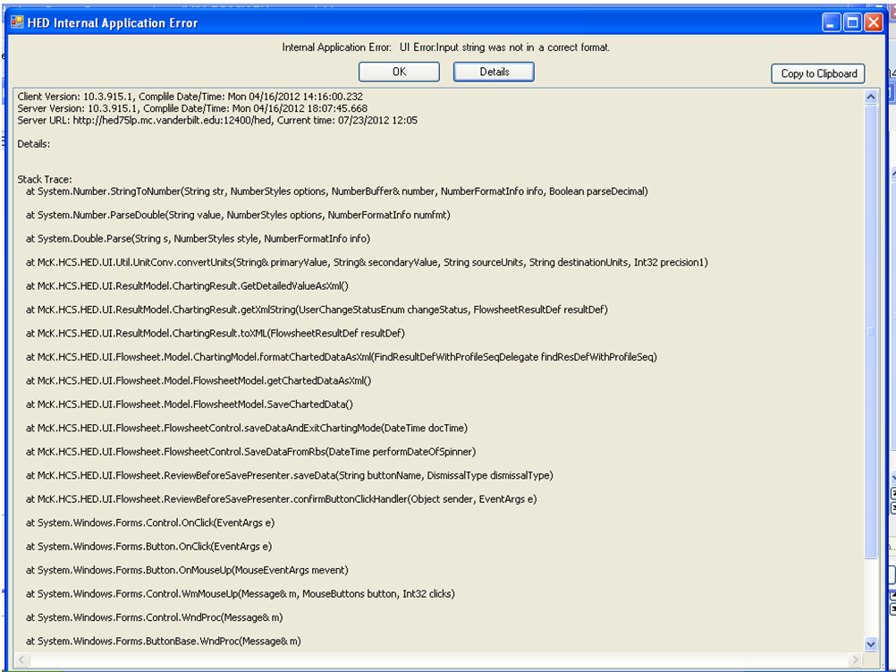
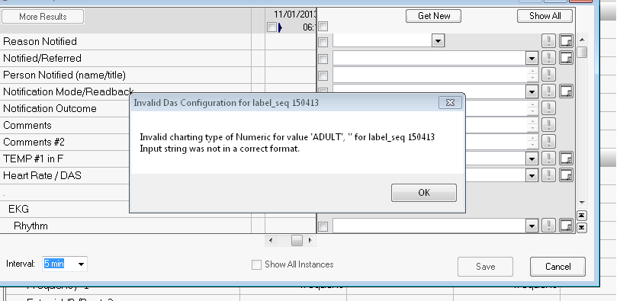

Ask the nurse to check the HED flowsheet for a value similar to these: STANDB* and ADULT.
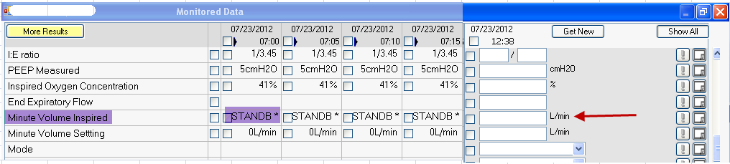
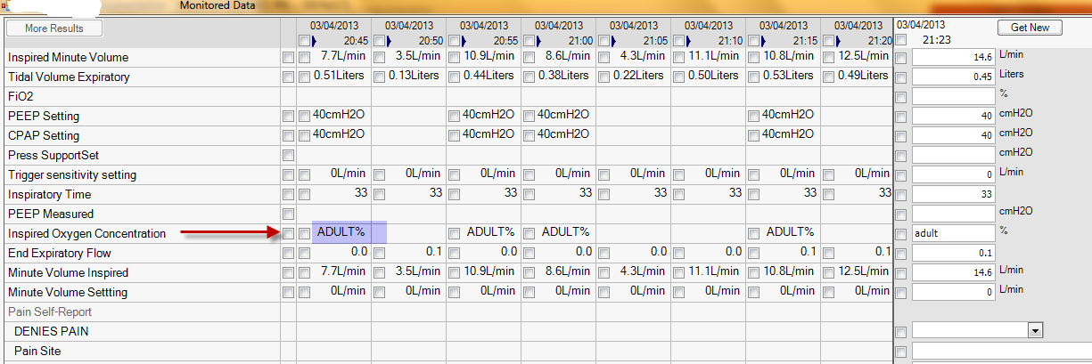

Workaround is to clear that value from the data entry field or uncheck the box if checked.
Cleared STANDB*
Unchecked STANDB*
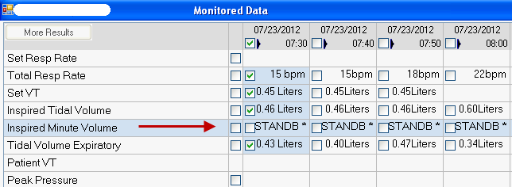
Fix is to have the nurse remove the VueLink module from the monitor, wait 10 seconds and reconnect.
If that does not correct the problem, Respirator y Therapy will need to restart the ventilator.

