How to Set Up Create Assignment Configurations
to Set Your Unit and Shift.
Click on: 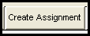
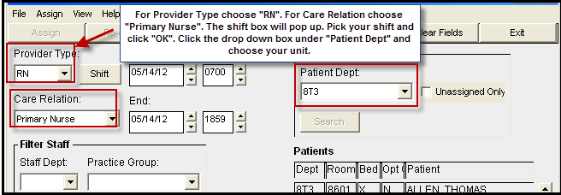

TIP: It is suggested to add 45 min to end of shift to keep your assignment should you need to document after report.
Day shift cannot be set to begin earlier than 7am and night shift cannot be set to begin earlier than 7pm.

