Configuring new WI-FI on Wireless devices
5.13
Using the VUMC Wireless Website:

- Click on the following link to access the website (Suggest you do this in Chrome if possible)

- https://ncs.mc.vanderbilt.edu/NCSBlackCMS/UI/CMS/CMS.aspx?PageID=1156

- IMPORTANT: Login to the website before you proceed any further with you vuNetID and ePassword. Follow the login directions provided on the page.

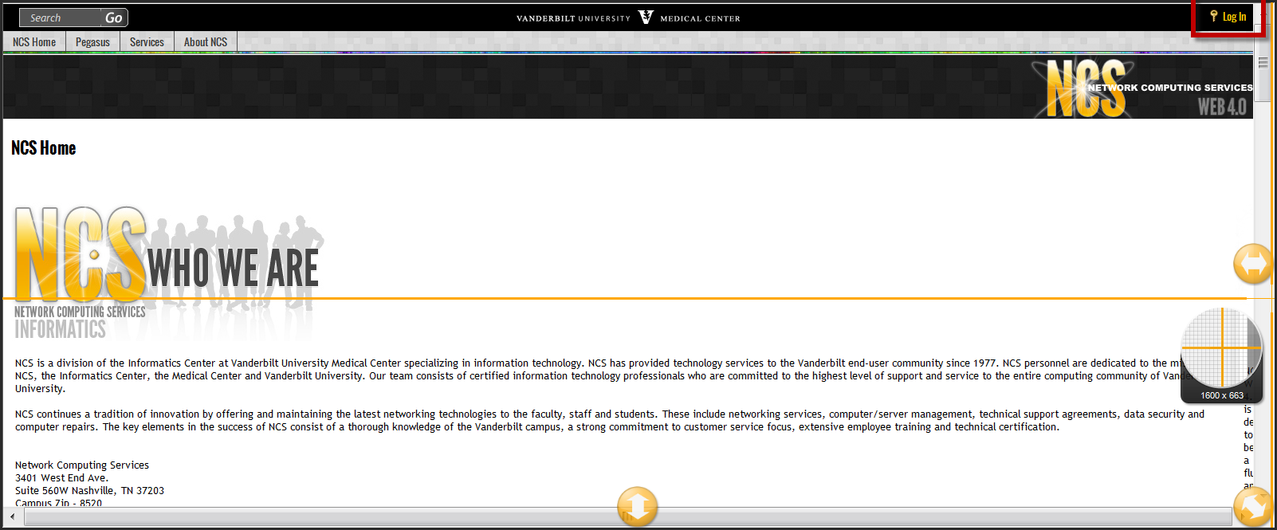

- Click on the “I’m a Student, Staff or faculty of VUMC” link.
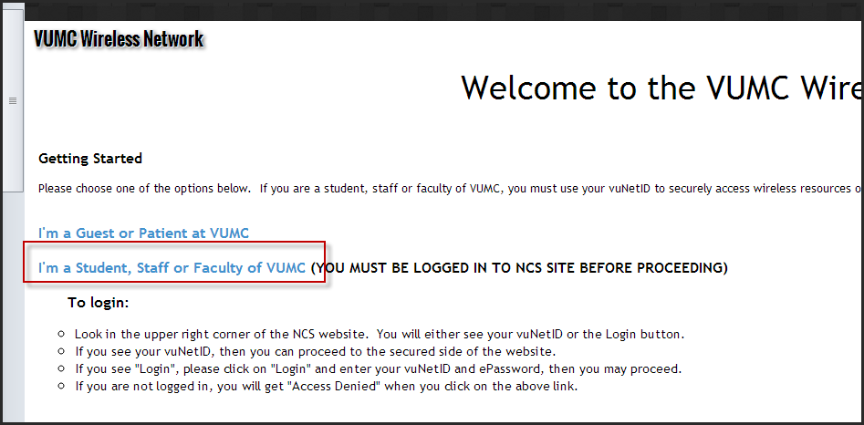

- On the right-hand side of the screen, you should see the “What’s New” panel with the “Wireless Resources” links listed below. If you do not see the panel on the right, follow the “Can’t view the screen properly?” instructions.
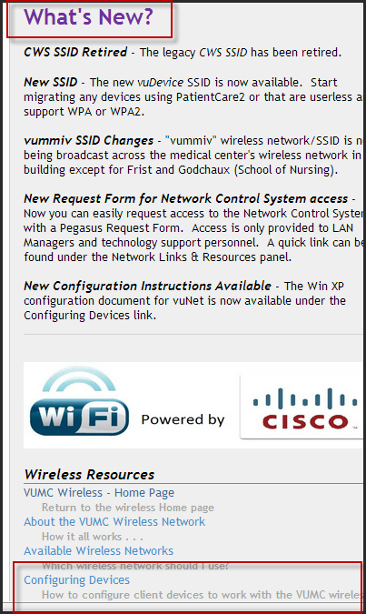
- Select the appropriate “Wireless Resources” link that you are interested in. To configure your device, you will want to click on the “Configuring Devices” link. The “Configuring Devices” instructions are designed for when you are in range of the vuNet wireless network, so you will need to be in the medical center where your device can “see” vuNet as an available network.

- Select vuNet and the device you want to configure
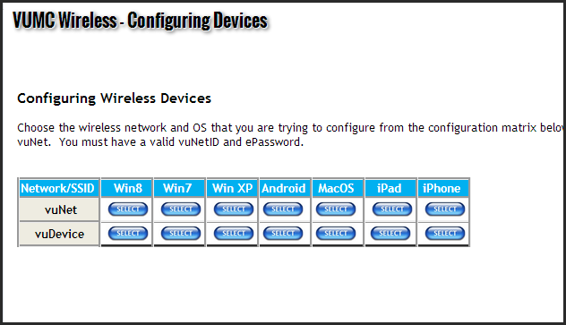
- TIP: click on your current WI-FI and then Click on Forget it at the top of the screen, turn WI-FI off and back on BEFORE you try to select the new WI-FI
- Follow the instructions for your device
- Follow the same steps for each of your devices (iPhone, iPad, Android, laptop etc.)

