**Clinical Tab**

The NEW CLINICAL Tab is designed to minimize the amount of non-clinical information that is displayed.  Selected information that is contained in All Docs will NOT be displayed when selecting the CLINICAL tab.  Examples of information that will not display in the CLINICAL include administrative data like: VOOM charges, authorizations, registration forms, FMLA paperwork, etc. (Administrative data is only excluded when the name/title of the entry has been assigned the structured naming convention standard).

The Clinical Tab is located next to the All Docs tab on the right.

cid:91506D42-83C7-4D6A-AB8B-5E6D1ED692C2

Users can create a preference to set the CLINICAL tab as the default tab.  Once selected, the CLINICAL tab will launch when opening a patient record.

**To set the preference:**

* Click on “Customize” below the patient’s MRN and name in the top frame (not the yellow bar frame)
* Click on the drop down next to “Default Tab”
* Choose “Clinical”
* This will now set your default to the Clinical tab
* If you would like to change it back to “All Docs” as the default follow the steps above but choose “All” instead

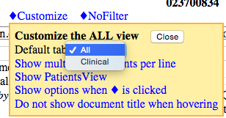

For technical questions please contact the HELP desk at 615.343.4357.

If you have questions or feedback regarding how the clinical tab is structured (i.e. the documents contained within the tab), please contact Health Record Standards at [healthrecordoffice@vanderbilt.edu](mailto:healthrecordoffice@vanderbilt.edu).