Changing Font Size for Starbrowser/Starpanel using Internet Explorer

PURPOSE: to be able to change FONT SIZE in Starbrowser/Starpanel
Date of Creation/initals: | 3/6/2012 CHS | Date of latest revision:

Steps on a CWS from Starbrowser:
- In Black Menu bar: click on the “Go To DESKTOP” icon
- Click on “Internet Explorer” (or you can click on Starpanel icon).
- At top left in the “menu bar” click on the “double A icon” drop-down arrow (see screenshot below)
- Select your font size by clicking on your choice (smallest to largest).
If you are in Starpanel, you will see the change immediately. Remember, when you sign-off, the next person will see the same font size you selected.
- You must “Exit” Internet Explorer.
- Sign off of the CWS.
- Sign back on and your Starbrowser/Starpanel font size either increase or decrease.

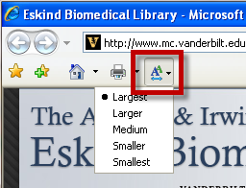

Remember, whatever font size you set to display will also display for the next user on that CWS.

