Health Care Team Module

Purpose - The purpose of the Health Care Team tool is to document the patient’s health care team. The Health Care Team is to include providers from both Vanderbilt and non-Vanderbilt areas who provide ongoing medical related care to the patient. This tool reflects the patient’s reported health care team and should be updated as often as necessary to ensure the most up-to-date list is available. The information from this tool will be utilized by Vanderbilt providers to communicate patient care information following an encounter.

Viewing the Patient’s Health Care Team Information – The Patient’s Health Care Team can be viewed in the following locations:

- The Patient Summary
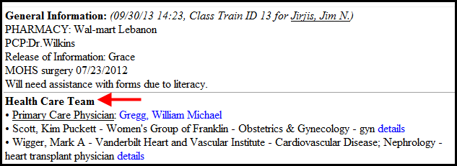

- The Team Summary
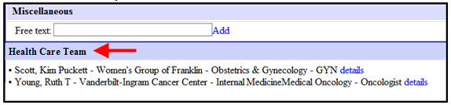

- The OPC
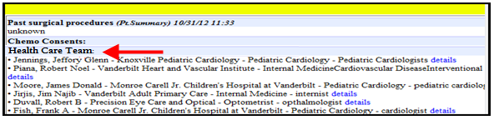
*Note-Clicking “details” anywhere in the Health Care Team Module will display detailed provider information.
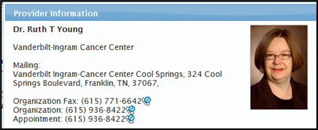
Updating the Patient’s Health Care Team Information - The Patient’s Health Care Team can be updated using the Actions menu.

- Click the “Actions” menu from the patient’s chart or from a patient list.
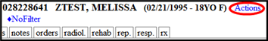 OR 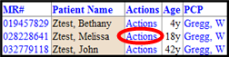

- Click “Care Team”.
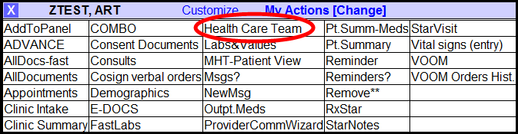

- The Health Care Team Module will be displayed. Click “*modify*”.
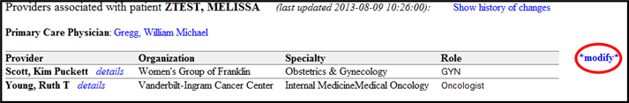

Adding a new provider:
  - Search the database using in the “Name” field.
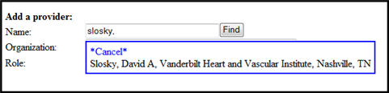

  - Add optional “Role” information of the new provider and then click “Add”.
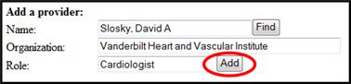

  - Verify changes and click “Save & Close”.
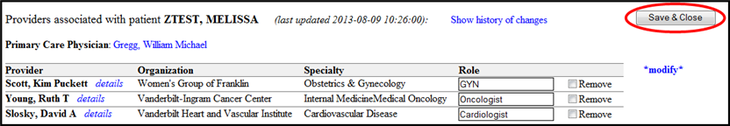

Removing a provider:
- Click “Remove” and then click “Save & Close”.
