CARE PARTNER CARE ORGANIZER CHANGES TIP SHEET
Care Partner Care Organizer Modifications –to see Labs only:
- Log into HED. Select View
- Click on Orders only
- Click on Configure
- Click <<Include
- Verify only LABS are in the Included column
- Click OK to SAVE
- Always use EXIT button to Exit CO and HED to keep your configuration!
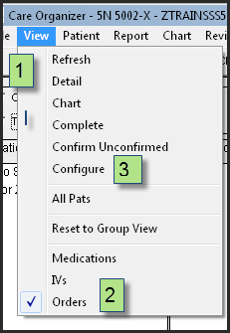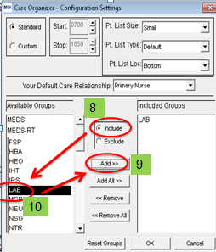
ReSet Unit and Shift in Create Assignment:
- Click Create Assignment
- Click on Provider type – select RN
- Click Care Relationship -Select Primary nurse or CP
- Click Shift -Select Days or Nights
- Click Pt Dept -Select your unit
- Click on File- Save Configuration
- Always click on EXIT to save configuration, here and exiting HED!
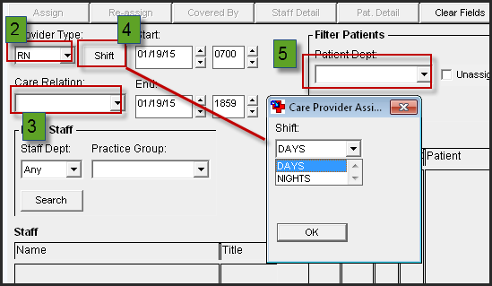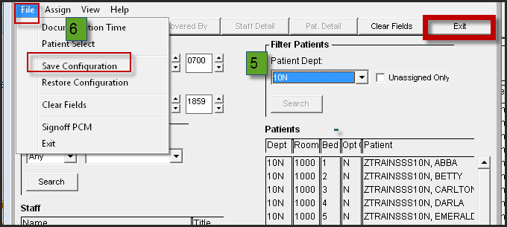

CP TIP SHEET for Care Organizer Changes:
- Labs will display by time due in the TO DO List
- Can see what is due 12h back and 12h forward
- STAT Labs will also display in Overdues after 30 minutes
- Routine orders will also display in Overdues after 60 minutes
- Labs will remain in Overdues for 72h to display outstanding tests such as troughs
Make sure Worklist is checked in To DO view to see times

How to Complete Labs in Care Organizer
- To remove the labs from your “To Do” or “Overdues” list, it must be Completed in Care Organizer once specimen is sent
- Click on the Complete button in the header of Care Organizer
- In the window that opens up, select the order(s) you wish to complete
- Click on the Complete Button
- The Lab will be marked as “Charted”
- Close the Window
The lab due time(s) will be removed from your work list.
*Care Partners and Registered Nurses will both need to Complete Labs they have drawn or collected.*

Always EXIT Care Organizer and HED using the exit button and NOT the Red X to preserve your configuration!

