HOW TO RECONFIGURE THE CARE ORGANIZER SCREEN FOR RT’S
- Click “View”... Confirm that “Meds” only is checked, uncheck “Orders”
- Click “View”, click “Configure”
- Click Default Care Relationship….Select Primary Nursing
- Click radial button Exclude in middle of box
- Scroll Available groups….select PHM. Hold CRT key down and select RES
- Click ADD…OK
- PHM and RES move to the right side, blocking ordered meds from displaying until checked by Pharmacy and schedules attached ( so you should see MEDS, PHM and RES)

HOW DO I FIND MY WORKLIST (MED SCHEDULES THAT DISPLAYS AT BOTTOM OF TO DO LIST):
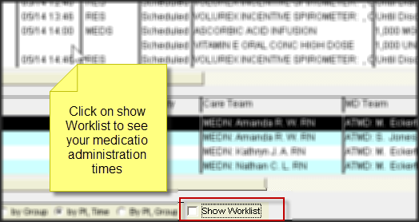
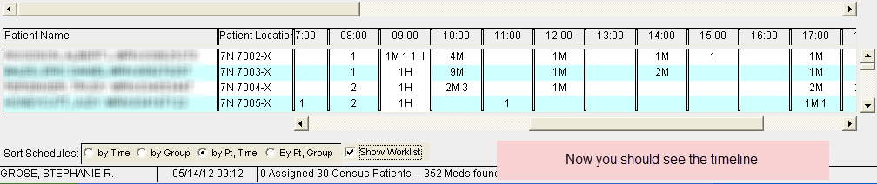
How to Save Your Configuration Settings in Care Organizer:
