Blood Ordering Changes in HEO/Wiz

- User can launch the RBC VGR for adults by typing in “transfuse” in the completer in WIZ/HEO and selecting the following option: The authorizing provider is a required field in the VGR.

- Inpatient units primarily use the “RBC to TRANSFUSE” section under #1.
  - Irradiated RBC or Washed RBC will automatically be marked if a previously ordered in the past. The user can uncheck the option if it discovered that this is not needed for the patient.
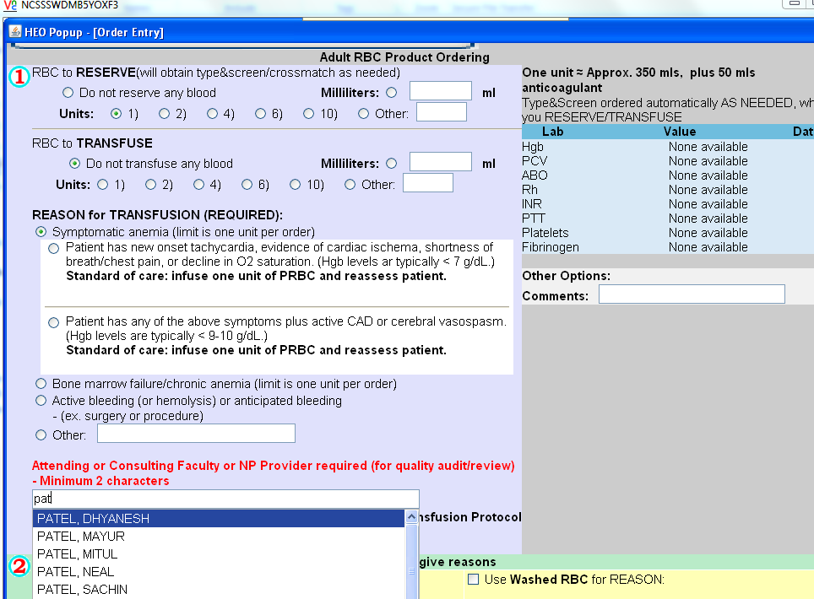

- Clicking on the RBC Turn-Around-Times under #3 will provide information delivery times for products from the blood bank.
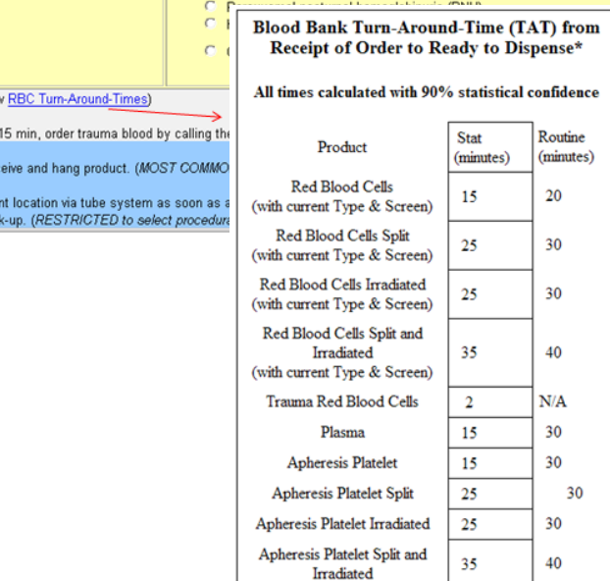

- When more than one unit is ordered with Symptomatic Anemia being the “reason for transfusion” the following popup will display in WIZ/HEO. If the user needs to order more than one unit, this is a clue that maybe the correct “reason for transfusion” was not selected. If this is not the case, then the user will need to process orders for the first unit before ordering further units for symptomatic anemia. In this case a report will be generated for review by the Transfusion Committee.
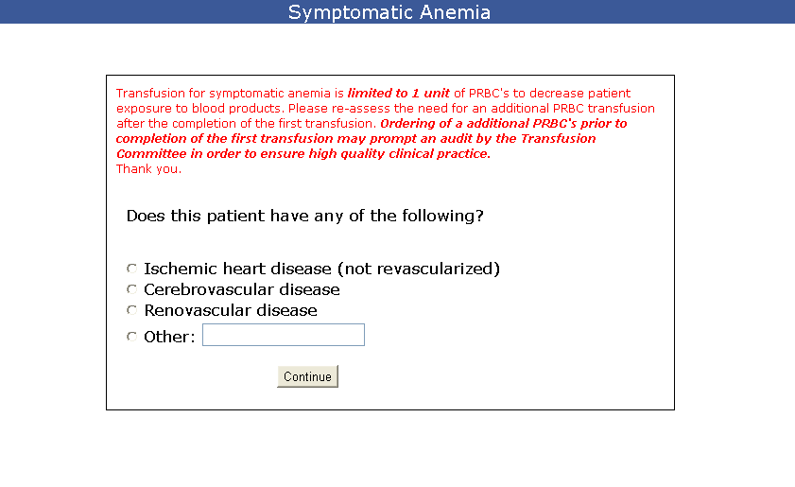
- A type and screen will not be required if there is already one on file in StarPanel within the last 72 hours. If more than 72 hours, WIZ will automatically generate an order for one.

