Security Manager’s Role in Assisting New Employees
- Security Managers verify the new employee’s VUNetID has been generated in AccessVU.
  - Link to AccessVU Administrative Tools: https://it.vanderbilt.edu/accessvu/admins/
  - For detailed instructions, see the Systems Support Services website at http://www.mc.vanderbilt.edu/root/vumc.php?site=sss2&doc=42882 then click on Systems Access Instructions 2013
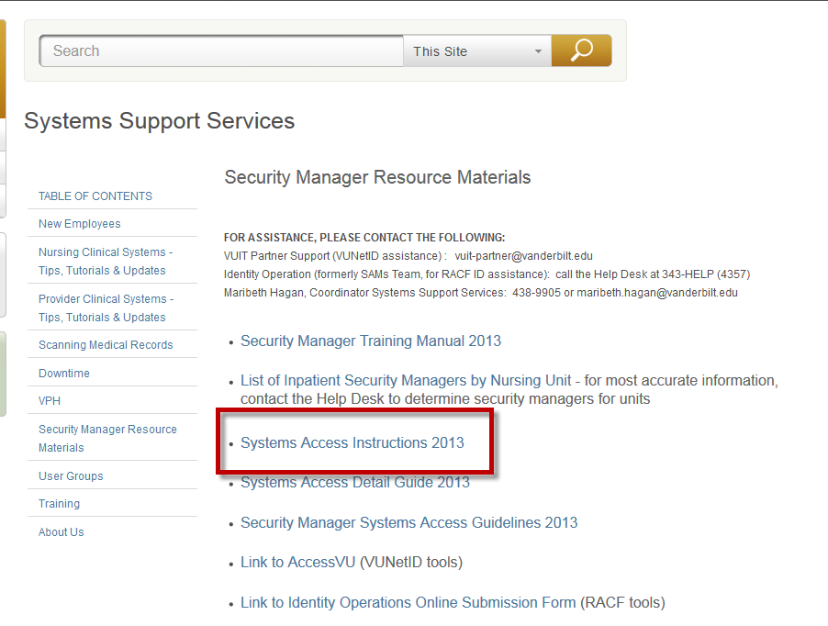
- Notify the new employee their VUNetID has been created and instruct them on how to claim it.
  - Link to AccessVU for New Employees: https://it.vanderbilt.edu/accessvu/
  - Click on Existing Users
  - Scroll Down to Section for Claim Account
  - Click on New Employee
  - Follow the prompts to accept the ID and create an epassword. (NOTE: Nursing Education no longer has a sign-on class to create passwords during New Employee Orientation and training IDs are used in the computer classes)
    - If they want to use one password for both their VUNetID and RACF ID, have them follow these guidelines instead of the ones listed for the VUNet and in the RACF Security Letter
    - It needs to be exactly 8 characters
    - It needs to contain at least one number
    - It needs to contain at least one capital letter
    - It cannot contain any special characters such as $,_,@, #, etc.
    - Example of a password following all guidelines is Coconut1
- Request the new employee’s RACF ID and systems access as quickly as possible.
- Once the systems access has been approved, give the new employee their security letter with RACF ID and temporary password and remind them they can use the same password as their epassword if they follow the guidelines in Step 2.e.
- Enter the employee in Medipac if needed.
- See the Systems Support Services Website Resource page for additional information: http://www.mc.vanderbilt.edu/root/vumc.php?site=sss2&doc=42882

