Add the patient to your panel and create your comment/note:
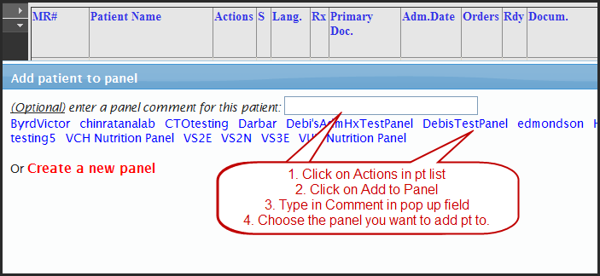
Set your panel up to display the Comment (displays in Note column):
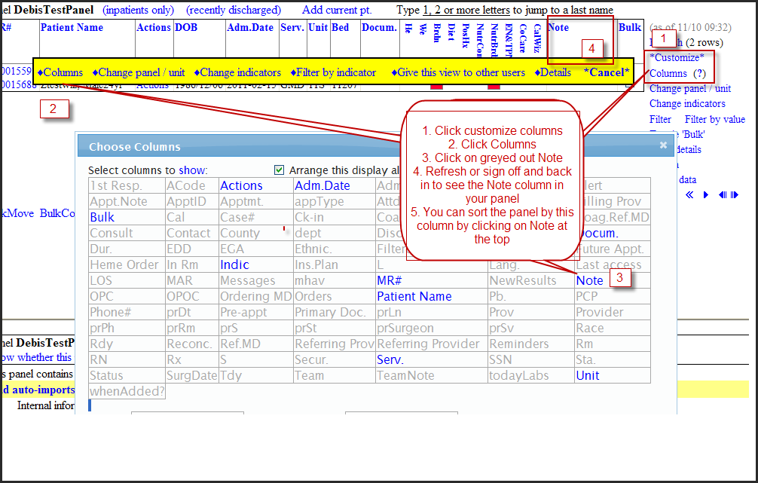
You can also share these comments with others that have access to your panel by clicking on Panel Details on the R of the panel and then choose “Share Panel comments with others…”

