Quicksteps for MR-Ancillary Dashboard set up as Favorite:
- Click on Dashboards in the black bar
- Click on Ancillary
- Click on MR-Ancillary
- Dashboard opens – click on Change Panel to select or change the floor
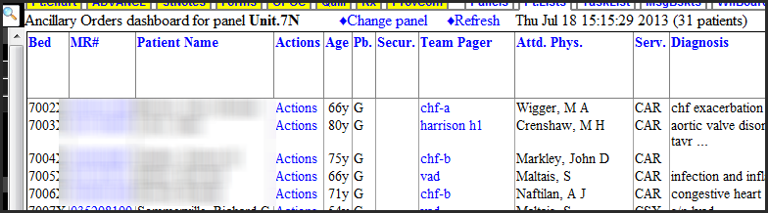
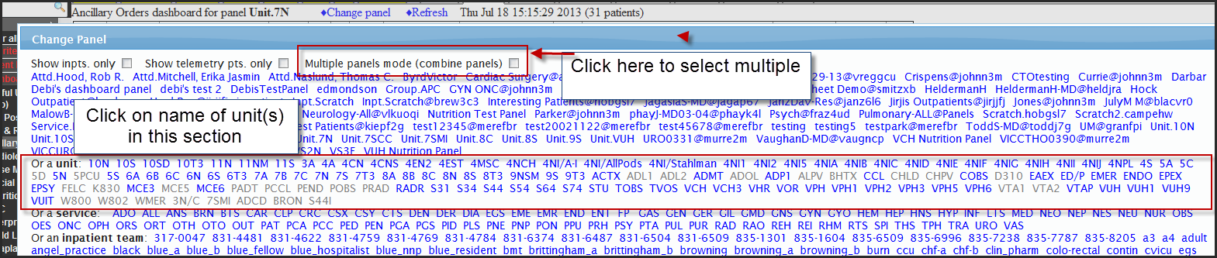
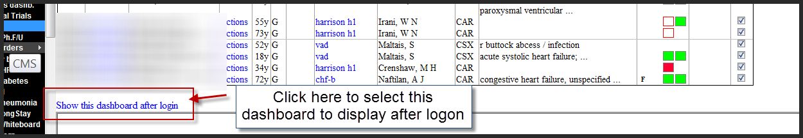
5. To set up your Inpatient Whiteboard census, click on InPt Census under patient Lists in the StarPanel blackbar, drag it up to the Favorites section and drop it, select your unit(s). Your main screen to work from will be the MR-ancillary dashboard and now you can easily toggle to the Inpatient Whiteboard if you need to.

