Laboratory Quick Reference

Contents

- Lab Setup Procedures

- Access to CORES Resources

- Lab Purchasing Information

- Capital Equipment

- Guidelines Governing Minors in Labs

- Lab Re-Location Procedures

- Lab Closure Procedures

- Favorite Contacts & Links

*Contributors: Whit Adams, Karin Sack, Mark Pavlack, Michael Jessing, Kay Brooks, Syd Mayberry, Julie Lemen

Lab Setup Procedures

- FIRST, contact the Safety Officer in Lab Compliance, Vanderbilt Environmental Health & Safety (VEHS), for procedures and assistance to ensure your lab is compliant with all regulations.
- They will provide: 1) hazard warning signs, 2) chemical waste collection supplies and tags for labeling waste items for disposal.
  - Lab Activation Fact Sheet link

- Contact the Assistant Director in the Biosafety Section. They will schedule a walkthrough of your lab, register your research in the Biowise system, and answer questions about biological waste disinfection and disposal. Biological research registration link

- Contact the Senior Safety Officer in Radiation Safety if you will use radioactive materials. Radioactive materials registration link

- Contact the Safety Officer in Lab Compliance when your chemicals are in place, so they can do a chemical inventory of the lab. Please send them a list of your chemicals and include the following: substance name, quantity and physical state. If possible, also include: a manufacturer name, CAS number and number of containers.

- Emergency contacts shall be listed on a Hazard Warning Sign Outside the Lab: Send the Safety Officer the following information: name and a home phone, cell phone or pager number for each person to be listed. VWHS will use this list to create the Sign. Once completed: Your Department should set-up a yearly recurring calendar event to review the list for any changes.

- Link for requesting a chemical waste collection

- Links for VEHS Trainings and Chemical safety training

- View the Chemical Hygiene Plan, making a copy for your staff to reference.

- Link to VEHS template for preparing a list of operating procedures for experiments involving Particularly Hazardous Substances (PHS) (carcinogens, mutagens, etc.). Appendix A: Chemical Safety Protocols. You may fill these forms out for the PHS’s you are using and keep them in your lab Chemical Hygiene Plan for reference or training purposes (EPA inspectors sometimes ask to see these as well).

- Link to the Lab Waste Guide
- Suggestion: Prepare a binder of Safety Data Sheets (SDSs) for the chemicals that you are using, especially the most toxic and/or flammable items. After sending your list of chemicals to the Safety Officer, they can get sign you up to use the Chemtracker program (it is a computer program that will help you compose operating procedures for your experiments, segregate chemicals by compatibility, help with ordering and other functions.)

- Securing your compressed gas cylinders is part of the OSHA Lab Safety Standard. Check this link to ensure you have the correct brackets installed before you order gases. You may purchase a bracket from Fisher or A-L Gas and Plant Services will install it for a fee.
  - Gases: Contact A-L Gas (615) 254-1457 to obtain an account number. You’ll provide them the exact delivery location for your gases. Use this account number every time you order gases and for empty cylinder pick-up. You have options on how to set-up paying for your gases and cylinder rentals. Contact your Research Purchasing Agent for assistance. After getting the account number from A-L you will use eProcurement to create your requsition.

- Emergency Entrance Plan

For safety purposes, please create an emergency plan for occasions when employees may become locked out of the lab after hours or on the weekend. This can be dangerous situation. Attaching a large object to spare keys will prevent staff from inadvertently taking keys home in their pockets.

Access to CORES Resources

CORES: Core Ordering and Reporting Enterprise System
CORES is an online system used to reserve and pay for use of the various Vanderbilt Cores, such as Mass Spec or Flow Cytometry. See the website for hundreds of services available.

- How to become active CORES member:
- First, your Private Investigator (PI) sets up a CORES user account (using his/her Employee ID #) by filling out the New User Account request form. Accounts are usually activated within one business day.
- Second, the PI works with your Administration Person to have his/her Center # added to CORES, with the PI as an administrator. A CORES Card for the purchasing of CORES services will be issued to the PI.
- Third, The PI assigns lab members access to purchase through the CORES website .
- Any time a PI’s Center # changes, the Administrative Person must make the Center # changes in the CORES system, but not in the eSirius system (see below). When the Center # changes, a new card will be issued.
Molecular Cell Biology Resource Core. A “store” that offers common lab reagents.
Located at 834 Light Hall. x2-7238.
- Lab Animals & Vet Drugs
- All animal purchases must go through the Division of Animal Care (DAC).
- Information on how to purchase animals and how to set-up an account with Patterson Vet for your animal pharmaceutical needs go HERE. (VUNet ID protected site)
- Use of Animals in Research:
To request your Center # be added into eSirius (online access to IACUC and Animal Care information):
- Log onto Animal Care and Use Program website. Click on DAC on right side of screen.
- Click on “Forms & Tools” at top left.
- Complete the “Add or Change a Center Number” form found under the heading of “CORES/Billing System”. You will receive a confirmation email once the request is approved.
- Any time a PI’s Center # changes, he/she must use the “Add or Change a Center Number” form to change it in the eSirius system only
- For information about the Animal Care & Use Program, contact the DAC.

Lab Purchasing Information
Research Procurement Website
If you are new to a lab or looking for more information on how to ensure you’re getting the best information on how to spend valuable research dollars, visit the Research Procurement site. There you will find information on: Discounts for New Labs, Who is Your Dedicated Research Purchasing Agent, extensive FAQ’s, what to ask when getting Quotes for Equipment, Supplier Buying Matrix, Supplier Information Page including discount information and cut-off times, Research Procurement News, and More!
eProcurement

- The lab is responsible for making purchases for lab supplies through eProcurement.
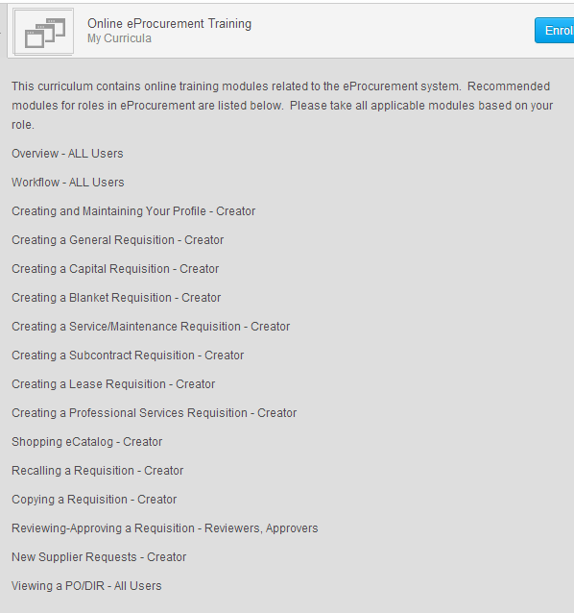
- LINK to eProcurement training in The Learning Exchange. Enter “Online eProcurement training”. You will take the “Creator Role” trainings only.

- When ordering in eProcurement, please insert an Allocation statement in the internal comments on your requisition. This statement should explain the justification for the cost allocation, especially if the purchase is being allocated to 2 or more grant cost centers (usually begin with 4-04-*).
- Examples:
1) Allocation between or among centers is based on prior consultation anticipated proportions of actual use of the item in working toward goals or aims of the funded project(s).
2) Expected usage based on assigned FTE's.

Blanket POs, Service Agreements and Capital Requisitions
Blanket POs, service agreements, and capital equipment requisitions must be processed through the Grants and Fiscal Management office of the department. Please contact Charles Paschetag (322-7366) to set up blanket POs and service agreements or for Capital Equipment requisitions.

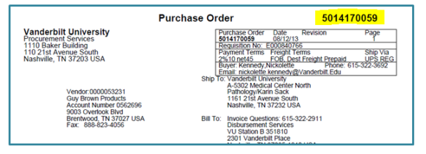
Maintaining purchasing records

- Please retain a copy of the PO (PO number should appear at the top-right as shown at right) with the packing slip attached for the labs purchasing records.

- On the PO copy, designate if all items from the order have been received, the date and initials of the person who checked them in and please mark any items which have been cancelled or returned.
  - From time to time the department initiates “encumbrance removals,” often resulting from discounts and cancelled/returned items, to open up dollar amounts no longer designated toward a specific purchase. Admin assistants will rely upon accurate recording from labs to help facilitate this process.

- Storage of purchasing files: Once supply orders are received, checked in and complete, labs may keep purchasing files in lab itself for future reference and to assist with encumbrance removals. If the lab does not wish to store the PO files in the lab, please contact Karin Sack to discuss having them stored at the grants office.

Capital Equipment

- Capital Equipment is defined as equipment costing $5,000 or more and having a useful life of more than one year (including any shipping charges). Go HERE for Vanderbilt’s Procedures for Acquisition, Management and Disposition of Capital Assets.
- Once delivered/installed you will receive a VU ID Tag (black/silver with number) from Asset Management.
- Custodial Departments are responsible for the proper use and protection of the asset. Guidelines are available in the Capital Asset link.
- Periodic VU Finance Department inventories and/or Federal audits will require you to account for the location of this equipment.
- For information on obtaining quotes visit the Research Procurement Website and click the section Getting a Quote From a Supplier.

Guidelines Governing Minors in Labs

Lab re-location Procedures

- Lab Move Fact Sheet LINK
- Moving chemicals to a new lab LINK
- Preparing to vacate a lab LINK
- Moving radioactivity to a new lab LINK
- Moving biological material to a new lab LINK

Lab Closure Procedures

- The PI is responsible for leaving the lab in a safe condition prior to vacating the premises. This Lab Close Out Guideline outlines the responsibilities in the Laboratory Close Out Process.
- Work with the VU Health & Safety Department to ensure that all chemicals are properly disposed of and the lab de-contaminated. Chemical Waste Pick-up Request. Biological Waste Disposal Information

FAVORITE CONTACTS and LINKS
Delta Operations Center |  | 3-0127
LabAlert sign up for the alerts | Critical Info & real time notification in the event of critical system outages
Surplus & Storage | 700 Fort Negley Ct. | 6-4626
Guidelines Governing Minors in Labs
Surplus Equipment Store
Grants - pre award | Charles Paschetag, 2-7366 | Loreita Little, 2-5217
Grants - Post award
Grants - Administrative Assistance | Karin Sack | 3-4880
Key Requisitions | Mikael Byrd | 3-3812
Purchase of Bulk Ethanol | Central Supply loading dock, Tuesdays & Thursdays - 2:00-3:00) | Basement of Light Hall. Loading dock for gases.
CORES: Core Ordering and Reporting Enterprise System
Molecular Cell Biology Resource Core | Kris Ellis, Lab Mgr. (2-7238) | 834 Light Hall
IT help | Pegasus
Purchasing: | Eprocurement sign in; Vendors In eProcurement; Gold Guide for Purchasing (Guide to most common suppliers)
Procurement Policies & Procedures
Eprocurement Training
Research Procurement Website | Contact: Michael Jessing, Research Sourcing Officer, 3-4375
Work Orders/Estimates – Medical Center | Whit Adams, 2-2264; Kay Brooks (TBRL), 3-9060
Vanderbilt Environmental Health & Safety
Mark Pavlack | Lab compliance Coordinator | 3-3528; pager: 835-4956
Robin Trundy | Biowise sytem, biological waste disinfection and disposal | 2-0927
Karl Witte | Radiation Safety | 3-7034
To request chemical waste collection
Training
Chemical Hygiene Plan
Lab Waste Guide
Chemical safety training
Search for NSF Accredited Class II Biosafety Cabinet Field Certifiers
Lab move documents
Lab closeout link

