Overview:
Citing the need for improved visibility to the cost center supply budget, reporting was developed to provide purchase information for various cost center managers. The information below includes elements of the report, as well as training to generate and export the actual data. The report engine was developed in Business Objects and is utilized through Vanderbilt’s Enterprise Data Warehouse or EDW. Access to EDW, along with cost center permissions, is required to produce the report. Either type of access can be obtained by contacting the Medical Center Systems Support team.

SECTION 1: Report elements
The PMM Purchase Summary by Cost Center report is a query against the PMM and Peoplesoft databases to provide purchase / payment information for items ordered / received for a cost center. The query can be executed for more than one cost center and particular date range. Below is a list of the standard data fields that are returned from the query:
REPORT ELEMENTS
Item Number | PMM Item Number
Item Description | PMM Item Description
Item Manufacturer Catalog Number | PMM Manufacturer catalog number listed for Item in PMM
Manufacturer Name | PMM Manufacturer listed for Item in PMM
PO Nbr | PO Number in PMM
PO Date | Date of the PO in PMM
Center | Cost Center number in PMM charged for item
Center Name | Cost Center name in PMM charged for item
Account | General Ledger Account number
Account Name | General Ledger Account name
Vendor Name | PMM Vendor listed for Item in PMM
Invoice Dt | Date of the invoice.
PO Line Quantity | Line quantity ordered on the PMM PO
Voucher Line UOM | Unit of measure from the voucher/invoice.
Voucher Line Qty | Qty charged on the voucher/invoice.
Voucher Line Unit Price | Price associated with the item unit of measure.
Distrib Merchandise Amt | Extended cost: Qty x Price Total purchase spend

Section 2: Running the Report
Go to the Business Objects (EDW) website and log in with your VUNetId and password:
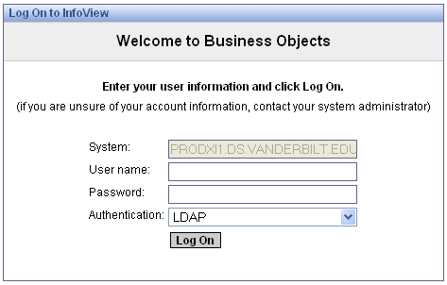
Make sure the Authentication box indicates “LDAP”
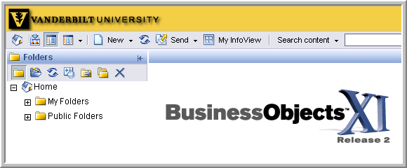
The home screen appears as in the image above.

Once logged in, navigate down the list of folders on the left. Click each “+” sign to expand all the folders, beginning with “Public Folders” until you reach PMM Prod Reports. The PMM Purchase Summary by Cost Center for Dept Mgrs will appear to the right, when PMM Prod Reports folder is selected.
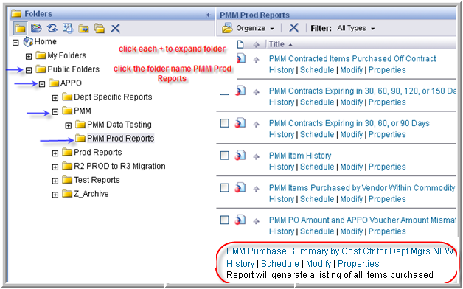
Report location: Public Folders APPO PMM PMM Prod Reports
If you do not see the PMM Prod Reports folder, email Deena Sharp (deena.sharp@vanderbilt.edu) to gain access.

Position the cursor over the report name and click once to open the report engine:
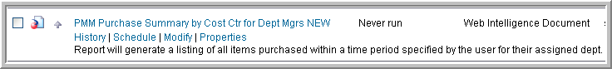
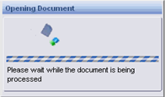
A dialogue box indicates the report is opening:
Document opens to the last instance of the report to run:
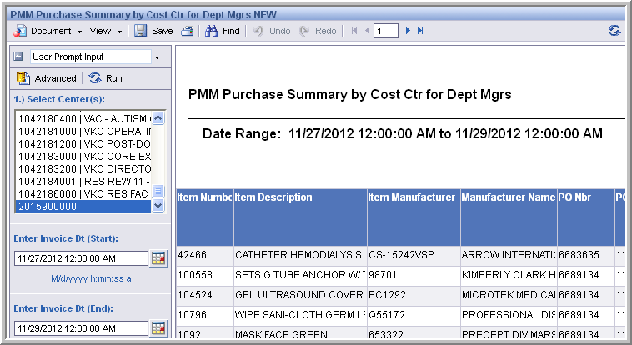
To run a new report, click the “Advanced” link to the left of the report:
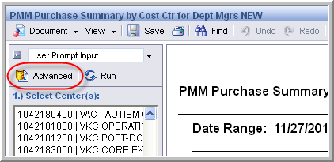

A dialogue prompt window opens to allow selection of the report parameters:
- Select the first parameter, the cost center.
  - Enter the cost center number & find the desired number in the field above the search area.
  - With the cost center is selected, move it to the right side by clicking the right-pointing arrow (remove any unneeded cost centers in the reverse manner).
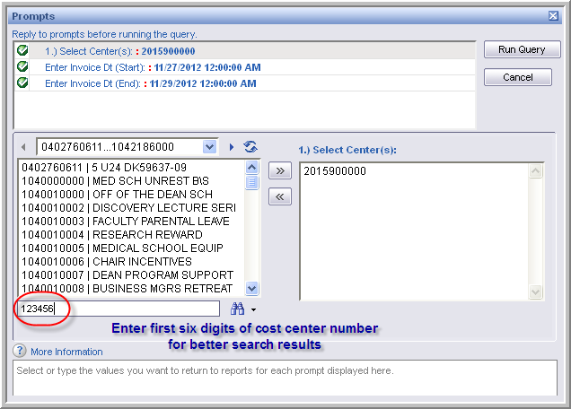

- Move to the second prompt field to enter the Start Date of the report. The Start Date reflects the payment date for items ordered.
  - On the right side of the dialogue box, around the middle there is a prompt to enter the date under “Enter PO Dt (Start).” Select the calendar tool to choose the beginning date for the report.
  - Once the Start Date is selected, move down to the third field and select an End Date for the report.
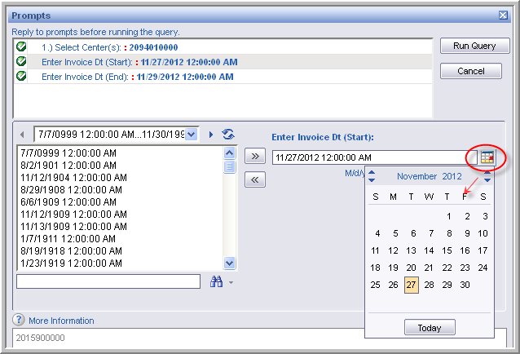

- Next, select the “Run Query” button in the upper right corner of the Prompts window:
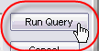
- A “Please wait” dialogue box opens, showing the progress of the report engine:

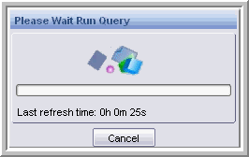

Once the report is finished you will see the results in the body of the window:

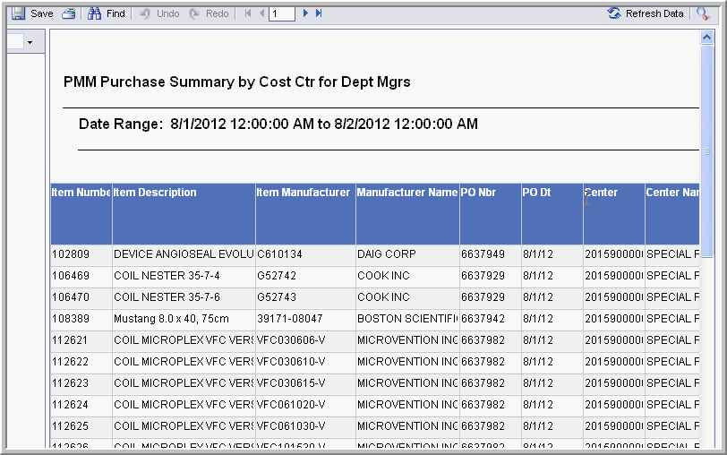

Section 3: Exporting the Report

To export the report in Excel format, simply cursor over to the Document drop-down menu as shown below:

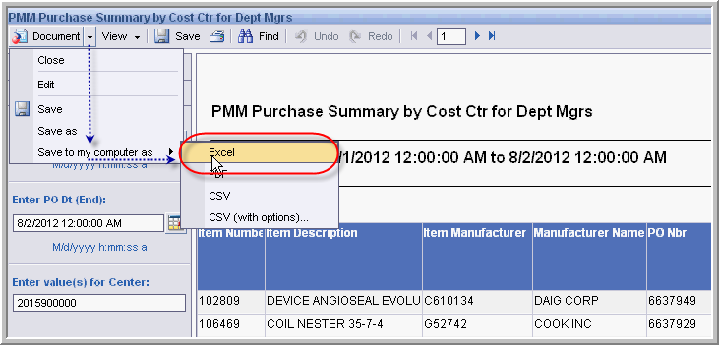

Choose “Save to my Computer As” Excel

