
Vanderbilt Asthma Sinus Allergy Program
2611 West End Avenue Suite 210 Nashville, TN 37203
p. 615.936.2727 f. 615.936.5767 toll free 1.866.390.0379
www.vanderbiltallergy.com

PAPERWORK

Please print the following forms and BRING to the clinic at your first appointment.

Do not mail or email back to us.

PLEASE USE BLACK INK ONLY
When filling out these forms.

Before your appt, please send last 2 clinic notes from your PCP/specialist, any pertinent lab test results and any scans/x-rays related to your condition.

PARKING

BE SURE TO ASK AT WHICH LOCATION YOU WILL BE SEEN:
To insure best directions from your starting location, please use GPS or MapQuest.

- 2611 West End Ave. between the Holiday Inn and J. Alexander’s restaurant, across the street from Centennial Park. Parking: Park at the rear of our building in the lot that we share with the Holiday Inn. Enter the second floor of the building by crossing the covered walkway.

- VASAP @ The Shoppes at Brentwood - 782 Old Hickory Blvd., Ste 203 Brentwood, TN 37027 Parking: The Shoppes at Brentwood parking lot.
Vanderbilt Asthma Sinus Allergy Program
2611 West End Avenue Suite 210 Nashville, TN 37203
p. 615.936.2727 f. 615.936.5767 toll free 1.866.390.0379
www.vanderbiltallergy.com

Welcome to the Vanderbilt Asthma, Sinus and Allergy Program. The following information will assist you with your visit. Please read and complete all enclosed forms.

We ask that you arrive 15 minutes before your scheduled appointment time.

Appointment day: _________________________________

Appointment time: ________________________________

Arrival time: _____________________________________

BE SURE TO ASK AT WHICH LOCATION YOU WILL BE SEEN:
To insure best directions from your starting location; please use GPS or Mapquest.
- 2611 West End Ave. between the Holiday Inn and J. Alexander’s restaurant, across the street from Centennial Park. Parking: Park at the rear of our building in the lot that we share with the Holiday Inn. Enter the second floor of the building by crossing the covered walkway.

- VASAP @ The Shoppes at Brentwood - 782 Old Hickory Blvd., Ste 203 Brentwood, TN 37027 Parking: The Shoppes at Brentwood parking lot

• Insurance/Referrals: If your insurance requires a referral from your primary care provider for your visit with us, YOU must obtain this before your visit. If you do not have your referral form, you will be given the option to reschedule your visit or pay for the visit at the time the service is rendered and file with your insurance company yourself. Your PCP may fax these forms to us at 615-936-5767 prior to your visit. If you have questions, please call us at 615-936-2727. Please bring your insurance card with you.

IT IS YOUR RESPONSIBILITY TO CHECK YOUR INSURANCE FOR BENEFIT AND COVERAGE INFORMATION PRIOR TO YOUR APPOINTMENT INCLUDING CO-INSURANCE, CO-PAYMENT AND DEDUCTIBLE AMOUNTS THAT MAY BE DUE BY THE PATIENT. POSSIBLE TESTING ON DAY OF VISIT MAY INCLUDE THE FOLLOWING:

ALLERGY TESTING, CHEST X-RAY, SINUS CT SCAN, AND PULMONARY FUNCTION TESTING
(The above test may require a pre-certification by your insurance and have co-insurance and deductible amounts due by patient)

• What to expect: Our team of healthcare providers will provide you with a thorough evaluation and will design an individualized education and treatment plan based on your evaluation findings. Tests that may be done include allergy testing, sinus CT scans, pulmonary function tests, and/or chest x-rays. All proposed testing will be thoroughly explained and discussed with you. Should you have any questions or specific needs regarding your visit, please contact us.

Vanderbilt Asthma Sinus Allergy Program
2611 West End Avenue Suite 210 Nashville, TN 37203
p. 615.936.2727 f. 615.936.5767 toll free 1.866.390.0379
www.vanderbiltallergy.com

• Preparation: To enable us to provide you with a thorough evaluation, please allow 4 hours for your initial visit. Due to the extensiveness of this evaluation, we ask that young children do not accompany you. Read all enclosed materials – especially note which medications need to be withheld in order to complete testing. Complete all enclosed forms ahead of time and bring these with you. Please do not wear (or anyone with you) any kind of perfume, after shave or fragranced lotions.

• Cancellations: While it is understood that patients’ schedules can change, we do require a minimum of 24 hours notice if you cannot keep your appointment. Please call us immediately if you need to reschedule.
Vanderbilt Asthma Sinus Allergy Program
2611 West End Avenue Suite 210 Nashville, TN 37203
p. 615.936.2727 f. 615.936.5767 toll free 1.866.390.0379
www.vanderbiltallergy.com
PATIENT APPOINTMENT REMINDERS

- Please discontinue use of antihistamines at least 5 days before appointment, unless you need them for hives or severe allergic reactions.
- Please discontinue use of inhalers 12 hours before appointment if possible, unless you are too sick to stop them.
- Please do not use your inhaler the night before and the day of your appointment.

ANTIHISTAMINES:  Accuhist  Actifed  Advil Allergy Sinus  Alavert (Loratadine)  Allegra / Allegra D (Fexofenadine)  Antivert (Meclizine)  Atarax (Hydroxyzine)  Benadryl (diphenhydramine)  Brompheniramine  Chlorphenirmaine  Claritin / Claritin D (Loratadine)  Clarinex  Compazine |  |  | Deconamine  Dimetapp  Doxepin Naldecon (cyproheptadine)  Nyquil  Periactin  Phenergan (Promethazine)  Rescon  Rynatan (azatadine)  Triaminic  Tylenol Allergy Sinus  Tylenol PM  Tussi-12  Xyzal (levocetirizine)  Zyrtec / Zyrtec D (cetirizine)
NASAL SPRAY ANTIHISTRAMINE
Astelin
Astepro
Patanase
INHALERS
Advair  Azmacort  Aerobid  Albuterol  Alvesco  Aerobid | Combivent  Duoneb  Ipratropium  Dulera  Flovent  Foradil  Maxair  Asmanex |  | ProAir  Proventil  Pulmicort  QVAR  Serevent | Spiriva  Symbicort  Ventolin
Vanderbilt Asthma Sinus Allergy Program
2611 West End Avenue Suite 210 Nashville, TN 37203
p. 615.936.2727 f. 615.936.5767 toll free 1.866.390.0379
www.vanderbiltallergy.com

New Patient Checklist

□ Eat breakfast

□ Wear comfortable clothes and shoes

□ If this is your first visit, please plan on being at the VASAP Clinic for a minimum of 4 hours

□ Please call Central Registration (888-567-5255 or 615-322-2971), if you have not done so already

□ Completed Patient Information form

□ Completed Medication form

□ Completed ASAP Patient Questionnaire form

□ Bring your insurance card / information to your first appointment

□ Provide us with your pharmacy name, address, phone and FAX numbers

□ Referral (if required)

□ Arrive 15 minutes prior to your appointment – we do our best to see patients timely, however, unforeseen events may cause delays. We do try our best to keep on schedule as much as possible

□ Prior to visiting us on your first visit to Vanderbilt ASAP – register for MyHealthatVanderbilt.com. This website allows you to send emails to us regarding appointments and prescription refills. Once you have registered and visited us in the office we can update your status so you can review your lab results.

□ Reading material or personal entertainment (iPods w/headphones, etc)

Any questions, please do not hesitate to contact us AT 615-936-2727.

Sincerely,
VANDERBILT ASTHMA SINUS ALLERGY PROGRAM (VASAP)
Vanderbilt Asthma Sinus Allergy Program
2611 West End Avenue Suite 210 Nashville, TN 37203
p. 615.936.2727 f. 615.936.5767 toll free 1.866.390.0379
www.vanderbiltallergy.com

MEDICATIONS
NAME: ______________________________________________ DATE: _________________

YOUR PHARMACY: _______________________________________PHARMACY PHONE #_____________________
PLEASE LIST BELOW ALL MEDICATIONS THAT YOU CURRENTLY TAKING.

(PLEASE INCLUDE ALL PRESCRIPTION, OVER THE COUNTER AND NON-PRESCRIPTION DRUGS, INCLUDING BIRTH CONTROL PILLS, INSULIN, ASPIRIN, SINUS MEDICATIONS, HORMONES, PATCHES, OINTMENTS, INJECTIONS, NASAL SPRAYS, ETC.)

NAME OF MEDICATION | STRENGTH OR DOSE | HOW MANY PER DAY/TIMES?
1.
2.
3.
4.
5.
6.
7.
8.
9.
10.

ADDITIONALLY, LIST ANY MEDICATIONS THAT YOU HAVE TAKEN IN THE LAST MONTH FOR ANY CONDITION.

NAME OF MEDICATION | STRENGTH OR DOSE | HOW MANY PER DAY/TIMES?
1.
2.
3.
4.

MEDICATION/DRUG ALLERGIES:

Please list below any medication/drug which you cannot take due to an allergy or a side effect from taking the drug and the reaction which occurs.

Name of Medication/Drug | Type of Reaction
1.
2.
3.
4.

Vanderbilt Asthma Sinus Allergy Program
2611 West End Avenue Suite 210 Nashville, TN 37203
p. 615.936.2727 f. 615.936.5767 toll free 1.866.390.0379
www.vanderbiltallergy.com

VASAP QUESTIONNAIRE
PLEASE COMPLETE IN BLACK INK

Patient Name:____________________________________________ Date of Birth: ____/____/_____

What is the reason for your visit today? ________________________________________________

Do you have any problems with any of the following?

Yes No Yes No
Nasal congestion ____ ____ Throat clearing ____ ____
Runny nose ____ ____ Hoarseness ____ ____
Itchy /watery eyes ____ ____ Loss of sense of smell ____ ____
Facial pressure/pain ____ ____ Itching (skin) ____ ____
Headaches ____ ____ Swelling (skin) ____ ____
Sinus infections ____ ____ Eczema ____ ____
Sneezing ____ ____ Coughing ____ ____
Post-nasal drainage ____ ____ Shortness of breath ____ ____
Wheezing ____ ____
Allergy: Please circle answers: Do you have allergies or hay fever? Yes No Don’t know
Have you ever been tested for allergies? Yes No What type of testing? Skin Blood (RAST)
Did you get allergy shots? Yes No For how long?________ Were they helpful? Yes No
Do you have any history of allergies to the following? Circle: Foods Latex Insect stings

Sinus: Do you have a history of sinus problems? Yes No Color of drainage today?____________________
How many times have you been treated for a sinus infection with antibiotics in the last year?_______________
Have you ever had an x-ray or CT scan if your sinuses? Yes No If yes, when and where?________________
Have you ever had sinus surgery? Yes No If yes, when and where?________________Did surgery help? Yes No

Asthma: Have you ever been diagnosed with asthma? Yes No
Have you ever been to the emergency room because of you asthma? Yes No How often?________________
Have you ever had to stay overnight in the hospital for your asthma? Yes No How often?________________

REVIEW OF SYMPTOMS: Please indicate if you have had any of the following IN THE LAST 30 DAYS:

Yes No Yes No
Fever ____ ____ Indigestion/Heartburn ____ ____
Weight change ____ ____ Constipation ____ ____
Fatigue ____ ____ Diarrhea ____ ____
Sleep problems/snoring ____ ____ Trouble swallowing ____ ____
Skin rashes/hives ____ ____ Urinary abnormalities ____ ____
Unusual bruising/bleeding ____ ____ Muscle pain, aches or cramps ____ ____
Heart pounding/palpitations ____ ____ Joint pain ____ ____
Chest pain ____ ____ Depression – feeling blue ____ ____
Swollen ankles ____ ____ Anxiety – feeling nervous ____ ____
Dizziness ____ ____ Problems with hearing ____ ____
Nausea/vomiting ____ ____ Problems with vision ____ ____

General: Have you had a chest x-ray or chest CT in the last year? Yes No Results: ______________________________
Have you had pneumonia vaccine shot (Pneumovax )? Yes No
Do you normally get a flu shot every year? Yes No
How many times in the last year have you had to take oral or injected steroids, such as prednisone or a Medrol dose pack?_______
Are there any family disputes/situations that make your or your child’s care more difficult?____________________________
Vanderbilt Asthma Sinus Allergy Program
2611 West End Avenue Suite 210 Nashville, TN 37203
p. 615.936.2727 f. 615.936.5767 toll free 1.866.390.0379
www.vanderbiltallergy.com

Patient Name:____________________________________________ Date of Birth: ____/____/_____
Past Medical History: Do you have or have ever had any of the following conditions?
Yes No Yes No
Hives ____ ____ Bowel/Intestinal disorder ____ ____
Thyroid disease ____ ____ Liver condition ____ ____
Diabetes/blood sugar problems ____ ____ Stomach ulcer ____ ____
Pneumonia ____ ____ Acid reflux ____ ____
Tuberculosis ____ ____ Anemia/low blood ____ ____
Positive TB skin test ____ ____ Stroke/”mini strokes” ____ ____
Frequent bronchitis ____ ____ Bleeding disorder ____ ____
COPD/emphysema ____ ____ Cancer ____ ____
Other lung condition ____ ____ Neurological condition ____ ____
Frequent strep throat ____ ____ Seizures/epilepsy ____ ____
Sleep apnea ____ ____ Migraine headaches ____ ____
CPAP machine ____ ____ Cataracts ____ ____
Heart arrhythmia/palpitations ____ ____ Glaucoma ____ ____
Heart problems ____ ____ Arthritis ____ ____
High blood pressure ____ ____ Back/spine problems ____ ____
High cholesterol ____ ____ Osteoporosis ____ ____
Hepatitis ____ ____ Depression/sadness ____ ____
HIV/AIDS ____ ____ Panic attacks/anxiety ____ ____
Kidney disease/decreased function ____ ____ Other psychiatric conditions ____ ____
Gynecology/female problems ____ ____ Alcoholism/drug dependency ____ ____
Male genital/prostate problems ____ ____
Family History:
Parent Sibling Child Grandparent
Mother/Father Male/Female Male/Female Maternal/Paternal
Asthma ____ ____ ____ ____ ____ ____ ____ ____
Sinus disease ____ ____ ____ ____ ____ ____ ____ ____
Hay fever/allergies ____ ____ ____ ____ ____ ____ ____ ____
Cystic fibrosis ____ ____ ____ ____ ____ ____ ____ ____
Emphysema ____ ____ ____ ____ ____ ____ ____ ____
Thyroid disease ____ ____ ____ ____ ____ ____ ____ ____
Heart disease ____ ____ ____ ____ ____ ____ ____ ____
Diabetes ____ ____ ____ ____ ____ ____ ____ ____

Surgeries/Hospitalizations: Please list all hospitalizations and surgeries and the years these occurred:
Social History:
Occupation:_________________________________ Hobbies:________________________________________________
Do you use/have you used tobacco products? Yes No Past Circle: Cigarettes cigars pipe snuff chew dip
How many per day? __________ How many years? ____________ If you’ve stopped, when did you stop?______________
Have you been exposed to second hand cigarette smoke? _______________ Where?______________________________
Do you use alcohol? Yes No Drinks per week? __________ Other drug use? Yes No
Do you have any HIV risk factors? Yes No

Environmental History:
Do you have any pets in the home? Yes No Cats Dogs Other Inside Outside Both
Do pets sleep in your bedroom? Yes No
Has there been any water leakage or water damage in your home? Yes No If yes, has this been repaired? Yes No
What type of flooring? Carpet Hardwood Tile Vinyl Other

FOR OFFICE USE: REVIEWED AND CONFIRMED WITH PATIENT BY:________________________ VISIT DATE?___________
Vanderbilt Asthma Sinus Allergy Program
2611 West End Avenue Suite 210 Nashville, TN 37203
p. 615.936.2727 f. 615.936.5767 toll free 1.866.390.0379
www.vanderbiltallergy.com

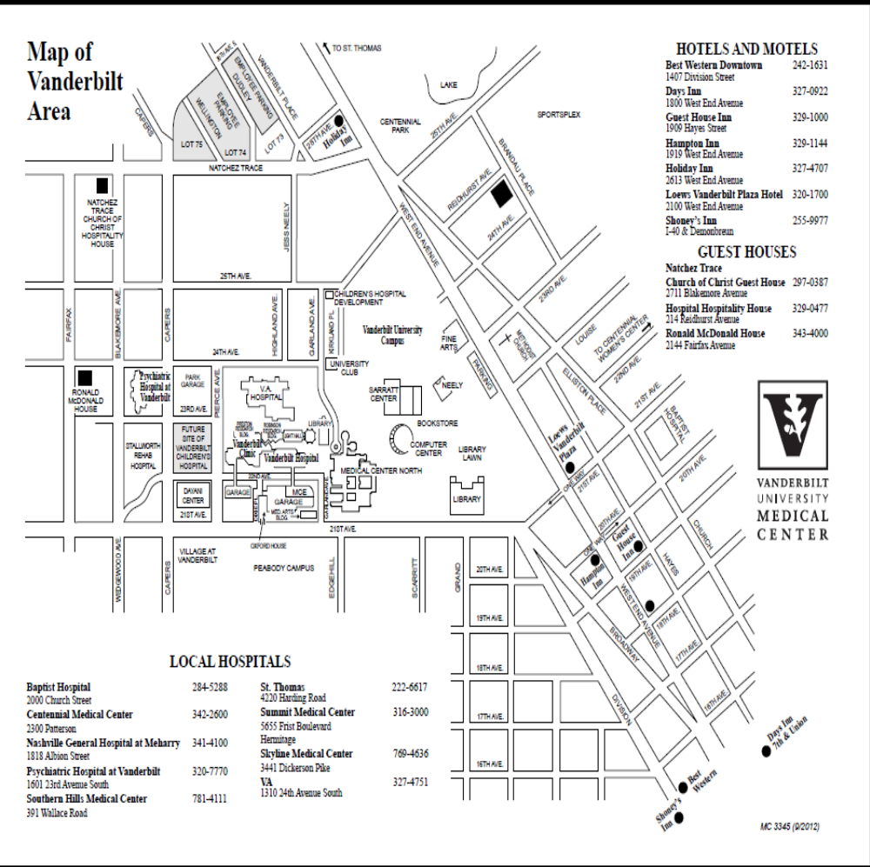
Vanderbilt Asthma Sinus Allergy Program
2611 West End Avenue Suite 210 Nashville, TN 37203
p. 615.936.2727 f. 615.936.5767 toll free 1.866.390.0379
www.vanderbiltallergy.com

2611 West End Avenue

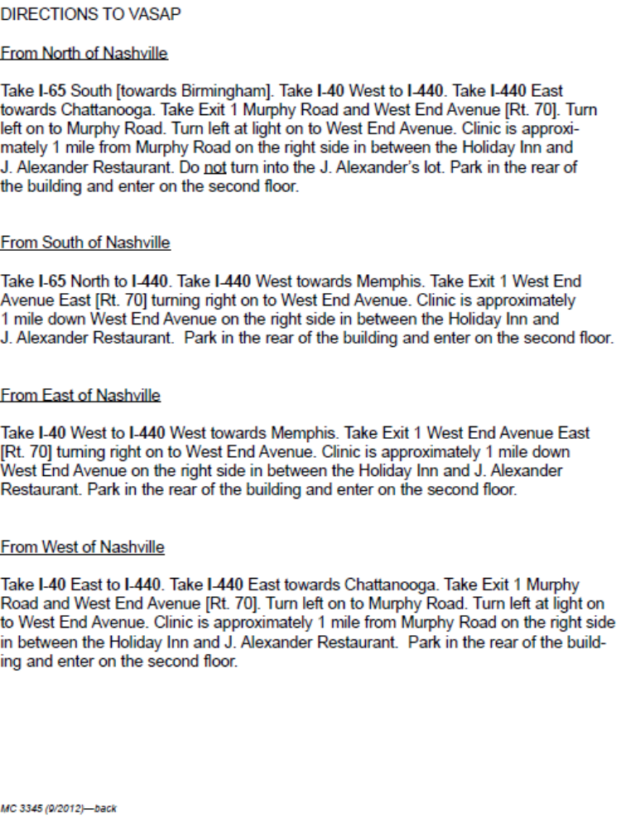
Vanderbilt Asthma Sinus Allergy Program
2611 West End Avenue Suite 210 Nashville, TN 37203
p. 615.936.2727 f. 615.936.5767 toll free 1.866.390.0379
www.vanderbiltallergy.com

VASAP SERVICES THAT MAY BE ORDERED BY YOUR PROVIDER ON YOUR FIRST VISIT
*Please use this list when calling your insurance provider to verify benefits and coverage prior to your appointment on ______________________________.
Patient name: ___________________________, _________________________ _______________
Last First MI

TEST |  | INSURANCE CODE BILLED
CT scan of the Maxillofacial Sinus  (*ask your carrier if you have a deductible, coinsurance or co-pay that you will owe for the imaging service) |  | 70486
Deductible: Y/N _____  Coinsurance: Y/N _____  Co-Pay: Y/N _____ | Amount $: _________  Amount %: _________  Amount $: _________
Allergy Skin Testing  (*ask your carrier if you have a deductible, coinsurance or co-pay that you will owe for the allergy skin testing) |  | 95004 and /or 94024
Deductible: Y/N _____  Coinsurance: Y/N _____  Co-Pay: Y/N _____ | Amount $: _________  Amount %: _________  Amount $: _________
Spirometry (breathing treatment for your lungs)  (*ask your carrier if you have a deductible, coinsurance or co-pay that you will owe for the breathing treatments) |  | 95010 and /or 94060
Deductible: Y/N _____  Coinsurance: Y/N _____  Co-Pay: Y/N _____ | Amount $: _________  Amount %: _________  Amount $: _________

Does my insurance require a referral to a specialist? Y/N _______

Does my insurance require me to use a specific laboratory when blood test or other specimen collection for treatment is performed? Y/N _____

If yes, name of laboratory: _______________________________________________________________

Insurance Benefits Checklist

