**HED AND ADMISSION HISTORY UPDATES EFFECTIVE 4/17/2012**

1. There is one change in HED:

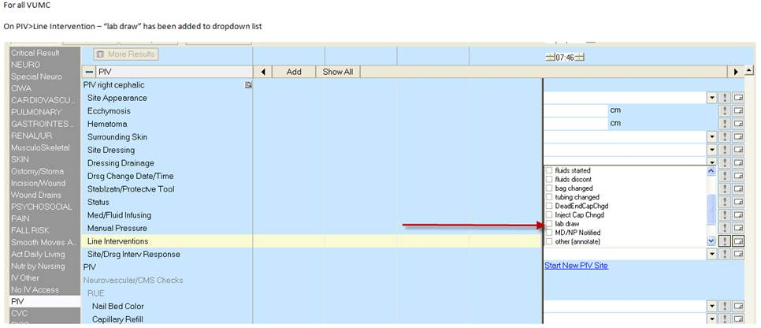

There is one additional HED change that affects 5N CVICU only. Effective 4/17/12 the new CRRT Tab will be available on that unit. Education being provided separately.

1. The following changes are on the Nursing Admission History StarForm:

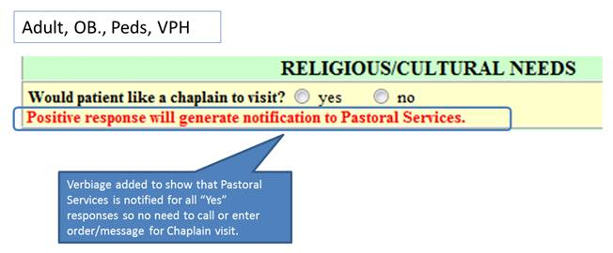

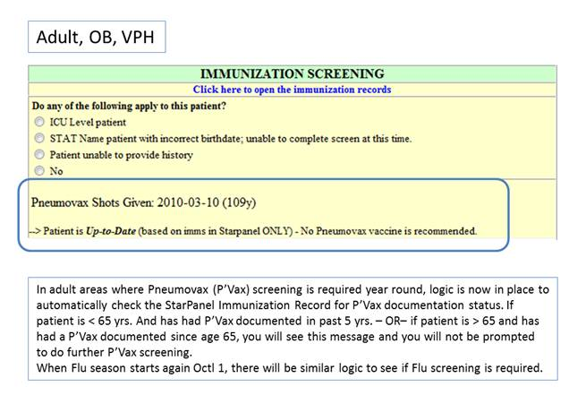

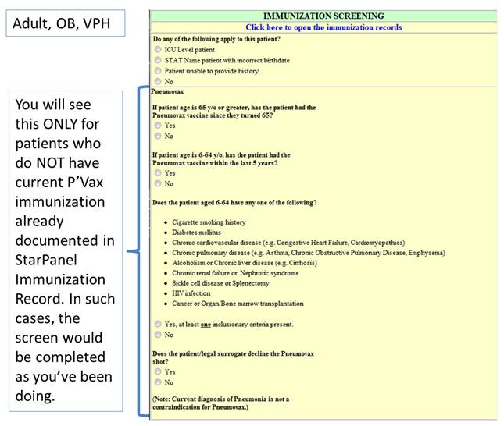

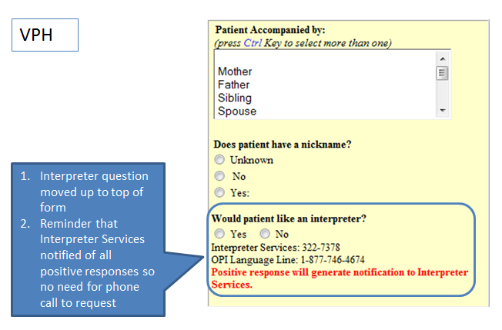

1. Changes to Peds Admission History form: 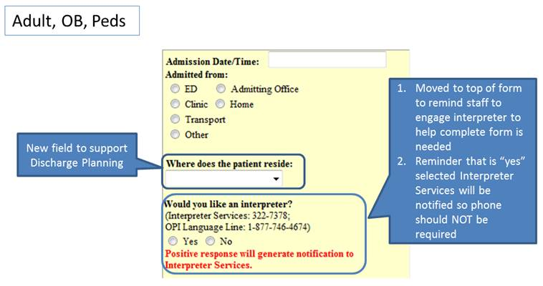

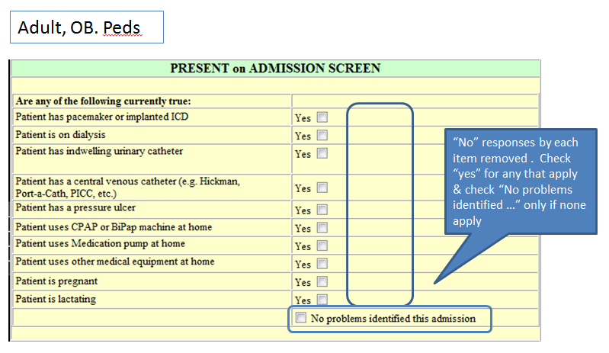

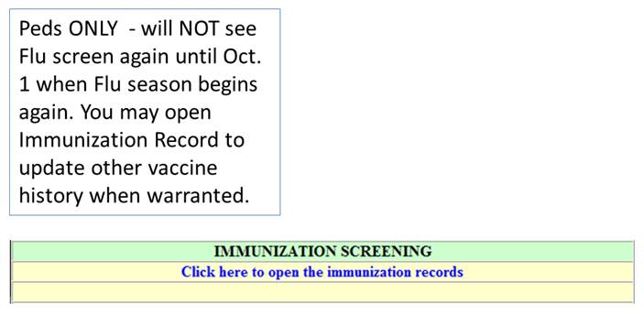

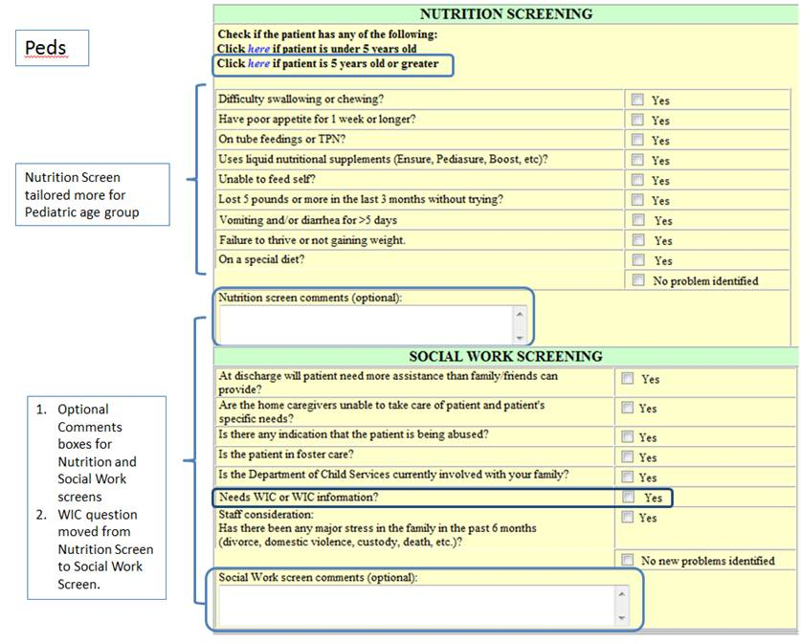

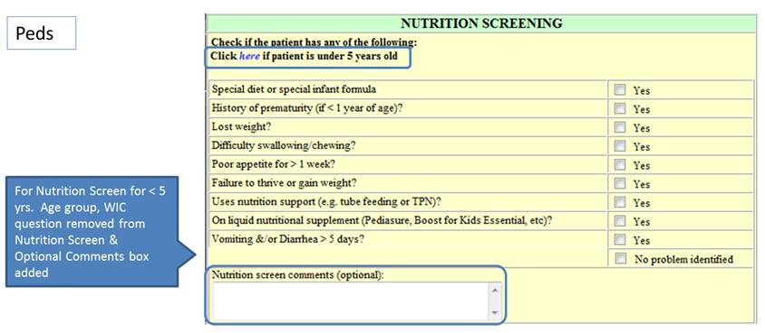

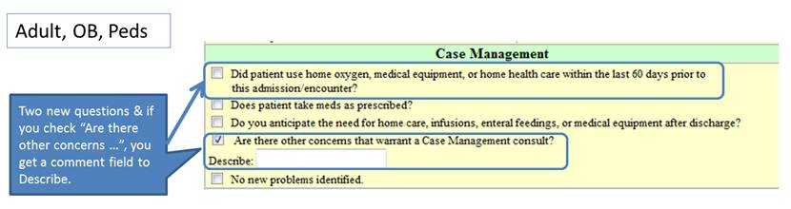

1. The following changes are on the Adult Admission History Form only:

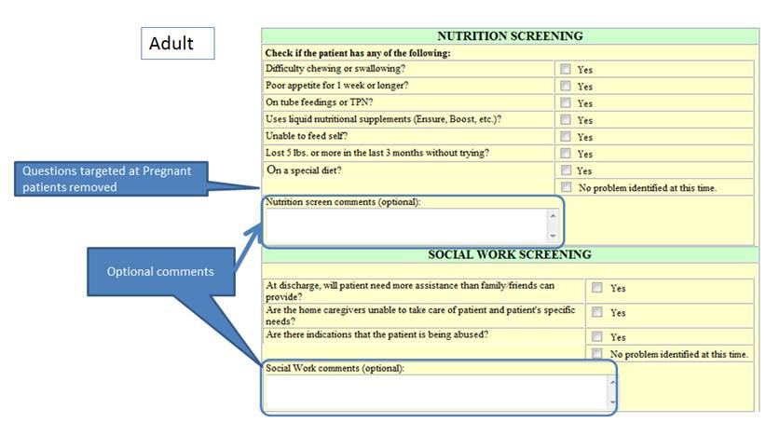

1. The following changes are on the OB Admission History Form only: 