For Adult, OB, and Peds Nursing Admission histories:
Update to the Tobacco screening.
Removed the question about smoking within the past 12 months.
Added in 3 questions on the time since last smoked a cigarette.
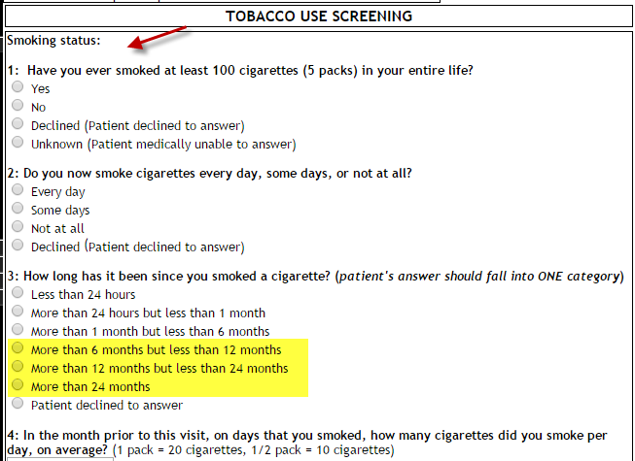

Added reminder to enter Patient Contact information and Height/Weight on the HED Vitals I&O tab: 