Three new fields have been added to the CDR documentations. Fentanyl, Hydromorphone, and Morphine now have a PCA (Demand) Dose field.
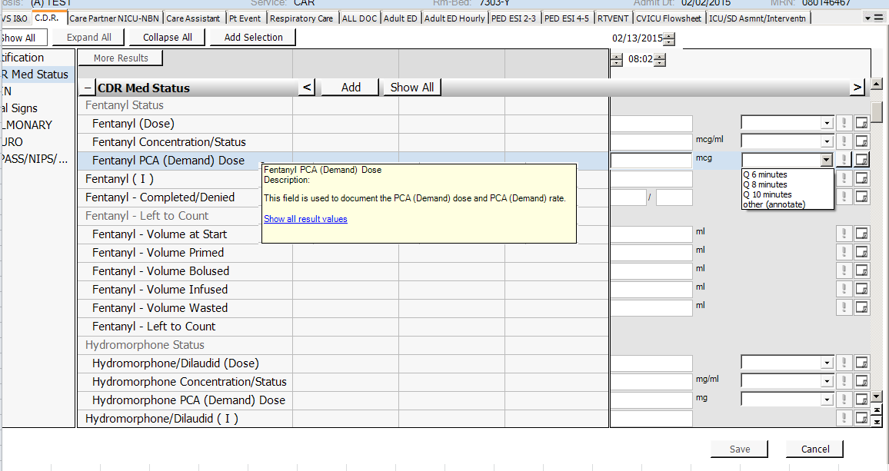
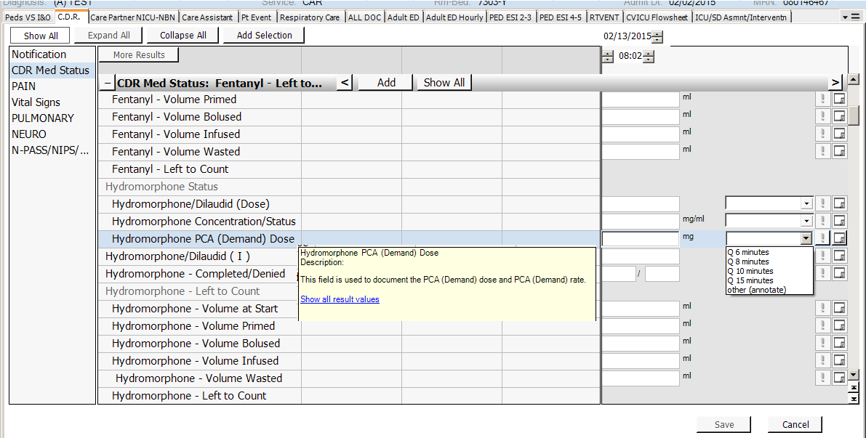
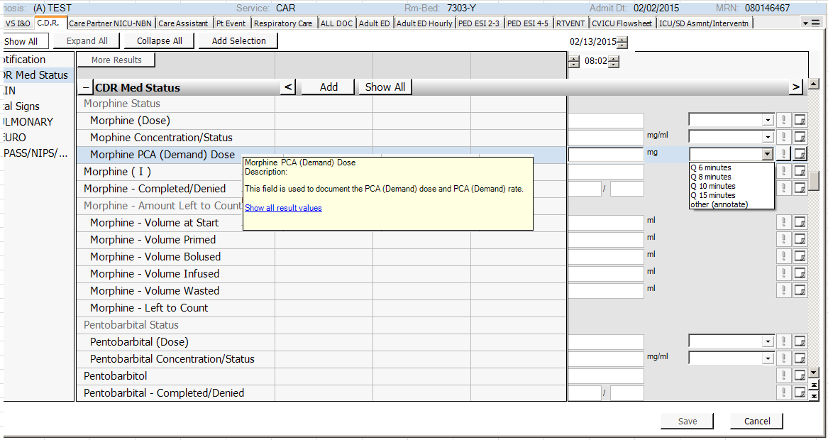

And hover definitions have been added to the CDR Med (Dose) fields
