**ALL VUMC:**

**Isolation Type** is now force display.

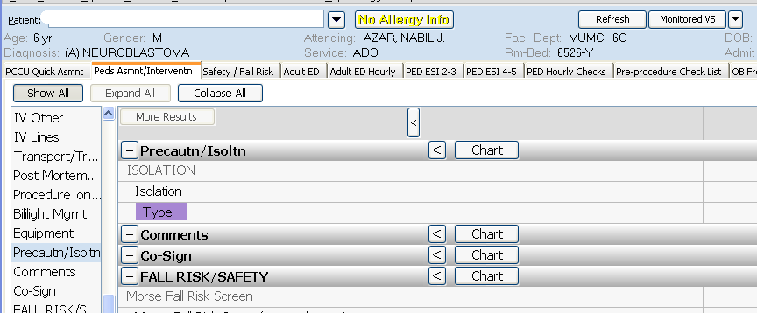

**Isolation type** will display in Precaution/Isolation section of Age-appropriate Assessment/Intervention tab to remind staff to document so that when patient is on isolation, it will consistently display on the OPC in upper right corner of Situation section.

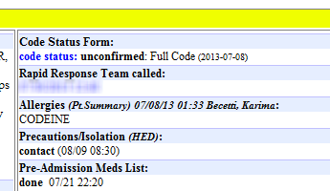

**VUH and VCH:**

Vitals & I&O - Med drips – **Opportunity to cosign med drips** – hover includes what is verified

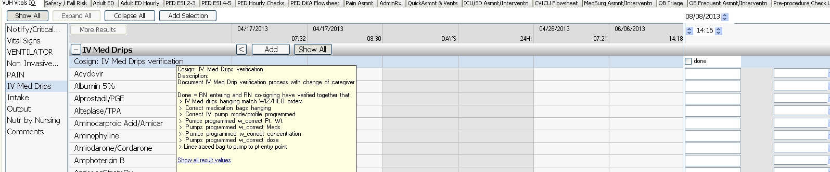

**Close up view of hover information shown above:**

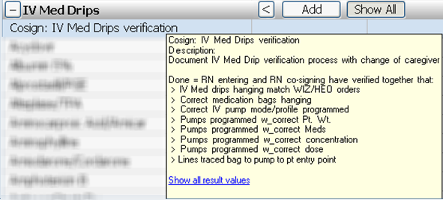

**Assessment tabs - Precaution/Isolation section:**

Added the results for **Suicide**, **Seizure**, **Aspiration** and **Chemotherapy** **precautions** to the **Precautn/Isolatn section** to allow the Peds ED to chart on these. These are shared with the Fall Risk/Safety section.

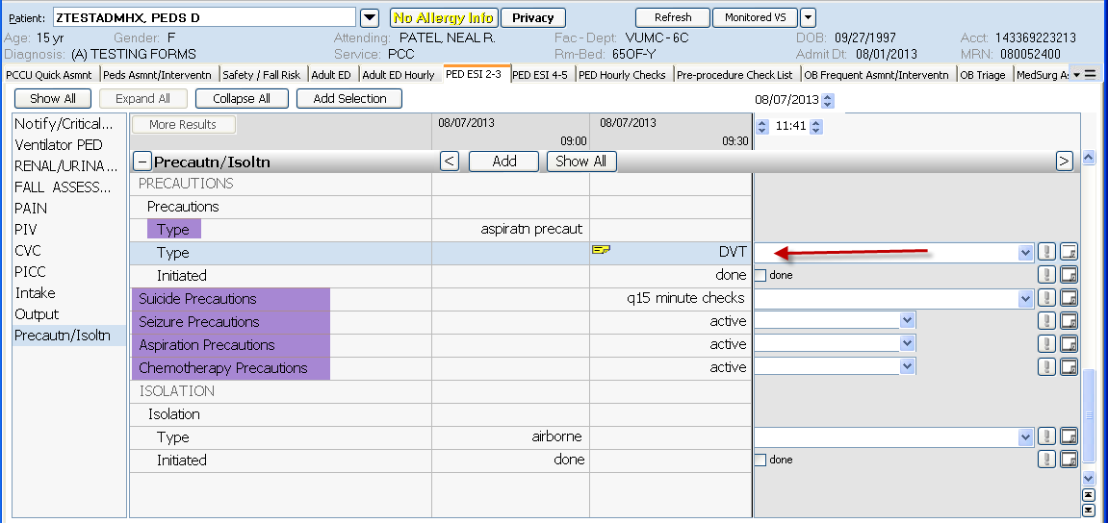

**ALL VUH and VCH (except NICU and NBN):**

Assessment tab - Falls Risk/Safety section. Violence/Injury Precautions

**“Appropriate Stimuli”** has been added to the dropdown list

