**VUH only**

>**Asmnt tab> Special Neuro** > new charting fields for Neuro Deficits has been added for Stroke patients

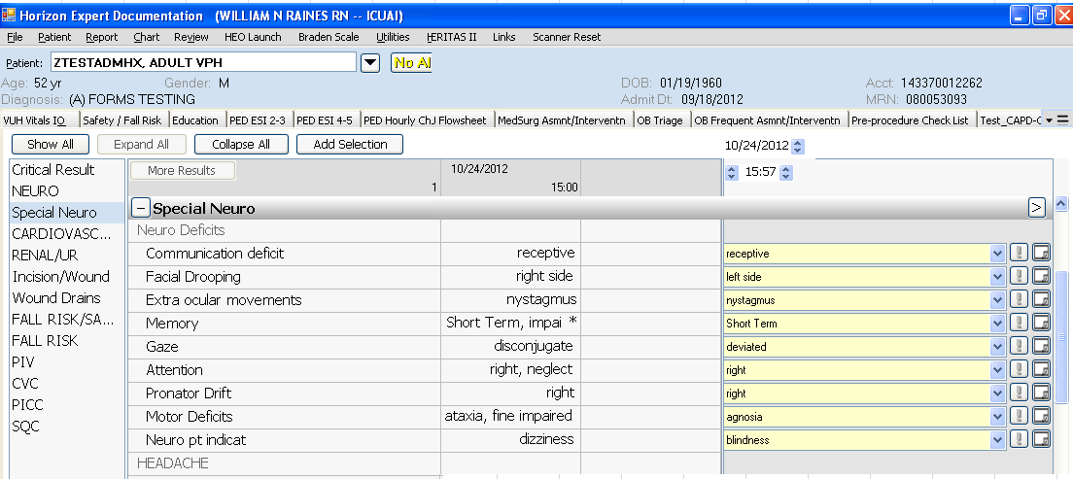

**For the new Safety Documentation**

the following units will be implemented on 10.30.2012 and screenshots below of changes made this week.

6T3, 4East, 4NLP, 4MSC, 8N, 8T3, 6N, COBS,

**Non-implemented units will see this**

Assessment tab>Precautions/Isolation>Precautions type list:

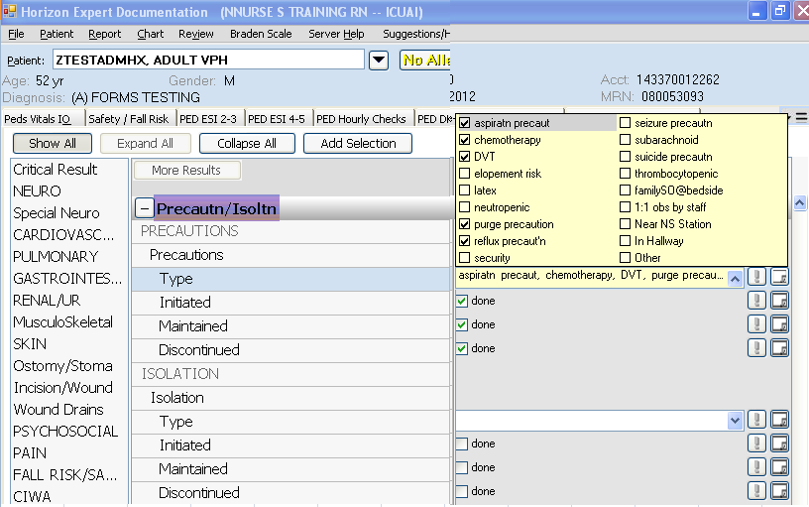

**Implemented units** will see an updated drop down list which excludes precaution options that are specifically identified in the Safety Build. Previous charting on the original precautions Type list will be visible however; these units will only be able to chart on the new list:  
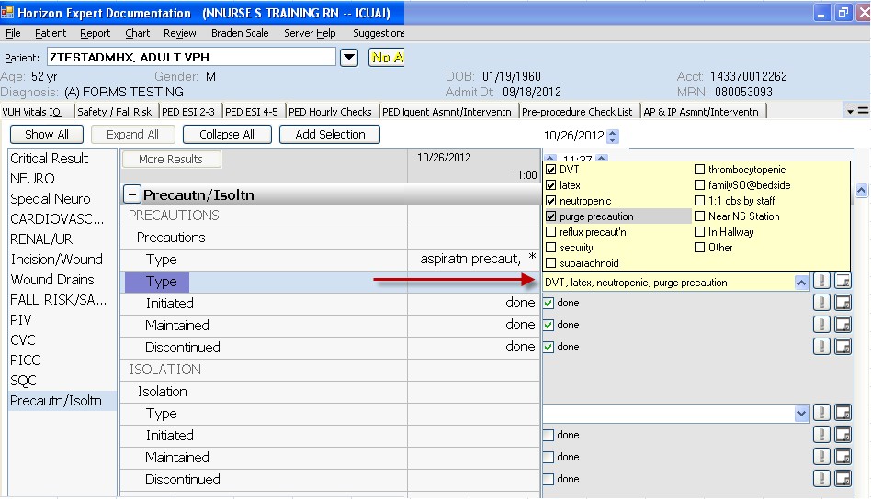

Example of a patient with Precautions charting both before and after the change.

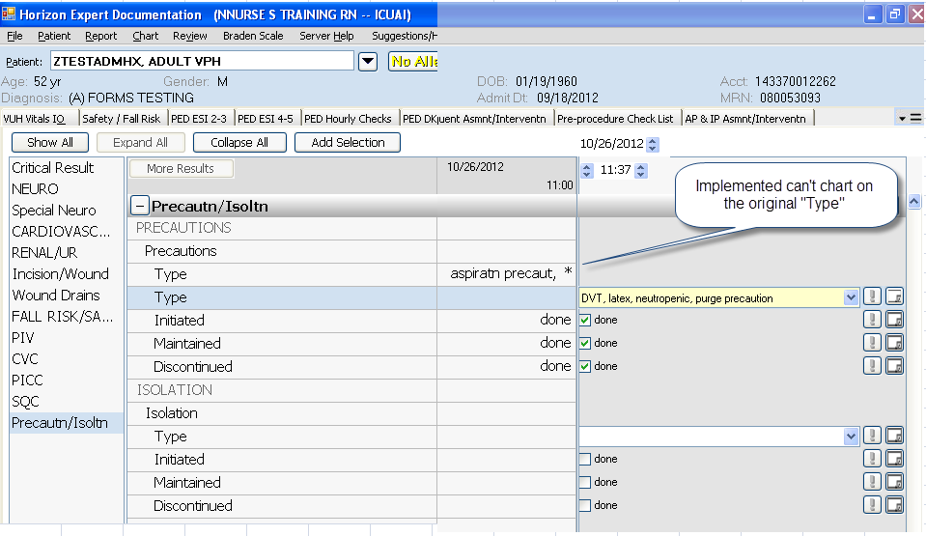

>**Education Record >Role Communication**> Interpreter Name

1. Interpreter Name changing to “Interpreter Name or ID Number

2. “Interpreter Name or ID Number now has hover feature to explain protocol for calling an Interpreter

3. “Interpreter Phone #” no longer chartable

