For VUH and PICCU
Fall Risk/Safety>Safety Monitoring - RASS Score has been added to the Safety Monitoring section. This is a shared field with the Neuro Section
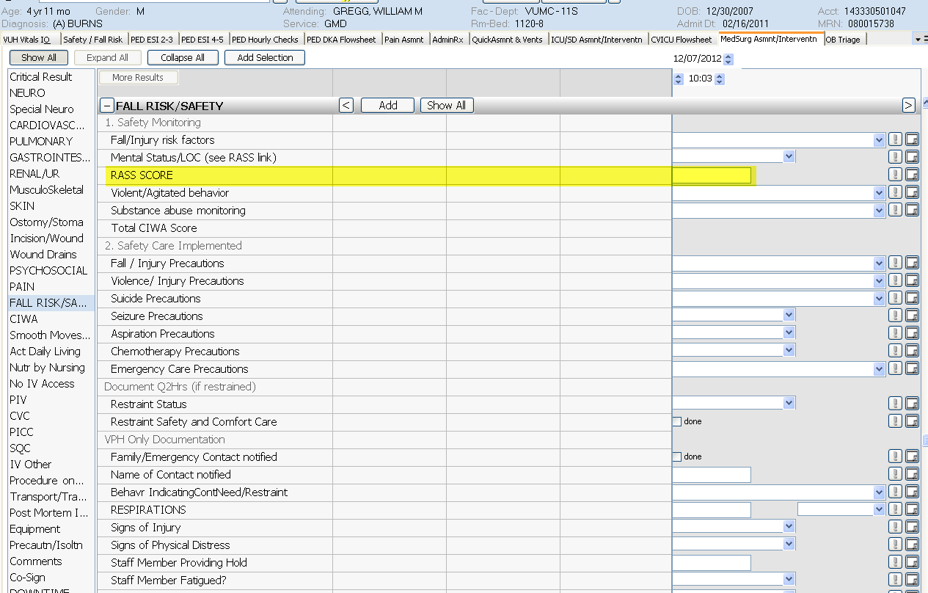

For VUH and VCH
Adult and Peds Vitals I&O tab, Chemo Infusion tab, and on the QuickAsmnt & Vents> new charting option of “Epoprostenol (Flolan) for Inhalation” has been added
