**VUH, ED, VPH and Peds ED, Peds Acute, PICU, PCICUs:**

1) Notify/Critical Results section is being renamed to “Notification”

2) “Radiology” is now an option under Reason Notified

3) MD and Midlevel Provider Communication fields are no longer chartable

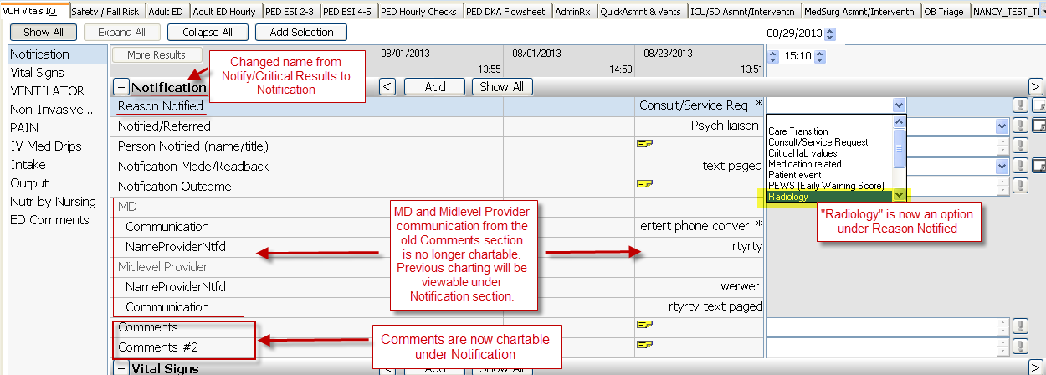

4) ‘Comments’ section is being re-purposed to only contain ED Comments.  Non-ED units will continue to see any charting that was done in the EDs,

but not be able to chart the fields.

