**HED changes and updates effective 7/15:**

Reminder that Functional Status Questions in Nursing Admit History StarForms are required. The response to these questions will be imported into the Provider Discharge Process tools.

Med List Tool (MLT) will be embedded in provider H&P forms :

* + If the nurse initiates the MLT the provider will see the med list created by the nurse to review/ edit and finalize and save to the Patient Summary.
  + If the provider finalizes the MLT before the nurse, the nurse **does NOT** need to edit the MLT unless additional information re: home medications is given by pt/ family.   If changes are made after the provider has finalized the MLT, communicate these changes to the provider as needed.

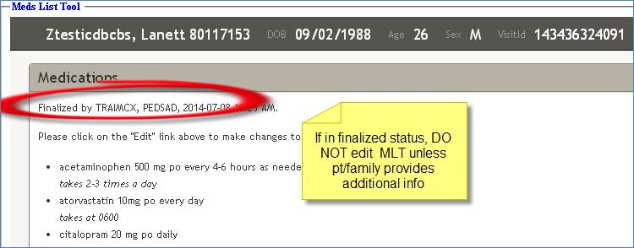

IV drip medications added to the IV Med Drips section :

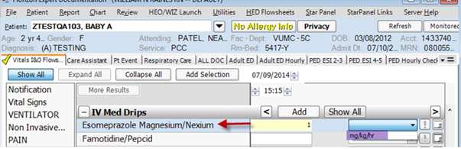

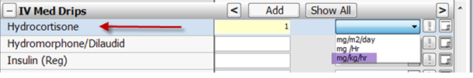

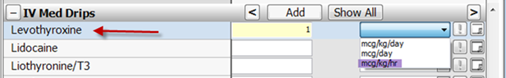

Updated display text for CAPD fluid removed or retained.

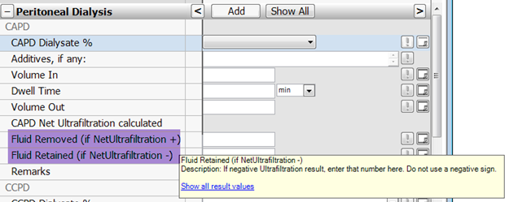

**Care Assistant tab changes:**

Care Assistant tab > Vital Signs > Added “Weight Equip”

