For VUH and VCH Assessment tabs

- NEURO>will receive Pupil Shape as new charting field.

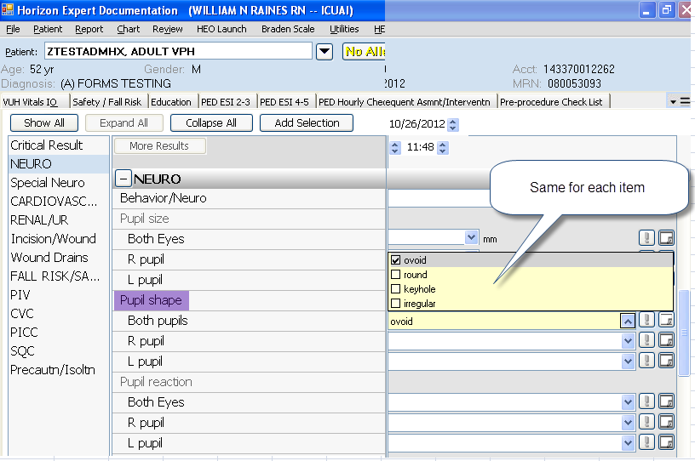

IV Other > “Antibiotic lock” added to Dialysis catheter status: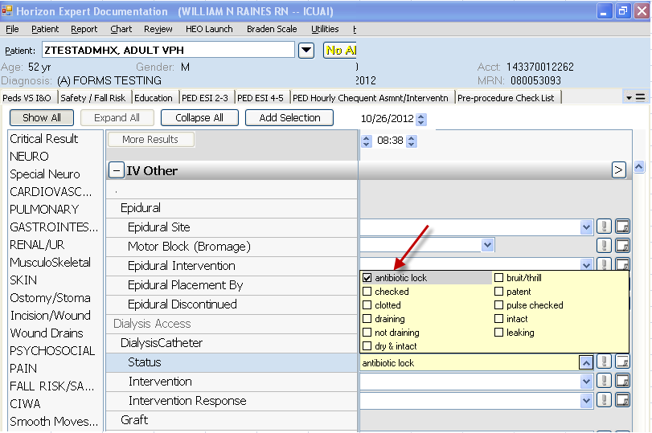
- Vitals I&O or QuickAssess Tabs > Med Drips

Hydrocortizone has additional dropdown option of mg/hr
