**VUH and VCH**

Priority Problems - **Bleeding Risk has been moved** from Tissue Perfusion to the Cardiac Priority Problem section

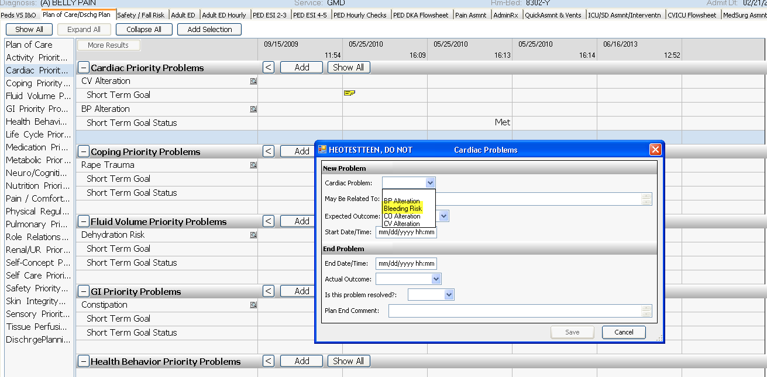

Tissue Perfusion Priority Problems has **additional options:**

**“Peripheral Tissue Perfusion Alteration” & “Tissue Perfusion Alteration – Other”**

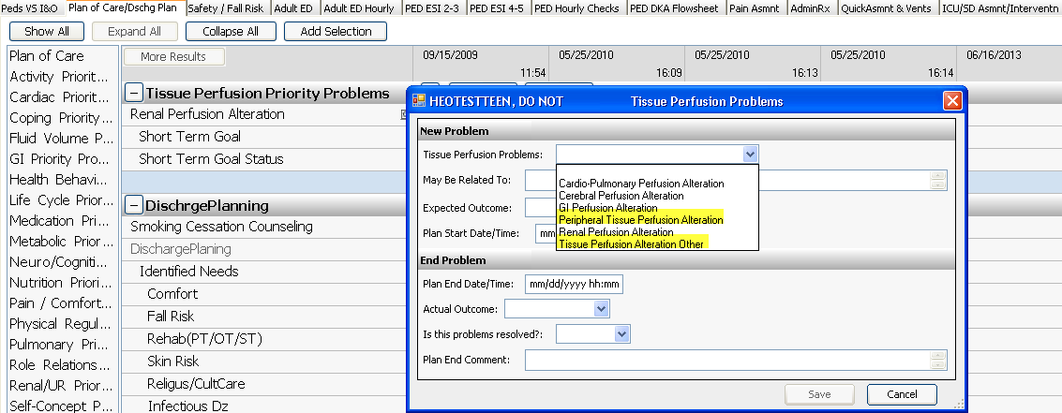

**Care Organizer and HED Links:**

New documents for **“Problem ID/Assessment Integration-FAQ”**

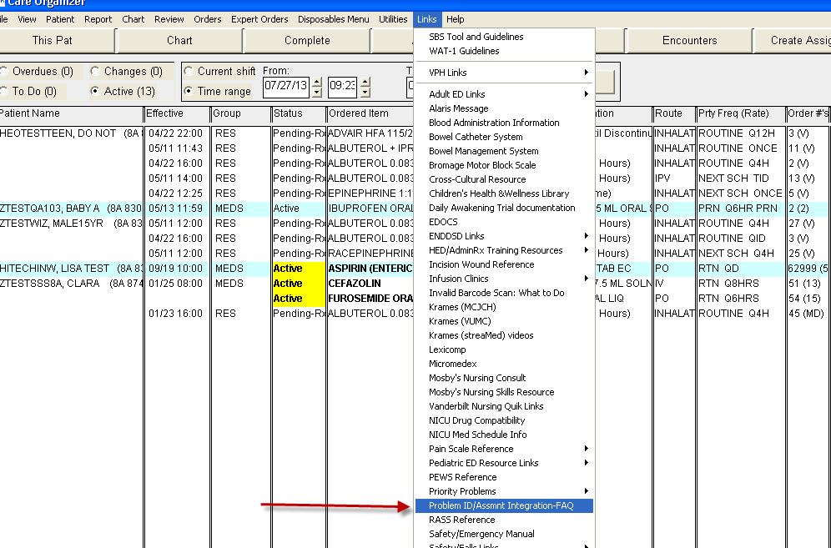

And updated document on **Nursing Problem Definitions (CCC)** to show the additional problems.

