**HED Changes effective 7/15/14: (please scroll to bottom for ventilator documentation changes coming 7/22)**

**MAJOR CHANGES TO CRRT:**

**Purpose of the HED change**

The CRRT “volume to pull” calculation format is changing to simplify data entry and decrease the potential for errors.

**HED Change Summary**

•          The actual CRRT fluid removed last hour is not currently used in the calculation formula.    As a result, an output subtotal (i.e., output except for ultrafiltrate) must be calculated and entered.

•          The improved method starts with total I & O - including ultrafiltrate pulled.   The formula then adds this fluid back in - compensating for its inclusion.    The amount pulled from the patient automatically populates the calculations section when it is entered in output.

**Purposes of HEO changes:**

•          Previously, CRRT orders were fragmented under orders to nursing, medications, and dialysis.    This made the order review and verification processes difficult.

•          CRRT orders can now be grouped and viewed on one screen.    This is done through use of the display button at the bottom of the current orders screen.

RNs in Adult ICUs and Dialysis *SHOULD* have had an LMS module assigned with information about these changes BUT in case you missed that training and work in an area where you will care for patients on CRRT, the module is available in LMS:

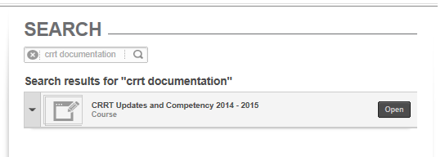

The following IV drip medications have been added to the IV Med Drips **section**:

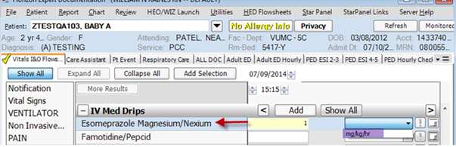

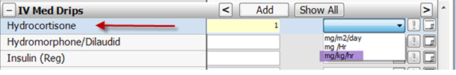

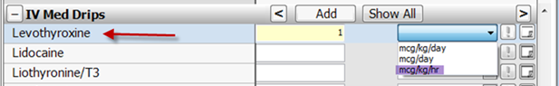

**Updated display text for CAPD fluid removed or retained**:

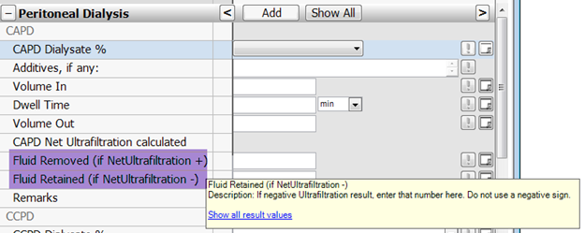

**Care Assistant tab HED changes:**

Care Assistant tab > Vital Signs > Added “Weight Equip”

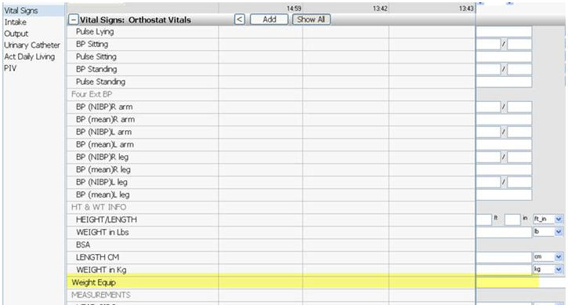

**VUH ICUS: ADULT Respiratory Care will begin documenting ventilator data in HED starting July 22**

* Paper Vent Logs at the bedside will NOT be used
* Respiratory Care will document an expanded data set, similar to paper flow sheets, every 4 hours, as per current routine
* Charting will be in real time and not back-timed to specific hours. Eg. If the Respiratory Therapist documents their Vent assessment at 10:07, the entry will display at 10:07, NOT at 10am
* It is NOT necessary for nurses to document vent data that Resp. Care has already documented. If the standard of care is to document Vent settings every 2 hrs. , Resp. Care will document every 4 hrs and Nursing will document on the alternating 4 hrs. saving nursing documentation time
* The data will populate the HED tabs  nurses are familiar with:

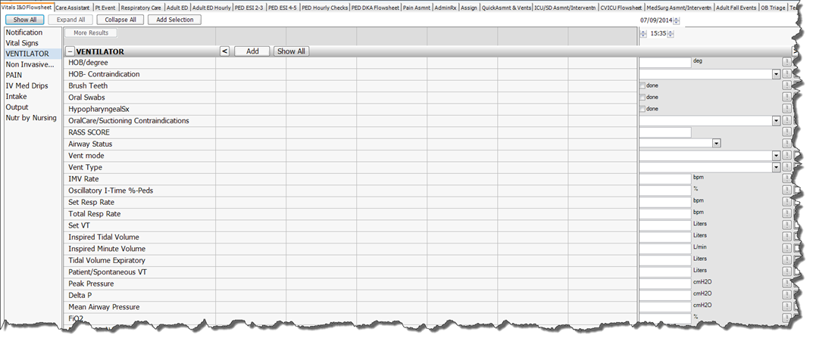

Respiratory Care will also have a new tab (Respiratory Care):

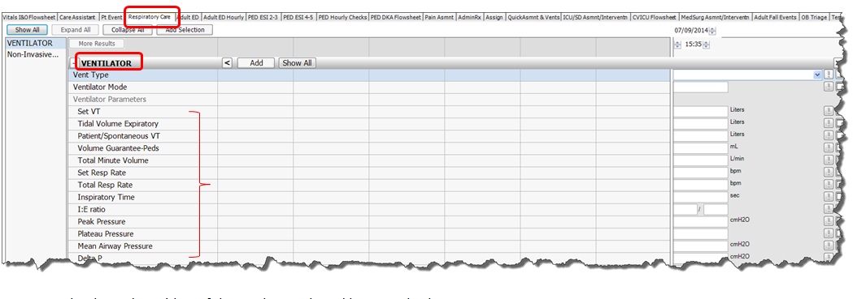

* Results charted on either of these tabs are shared between both
* Providers who are allowed to make vent changes should communicate those changes via through WIZ order entry changes (and if that is not possible in emergency situations, by communicating directly to the Respiratory Therapist as a verbal order)

Warning of a possible scenario that might happen rarely: If a Respiratory Therapist has documented Vent settings and related data at (eg. At 15:35pm) and a nurse later tries to document any of those same values and back time for the exact same time (15:35pm), they will get an error message showing duplicate values for the same minute. The 2nd person trying to enter documentation for the exact same minute will either need to set a new time or cancel entry of the duplicate data element(s). Once there is no duplication, the charting may be saved.

