VUH
Assessment tabs - all systems assessments will now be replacing the “Standard met/ Standard met except” with the “new Assessment problems”. The “Standard met/Standard met except” previous charting will be viewable but no longer chartable. The corresponding Priority Problem link has also been placed under the assessment.
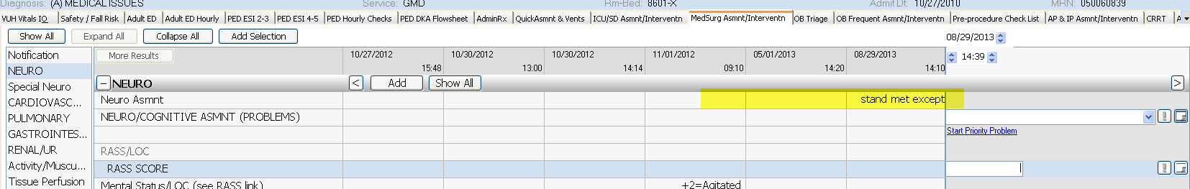
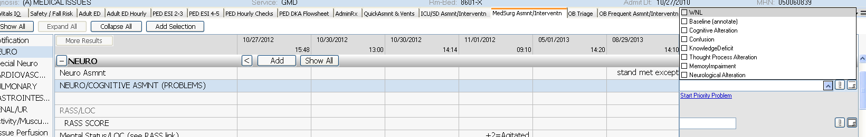

The Musculoskeletal section has a new name of “Activity/Musculoskeletal”, and there are six new section added to the Assessment – “Tissue Perfusion, Fluid/Electrolyte, Life Cycle, Metabolic, Physical Regulation, and Sensory”
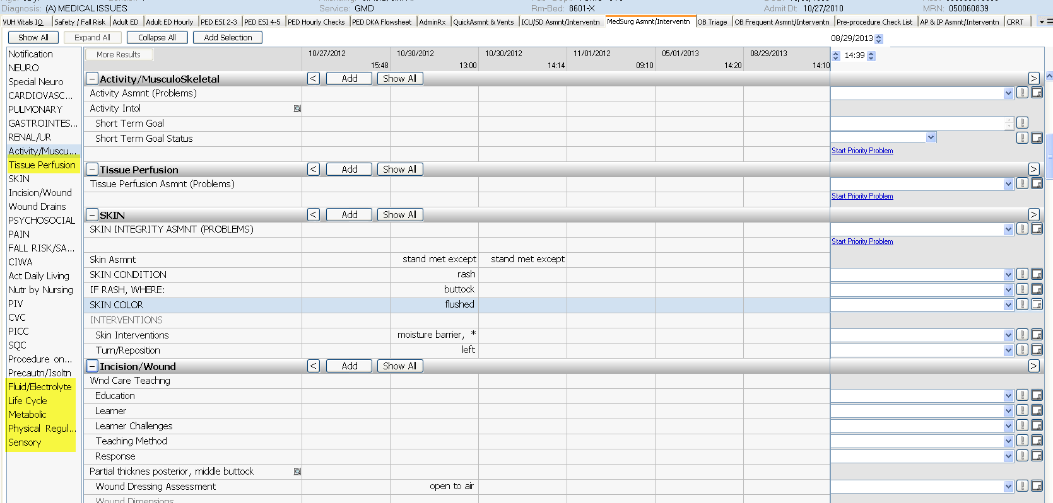

“The new Care Plan Tab” will now be available and will be replacing the Plan of Care/Discharge tab. It provides each assessment problem which will share with the Assessment tabs.
