**All VUMC** : Education Record > Pulmonary Education – Adding 4 options:

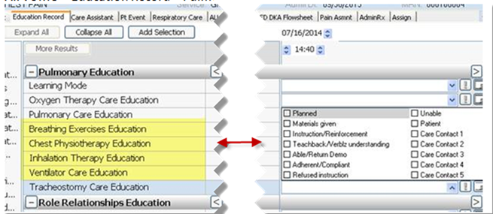

**All VUMC**: Links Menu > Misc – Adding Mosby’s Nursing Consult

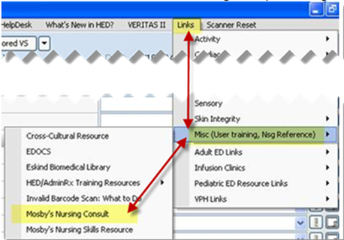

**All VUMC:**

1. Med List Tool (MLT) is embedded in provider  H&P forms.
   * If the nurse initiates the MLT the provider will see the med list created by the nurse to review/ edit and finalize and save to the Patient Summary.
   * If the provider finalizes the MLT before the nurse, the nurse **does NOT** need to edit the MLT unless additional information re: home medications is given by pt/ family.
   * If changes are made after the provider has finalized the MLT,  communicate these changes to the provider as needed.

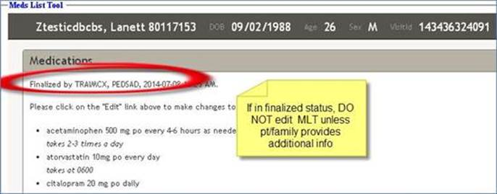

**ATTENTION VUH NURSING STAFF IN *ICU AREAS* ONLY**

**Changes made to Nursing Documentation in VUH ICU areas ONLY:**

**VUH ICUs**:

ICU/SD Asmnt/Interventn > Special Neuro > EVD Site Dressing and Lumbar Drain Site Dressing:  “Chlorhex drsg” has been removed from the dropdown

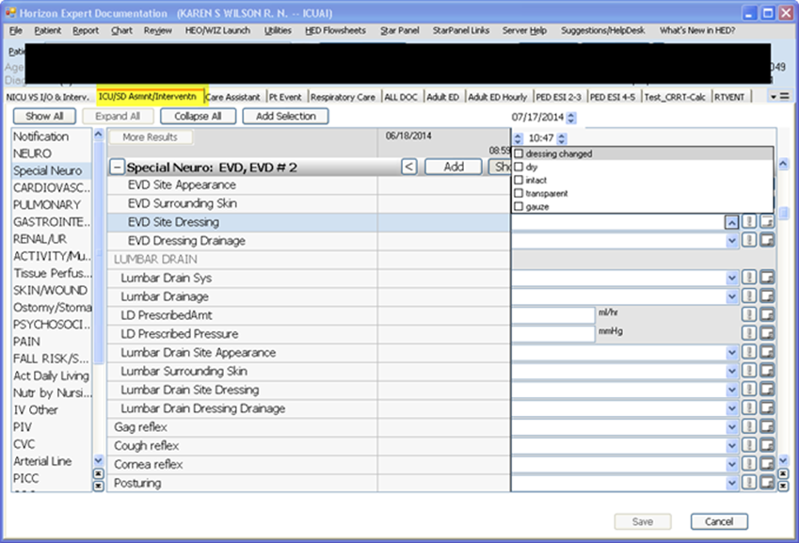

**VUH ICUs:**

* Swap Nursing current “Vent mode” field, which is a manual drop-down list to the new “Ventilator Mode” field RTs are now using
* The new view uses the DAS feed and the hover to explain the DAS abbreviations:

**Current Nursing:**

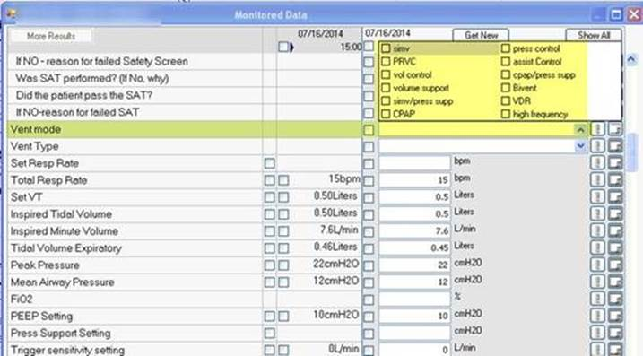

**To be changed to:**

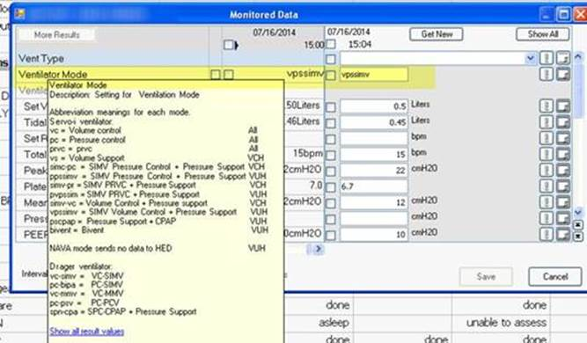

**VUH ICUs:**

1. **Beginning July 22, 2014 ADULT Respiratory Care will document ventilator data in HED.**

* Paper Vent Logs at the bedside will **NOT** be used.
* Respiratory Care will document an expanded data set, similar to paper flow sheets, every 4 hours, as per current routine.
* Charting will be in real time and not back-timed to specific hours. Eg. If the Respiratory Therapist documents their Vent assessment at 10:07, the entry will display at 10:07, NOT at 10am.
* It is NOT necessary for nurses to document vent data that Resp. Care has already documented. If the standard of care is to document Vent settings every 2 hrs. , Resp. Care will document every 4 hrs. and Nursing will document on the alternating 4 hrs. saving nursing documentation time.
* The data will populate the HED tabs  nurses are familiar with:



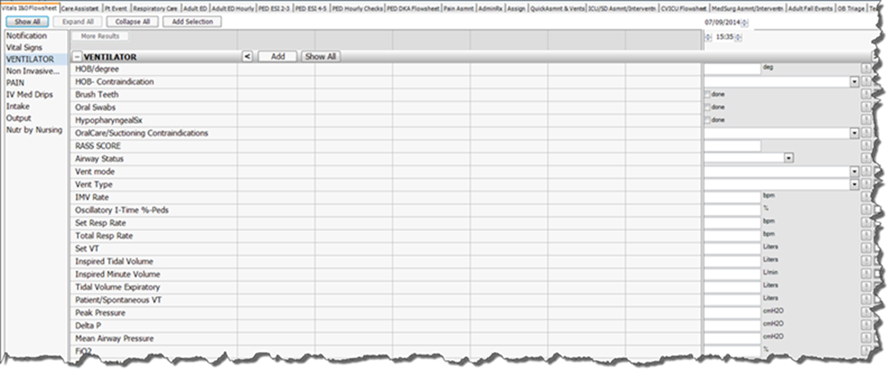

**Respiratory Care will also have a new tab (Respiratory Care):**

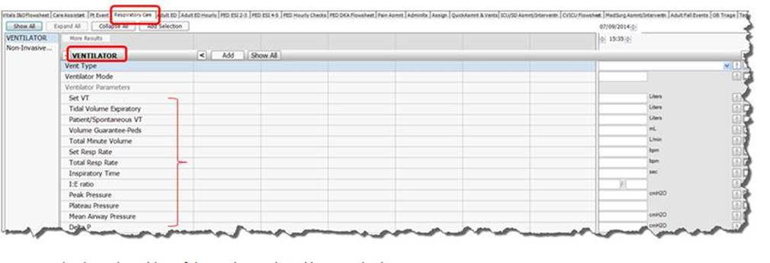

* Results charted on either of these tabs are shared between both.
* ****Providers who are allowed to make vent changes should communicate those changes through WIZ order entry changes (and if that is not possible in emergency situations, by communicating directly to the Respiratory Therapist as a verbal order).

**Warning** of a possible scenario that might happen rarely:

* If a Respiratory Therapist has documented Vent settings and related data at (eg. At 15:35pm) and a nurse later tries to document any of those same values and back time for the exact same time (15:35pm), they will get an error message showing duplicate values for the same minute. The 2nd person trying to enter documentation for the exact same minute will either need to set a new time or cancel entry of the duplicate data element(s). Once there is no duplication, the charting may be saved.

