For VUH and VCH
There will be a new section for documenting Artline. The new charting fields will be in site management format
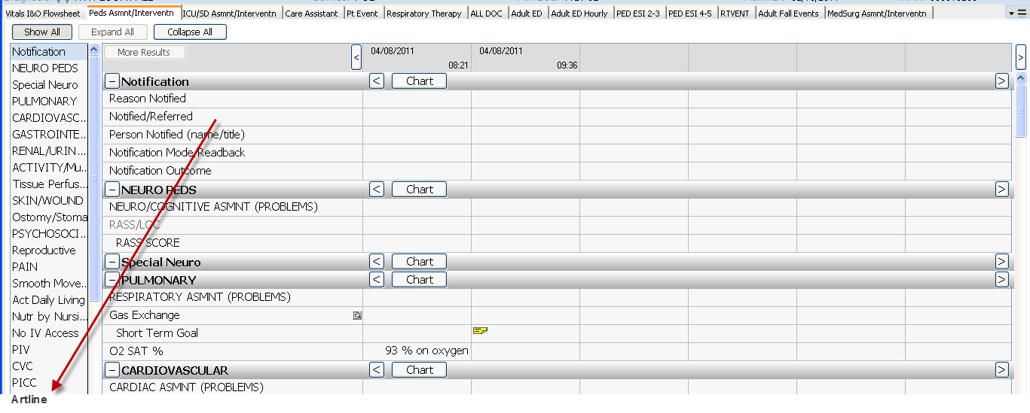
New Artline Template - Mandatory fields for Artline One Time data Site, Side, Start Date
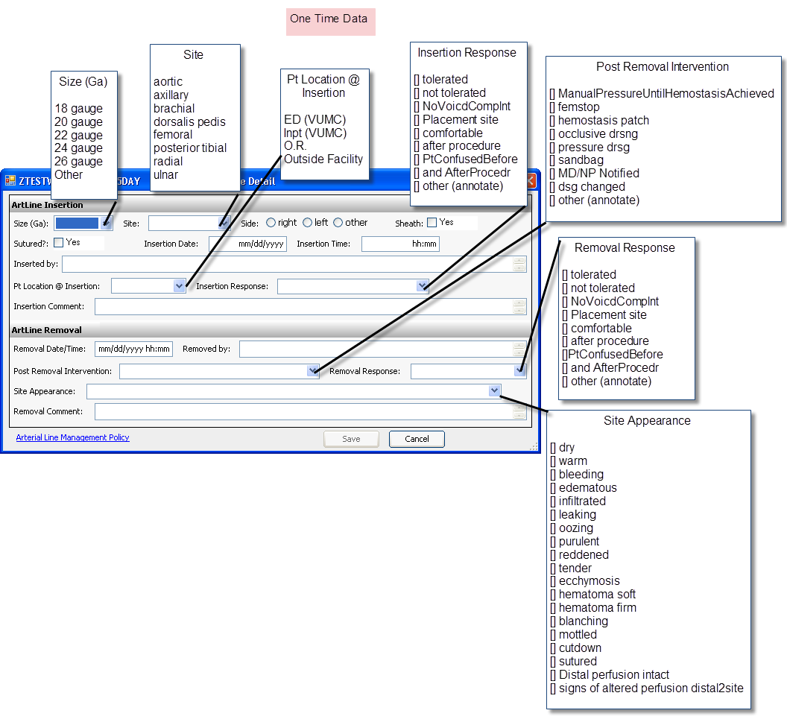
There will be an addition to the CVC “Lumen Status” and “Lumen Interv” of “transduced” and zeroed/leveled@phlebax
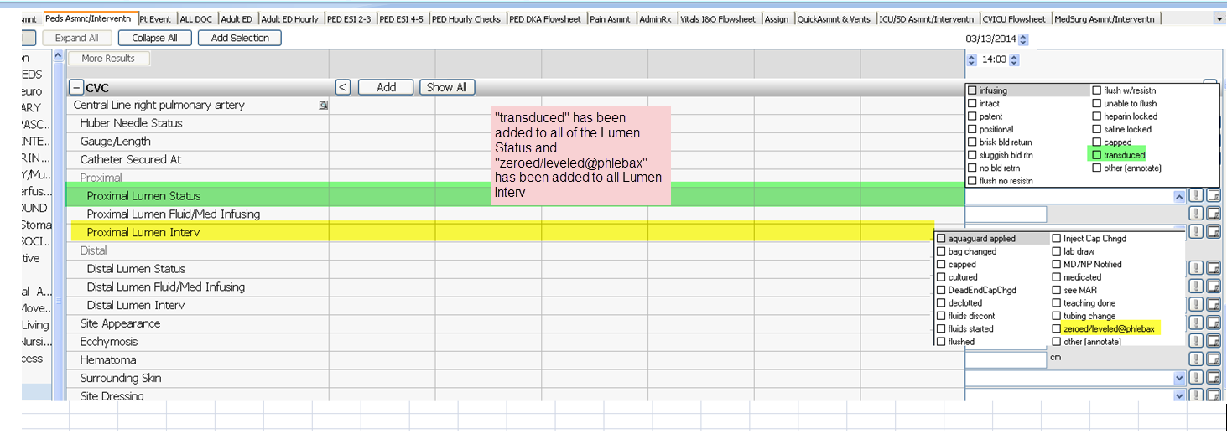

All other Artline documentation will no longer be chartable. Previous charting will remain viewable. There will be no change to the PA catheter documentation.
