VCH except NICU and Newborn Nursery will see the new Care Plan tab and new Problem Assessment charting fields.
The Care Plan tab will replace the Plan of Care/Dschg Plan tab for these units.
Problems identified during assessment charting: 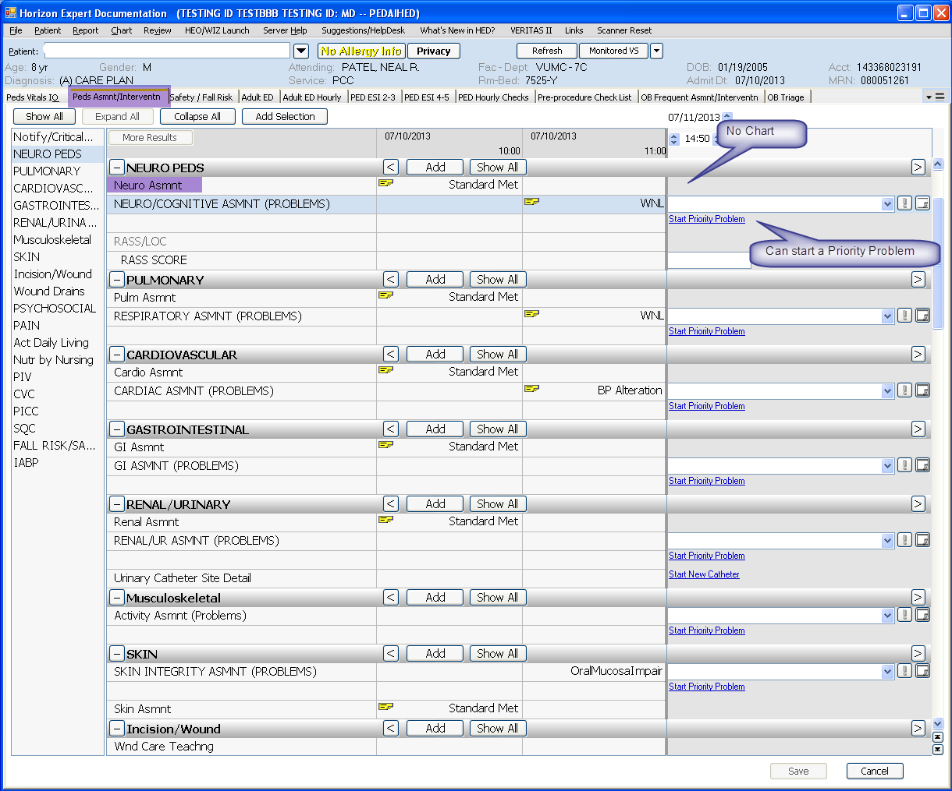
Will share with the new Care Plan tab:
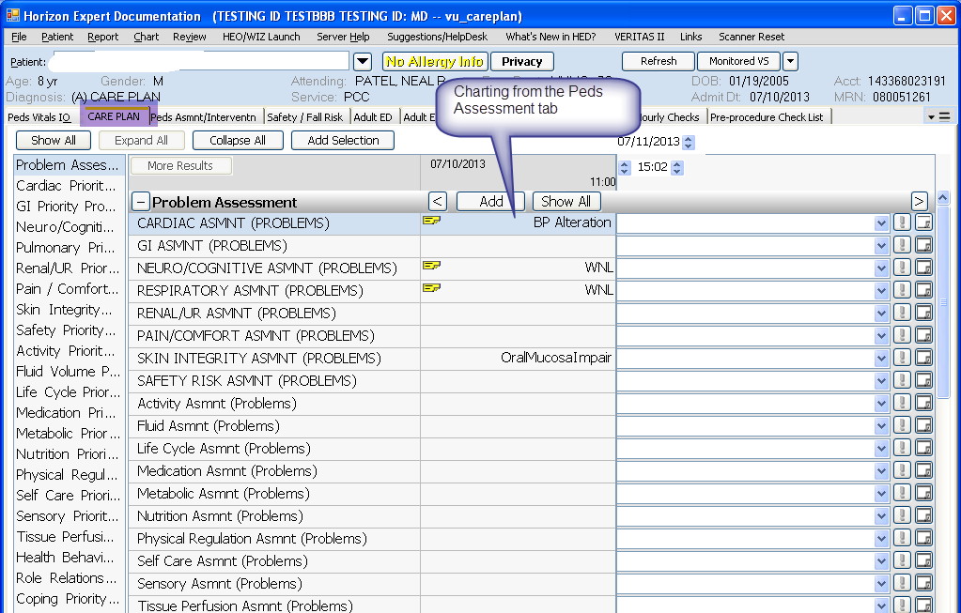

Priority Problems can be started from the Assessment tab:
