**VCH:**

VCH will now have the same **Precautions Type documentation** field as VUH. The old documentation field, if it has previous documentation, it will be viewable but not chartable.   
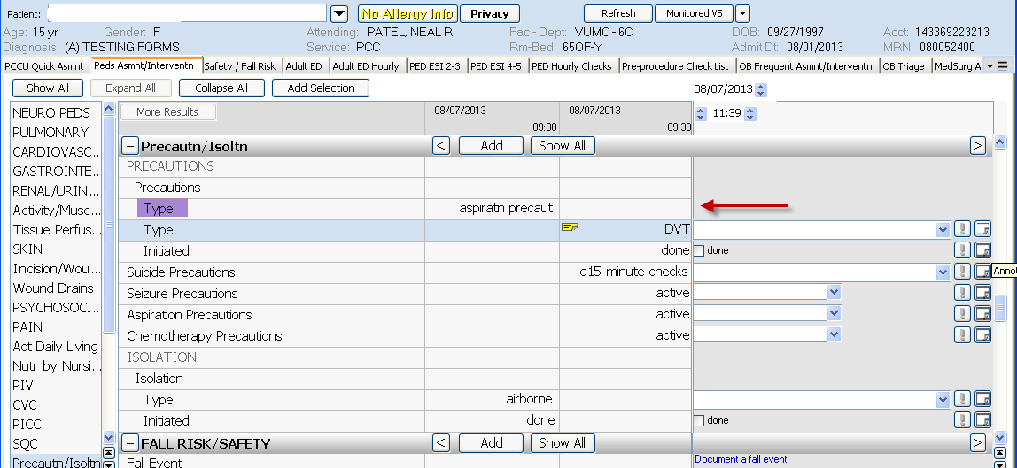

**CarePlan tab** and **Assessment tab** - Problem Assessment results have been modified: Added **“Baseline (annotate)**” to legends and changed hover text to what is in the screenshot:  
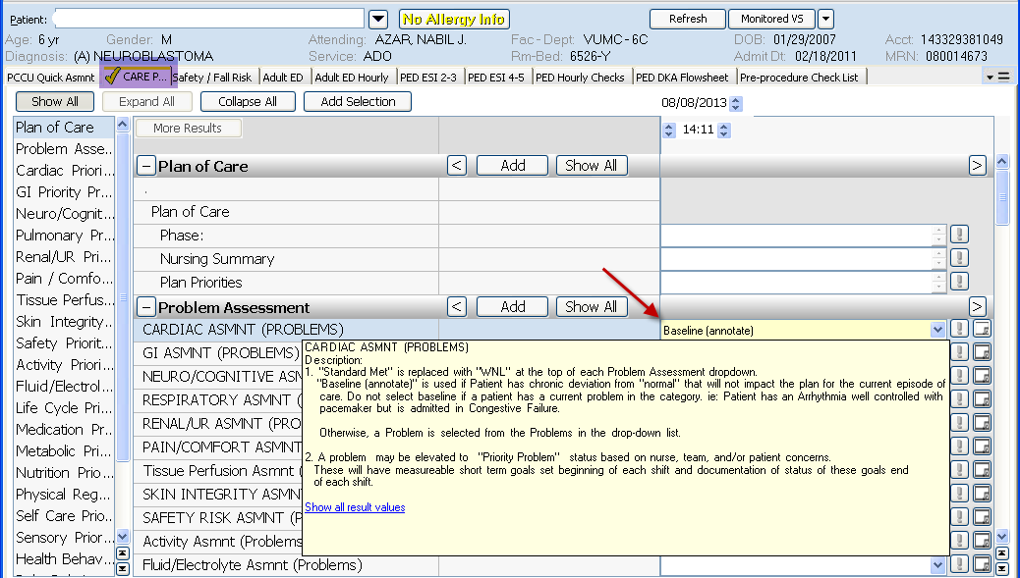

Enlarged picture of hover box contents shown above:

