**VCH except NICU and Newborn Nursery**

Peds Assessment/Intervention Tab and Care Plan Tab

**Bleeding Risk has been moved** from the Tissue Perfusion Assessment (Problems) to the **Cardiac Assessment (Problems)**

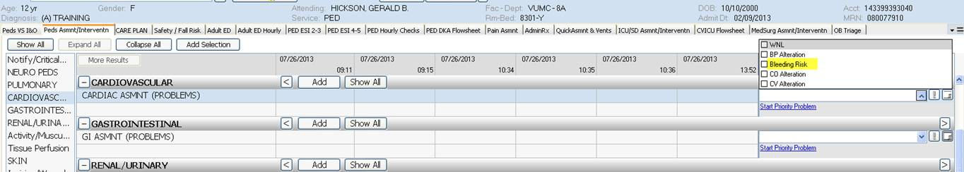

And **Tissue Perfusion Assessment (Problem)** has been **moved** above *Skin on the Care Plan Tab*

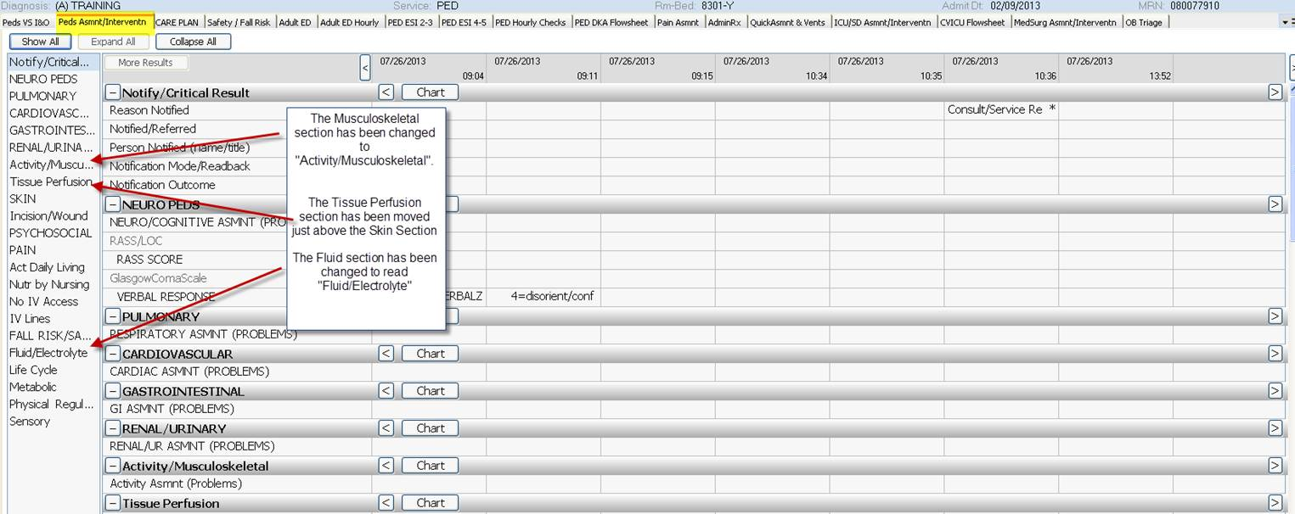

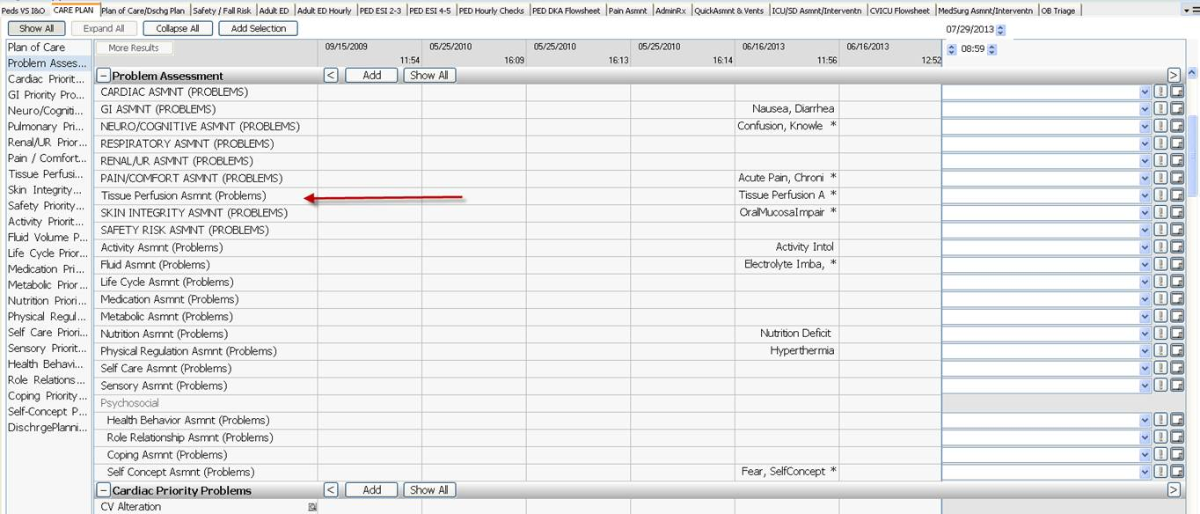

**New additions to the Tissue Perfusion Assessment (Problems**) of Peripheral Tissue Perfusion Alteration and Tissue Perfusion Alteration – Other

