VCH ONLY!
Peds Acute floors:
Added Nutrition by Nursing and Activities of Daily Living sections from the full Peds Assessment/Intervention tab to the Peds Vitals I&O tab to ease student nursing charting. These sections also remain on the full assessment and will share:
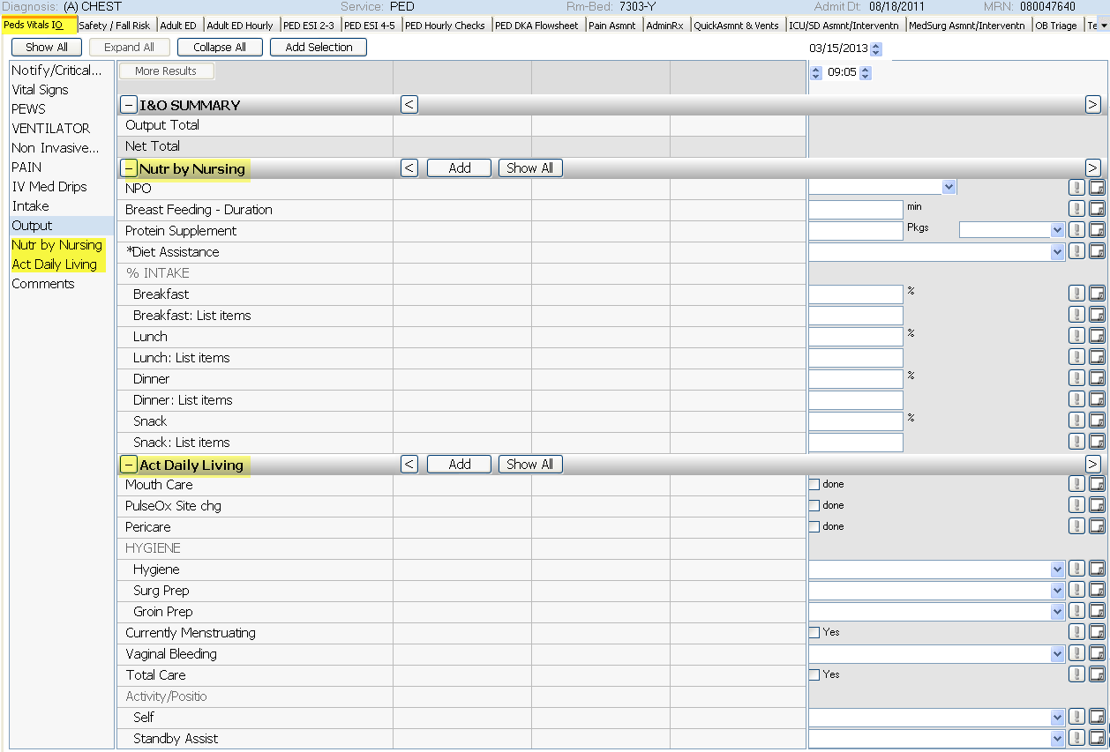
Peds Asmnt/Intervention tab - PULMONARY - IF Trach/Airway - AIRWAY TYPE – added “cuff deflated” to dropdown.