Attention! Upgrades to Inpt. Nursing Documentation Tools in HED and StarPanel Admission History

Coming Tue., July 17, 2012 - Please print, post, and share with all users in your area!

1. **Admission History enhancements**:

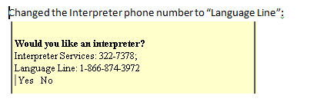

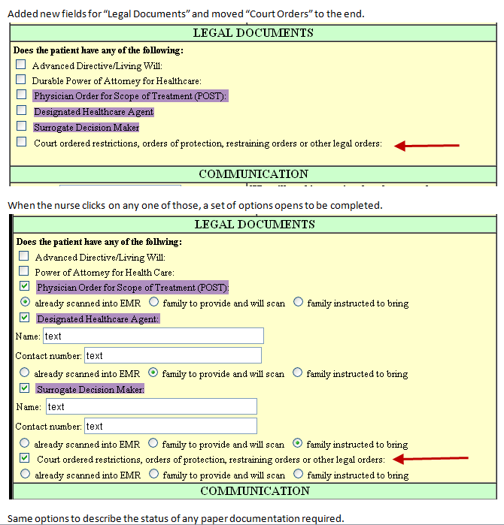

1. **HED changes**:

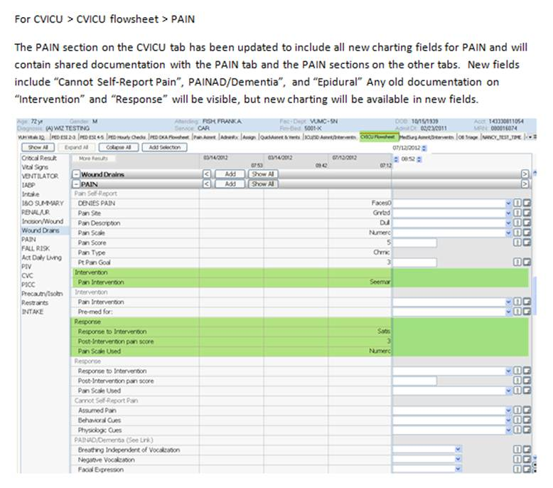

**b.**

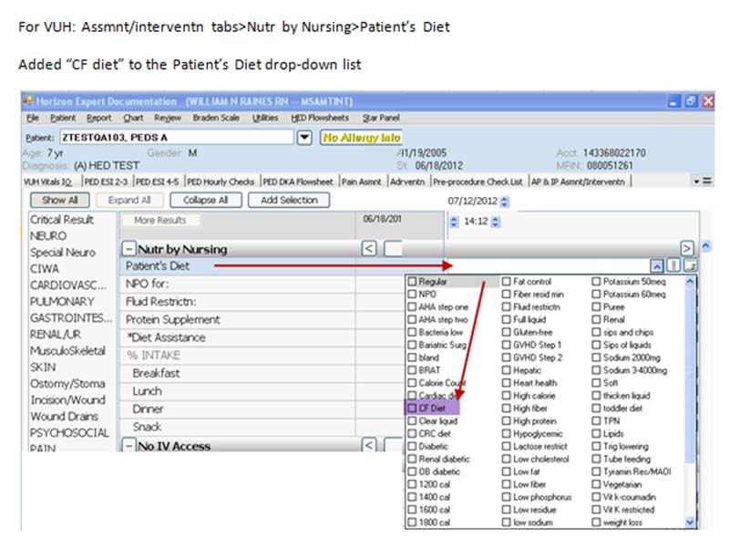

**c.**

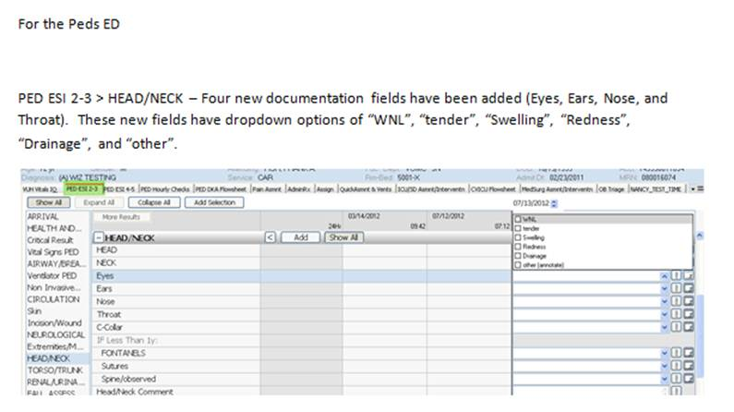

**Karen Hughart, MSN, RN-BC**

Director, Systems Support Services

1009 Oxford House

Vanderbilt University Medical Center

Nashville, TN  37232-4740

(615)936-6779

[karen.l.hughart@Vanderbilt.edu](mailto:karen.l.hughart@Vanderbilt.edu)