For all of VCH
The new Peds Fall Score(Graf-Pif) will be available.
Peds Asmnt/Interventn> FALL RISK/SAFETY
NICU Assessment> FALL ASSESSMENT
Newborn Nursery Flowsheet > FALL ASSESSMENT
PED ESI 2-3 and PED ESI 3-4> FALL ASSESSMENT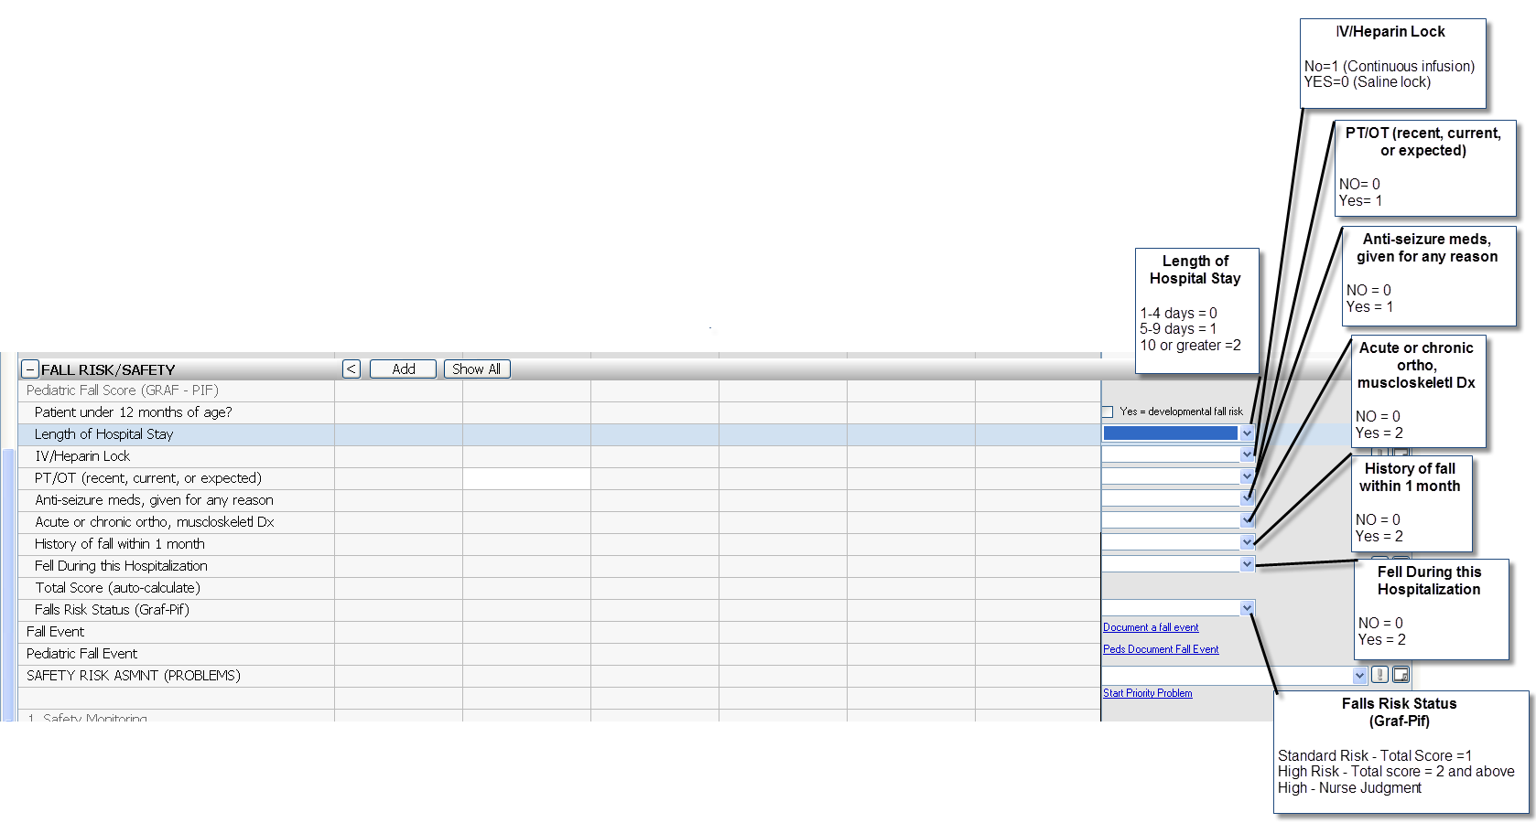
For VCH except NICU and NBN
Peds Assmnt/Interventn> FALL RISK/SAFETY>Safety Care Implemented
The Fall/Injury Precautions hover has been updated with new Peds Fall Risk Precautions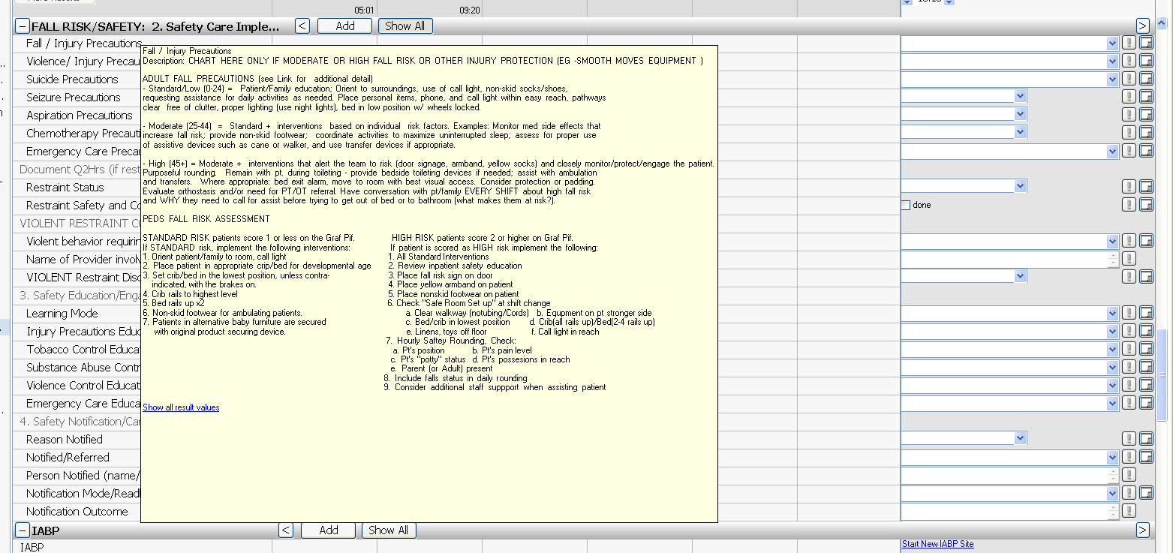
For NICU and NBN

Newborn Nursery Flowsheet>FALL ASSESSMENT
NICU Assesment>FALL ASSESSMENT
The old Peds Fall Parameters and Risk Prevention will be no longer chartable. Standard and High risk preventions will be listed in the hover of the new Graf-Pif fields. Any previous documentation for the old parameters will be viewable
