**10-01-13 updates to the StarPanel Nursing Admission History:**  
  
Tobacco use screening will be updated with 2 new selections: Light smoker and Heavy smoker. The Smoking section will pre-fill with data entered from a previous nursing admission form or from the Clinic Intake form (it is necessary to click on the “Yes” option to view entries from the Clinic Intake form).  
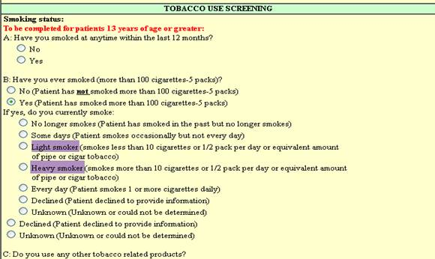

Influenza Screening returns to all forms.  
The screening will only display if the patient is due.   
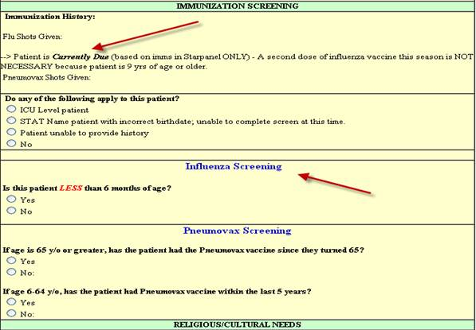

On the Adult, OB and VPH forms, completing the screen and answering the “No to All” exclusion question will generate a protocol HEO order for the Influenza vaccine administration.

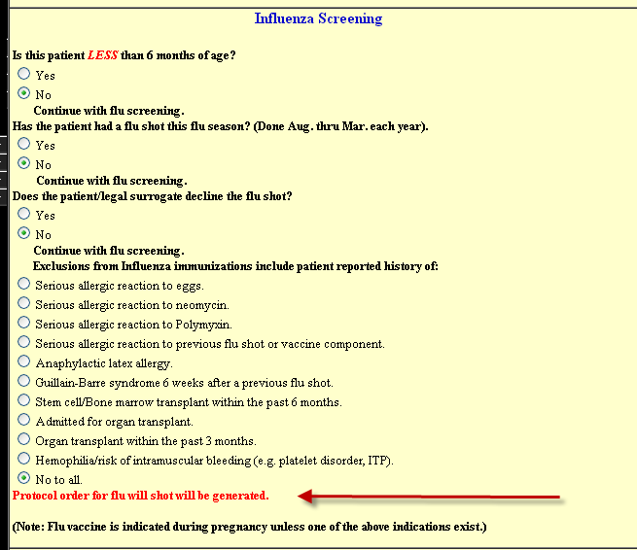

The VCH version of the influenza screen is different.  
Completing the screen and answering the “Does patient/legal surrogate decline the flu shot” question with either a Yes or No answer will generate a protocol HEO order for flu shot eligibility status:

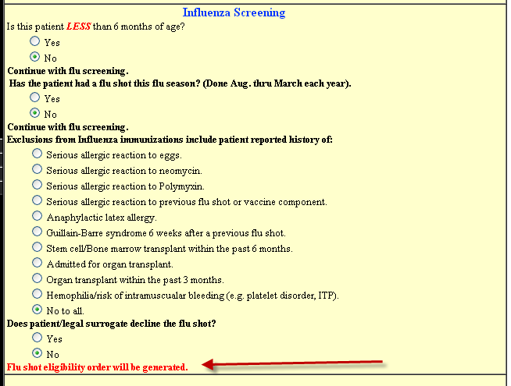

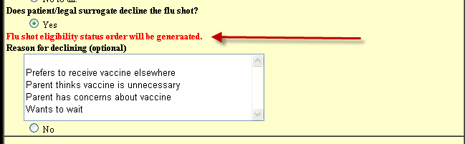

Functional Screening sections of the Nursing Admission History forms will change 10-01-13.  
The current Nursing admission hx Functional Screening section (Adult, Peds, OB and VPH) will be removed…  
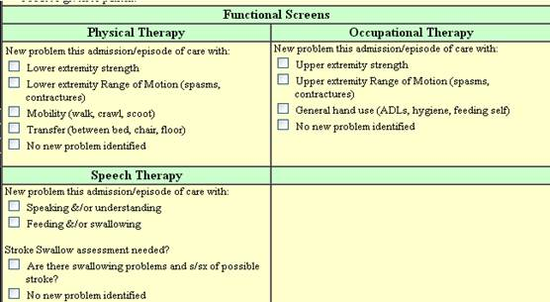  
  
and replaced by the New Functional Screening section. This will send and receive updates to/from the Clinic Intake form.

